FOR IMMEDIATE RELEASE
NOVEMBER 28, 2022

TEENAGE DISASTER UNVEILS CREEP

EDGY HUMBOLDT COUNTY NATIVE UNLEASHES ATLANTIC RECORDS DEBUT PROJECT,
INCLUDING NEW SINGLE “DOUBT”

NORTH AMERICAN TOUR WITH SUB URBAN KICKS OFF NOVEMBER 30 IN SAN FRANCISCO, CA
INCLUDES STOPS AT LA’S TROUBADOUR AND NY’S GRAMERCY THEATRE

CREEP IS AVAILABLE EVERYWHERE NOW
LISTEN HERE

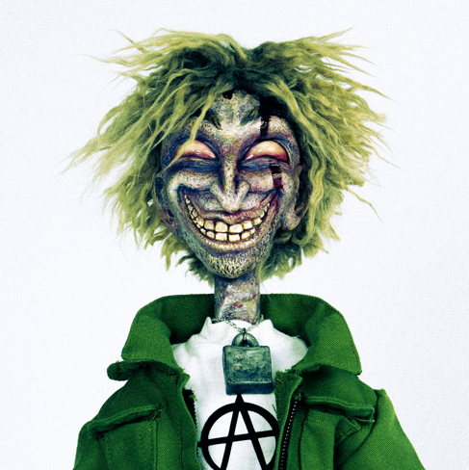
DOWNLOAD ARTWORK HERE

The dark and edgy Teenage Disaster has released his Atlantic Records debut project, CREEP – available now at all DSPs and streaming services HERE.

Teenage Disaster’s CREEP includes new single “Doubt,” alongside “RELOAD (feat. Afourteen),” “MASK (feat. BLCKK),” “MANHUNT (feat. Jasiah)” and several other singles released earlier this year. The edgy Humboldt County native artist and producer is a new artist at Atlantic Records, which was announced exclusively on Rolling Stone HERE, and will be kicking off an electric tour across North America with Sub Urban on November 30th in San Francisco, CA. For complete details and ticket information, please visit https://www.teenagedisaster.com/.

CREEP – TEENAGE DISASTER

- MURDER (KILL SHIT)
- Takes 2 To Kill Me
- Exit Strategy
- Chop Chop
- STFU
- RELOAD (feat. Afourteen)
- MANHUNT (feat. Jasiah)
- MASK (feat. BLCKK)
- Drive Alone
- I Hate Me Too
- Shitlist
- Doubt
- Missing Persons

TEENAGE DISASTER TOUR 2022

NOVEMBER
30 – San Francisco, CA – Rickshaw Stop

DECEMBER
1 – Santa Ana, CA – The Observatory
2 – West Hollywood, CA – Troubadour
5 – Denver, CO – Larimer Lounge
7 – Dallas, TX – Trees
8 – Houston, TX – White Oak Music Hall
10 – Atlanta, GA – The Masquerade – Purgatory
12 – Washington, DC – Union Stage
13 – New York, NY – Gramercy Theatre
14 – Philadelphia, PA – The Foundry
16 – Boston, MA – Brighton Music Hall
17 – Asbury Park, NJ – House of Independents
19 – Columbus, OH – A&R Music Bar
21 – Chicago, IL – Lincoln Hall

ABOUT TEENAGE DISASTER
Humboldt County native, Thorne Baker, better known as Teenage Disaster, builds his sound from the perspective of threatening characters, which stems from growing up in a home full of horror film paraphernalia. He became captivated with horror and his latest project, CREEP, is highly visual with artwork and animations that he created himself.

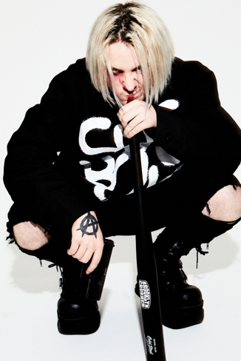
DOWNLOAD PRESS PHOTO HERE
CREDIT: JIMMY FONTAINE

CONNECT WITH TEENAGE DISASTER
INSTAGRAM | TIKTOK | TWITTER | OFFICIAL WEBSITE

CONTACT
Jessica Nall // Jessica.Nall@atlanticrecords.com

