FOR IMMEDIATE RELEASE
DECEMBER 5, 2022

ABSOFACTO RETURNS WITH “VIBE TIL I DIE”
FEAT LOVE-SADKID AND LIMBO

AN INTRODUCTION TO A WHOLE NEW WORLD – NITESHIFT

LISTEN HERE | WATCH VIDEO HERE

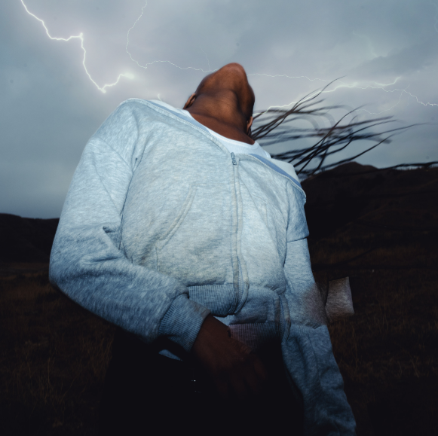
DOWNLOAD ARTWORK HERE
Photo by Elinor Kry, Design by Jacqueline Kulla

The platinum-certified Los Angeles-based artist, producer and creator, Absofacto (Jonathan Visger), has uncovered a whole new world – NITESHIFT, a multidimensional, ongoing experience which will consist of a series of singles, visuals, films, interactive elements, and much more. The first piece to be revealed is “VIBE TIL I DIE,” which features love-sadKID and LIMBO and was mixed by Jeff Ellis (Frank Ocean, Joji, Omar Apollo) – available now at all DSPs and streaming services HERE. The piece released alongside a stunning cinematic video created by Jacqueline Kulla and Absofacto – watch HERE.
“NITESHIFT is for people who want to feel challenged and discover something truly new for themselves,” Absofacto shared. “Yes, it’s a literal place… but it’s also a puzzle, a mystery, a community, and a tool for expanding your horizons in every way. Stories on stories. Discoveries on discoveries. It’s about immersing yourself in the infinite depth of being alive. The scope of it will become apparent over time, and it can actually transform your perspective on the world around you. As human beings on Earth, we all have the same confusing experience of being born into a structure we didn’t design and having to make sense of the world around us. We wonder, ‘What direction are we supposed to go in? What are we supposed to value? Why are we even here?’ Within NITESHIFT, you get to embrace that mystery and search for answers for yourself.”
Absofacto initially achieved global impact with the platinum hit “Dissolve,” tallying half-a-billion streams and paving the way for future fan favorite singles such as “Someone Else’s Dream.” Even as his profile rose, he had the unshakable feeling that there was a much deeper pursuit to go on, especially in the final hours of the day before sleep when a deluge of visions flooded his mind. From here, the door to NITESHIFT came into focus. And now we are all invited to step inside and begin our own journeys into the mysterious depths.

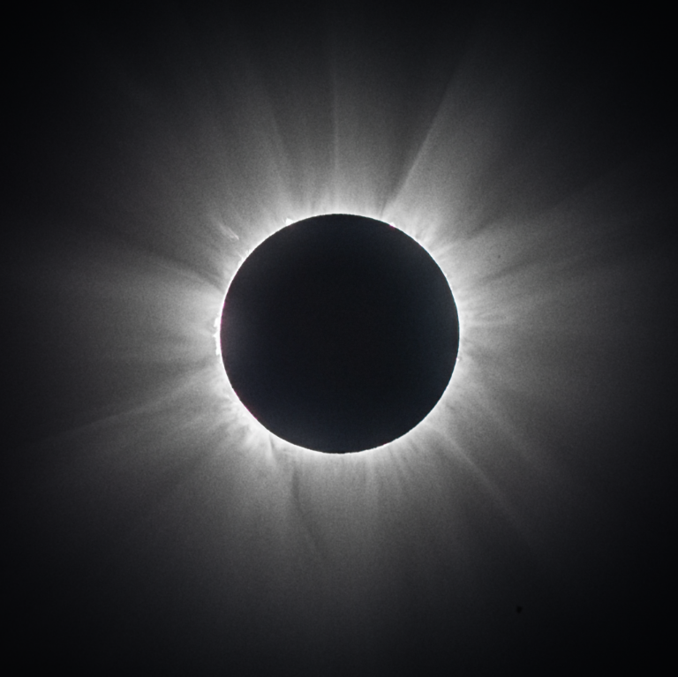
DOWNLOAD NITESHIFT PHOTO HERE

CONNECT WITH ABSOFACTO
OFFICIAL | FACEBOOK | TWITTER | INSTAGRAM | YOUTUBE

CONTACT
Jessica Nall // Jessica.Nall@atlanticrecords.com

