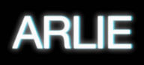

VISIONARY PSYCHEDELIC POP ACT ARLIE RELEASES ACOUSTIC VERSIONS OF FAN FAVORITE TRACKS “big fat mouth” & “crashing down” – BUY/STREAM HERE

ANNOUNCES FEBRUARY-MARCH 2023 US HEADLINE TOUR
TICKETS ON SALE HERE

TOUR KICKS OFF IN BIRMINGHAM, AL ON FEBRUARY 2 + INCLUDES SHOWS AT NYC’s BOWERY BALLROOM & LA’s TERAGRAM BALLROOM

DEBUT ALBUM BREAK THE CURSE OUT NOW
BUY/STREAM HERE

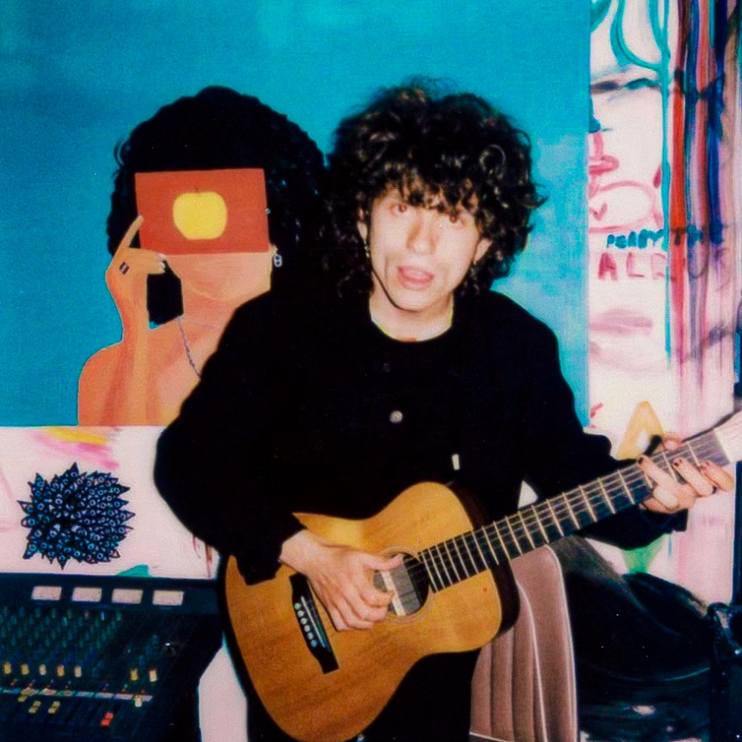
download hi-res artwork here

Today, visionary psychedelic pop act Arlie shares two new acoustic versions of fan favorite tracks, “big fat mouth” and “crashing down” (buy/stream here). “big fat mouth” has been streamed over 24M times since its initial single release – an immediate standout in Arlie’s early catalog – while “crashing down” appears on the band’s impressive first full-length, BREAK THE CURSE, which debuted to critical acclaim this past summer.

Of these new versions of both songs, singer-songwriter and multi-instrumentalist Nathaniel Banks shares:

“Recording these acoustic versions reminded me of the core of what made me write these songs and why they matter to me.”

The Nashville-based outfit, led by Banks, has also announced an upcoming US headline tour, set for February-March 2023. Kicking off on February 2 in Birmingham, AL, the run will include stops in Boston, DC, Chicago, San Francisco, and at LA’s Teragram Ballroom and NYC’s Bowery Ballroom.

General on-sale begins today, Friday, December 9 at 12pm ET. For more information and complete ticketing details, please visit the band’s website.

Arlie will also join the stacked lineup for the 10-year anniversary edition of Atlanta’s Shaky Knees, set to perform at the festival on Friday, May 5, 2023.

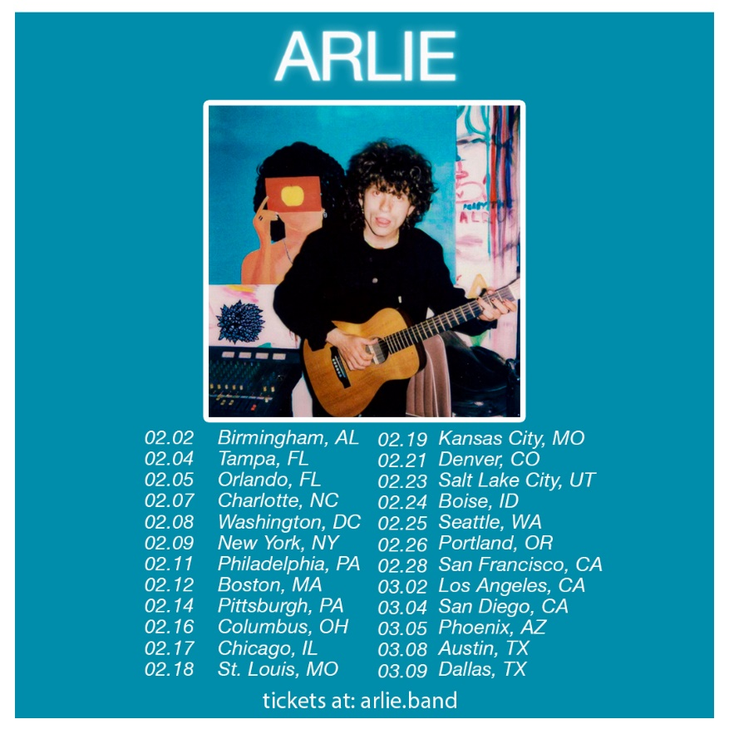
download hi-res admat here

Today’s announcements follow Arlie’s recent fall tour supporting LA natives and fellow indie pop band The Wrecks, which saw both artists traverse the country from San Diego to Rhode Island throughout October and November.

Earlier this year, Arlie marked their debut headline US run with the BREAK THE CURSE tour, the majority of which was entirely sold out, including shows in LA, Chicago, Austin, Denver and at NYC’s Mercury Lounge.

BREAK THE CURSE – the band’s highly-anticipated, first LP – marked the follow-up to 2018’s debut EP WAIT, and was met with critical acclaim from outlets including Ones to Watch and V Magazine (“The indie-pop song ‘landline’ expands upon the band’s saturated sound heard on ‘WAIT,’ taking them to a groovier and more upbeat level.”).

“A true collage of everything from pop to alternative, pulled together with a squelching kaleidoscopic flare… beaming with lyrical savviness that exudes alternative infatuation.” – ONES TO WATCH

“…fusing a sound both futuristic and vintage… Arlie flirts with an aroma of nostalgic youth, like a mix between a 1984 Testarossa and The Jetsons’ hovercraft.” – FLAUNT

“Arriving in the wake of the band’s 2018 EP, WAIT, and a string of stellar singles, the record found lead singer/songwriter and multi-instrumentalist Nathaniel Banks returning to music after taking an extended hiatus for his mental health. His return once again burst with colorful melodies and irresistible indie pop grooves, but also cultivated a more vulnerable side, with Banks reflecting on ‘breaking the curse’ of societal and generational trauma.” – UNDER THE RADAR

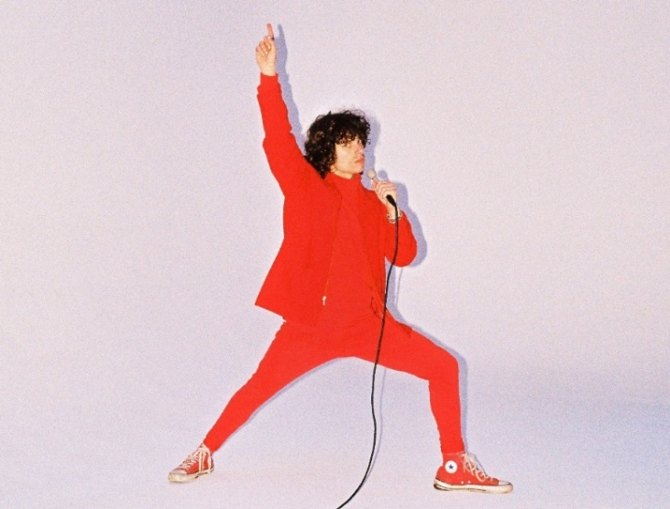
download hi-res press photo here; Credit: Gabe Drechsler

With over 104M worldwide streams and counting, Arlie first began in the summer of 2015 as a solo bedroom project for Banks, eventually evolving to a full-band live act by 2017 and growing a fervent fan following in their hometown of Nashville and beyond.

Hailed for its striking synthesis of classic pop melodies with wildly creative modern production, Arlie’s 2018 WAIT EP included such hit singles as “didya think” and “big fat mouth.” The project immediately drew acclaim for its invigorating songcraft, meticulous production, and playful, summertime energy.

*****

UPCOMING LIVE DATES:
DECEMBER 31, 2022 – Atlanta, GA – Buckhead Theatre*
FEBRUARY 2, 2023 – Birmingham, AL – TrimtTab
FEBRUARY 4, 2023 – Tampa, FL – The Orpheum
FEBRUARY 5, 2023 – Orlando, FL – Level 13
FEBRUARY 7, 2023 – Charlotte, NC – Neighborhood Theatre
FEBRUARY 8, 2023 – Washington, DC – Union Stage
FEBRUARY 9, 2023 – New York, NY – Bowery Ballroom
FEBRUARY 11, 2023 – Philadelphia, PA – Kung Fu Necktie
FEBRUARY 12, 2023 – Boston, MA – Brighton Music Hall
FEBRUARY 14, 2023 – Pittsburgh, PA – Club Café
FEBRUARY 16, 2023 – Columbus, OH – The Basement
FEBRUARY 17, 2023 – Chicago, IL – SUBTERRANEAN
FEBRUARY 18, 2023 – St. Louis, MO – Blueberry Hill Duck Room
FEBRUARY 19, 2023 – Kansas City, MO – Record Bar
FEBRUARY 21, 2023 – Denver, CO – Larimer Lounge
FEBRUARY 23, 2023 – Salt Lake City, UT – Soundwell
FEBRUARY 24, 2023 – Boise, ID – The Shredder
FEBRUARY 25, 2023 – Seattle, WA – Vera Project
FEBRUARY 26, 2023 – Portland, OR – White Eagle Saloon
FEBRUARY 28, 2023 – San Francisco, CA – Bottom of the Hill
MARCH 2, 2023 – Los Angeles, CA – Teragram Ballroom
MARCH 4, 2023 – San Diego, CA – House of Blues: Voodoo Room
MARCH 5, 2023 – Phoenix, AZ – The Rebel Lounge
MARCH 8, 2023 – Austin, TX – 3TEN
MARCH 9, 2023 – Dallas, TX – Club Dada
MAY 5, 2023 – Atlanta, GA – Shaky Knees Music Festival

*w/ flipturn & Hotel Fiction

# # #

CONNECT WITH ARLIE:
OFFICIAL | INSTAGRAM | FACEBOOK | YOUTUBE | TWITTER

FOR ALL PRESS INQUIRIES, PLEASE CONTACT:
Libby Kober | Libby.Kober@AtlanticRecords.com
Gabby Reese | Tour/Online | Gabrielle.Reese@AtlanticRecords.com

