FOR IMMEDIATE RELEASE
DECEMBER 14, 2022

BANKROL HAYDEN IS SITTING “COURTSIDE”

SLAM DUNK ANTHEM MARKS LATEST INSTALLMENT IN
ATLANTIC RECORDS AND ESPN’S PARTNERSHIP
SOUNDTRACKING THE 2022-2023 NBA SEASON

BESPOKE TRACK TO BE USED FOR ESPN AND ABC’S
“NBA ON CHRISTMAS DAY” COVERAGE

RISING HIP-HOP STAR ALONG WITH “COURTSIDE” PRODUCER EINER BANKZ
TO CELEBRATE WITH FEATURED APPEARANCE AND LIVE PERFORMANCE
NEXT WEEK ON NBA TODAY, AIRING ON ESPN

LISTEN TO “COURTSIDE”

WATCH NBA ON CHRISTMAS DAY SPOT
FEATURING “COURTSIDE”

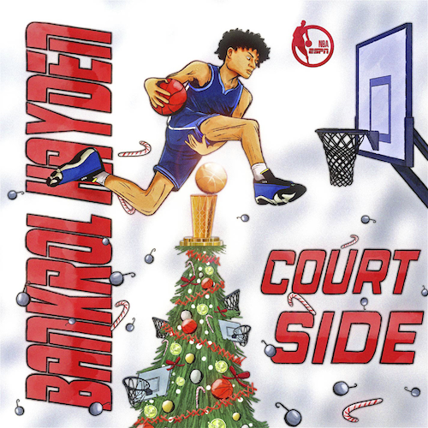
DOWNLOAD HI-RES ARTWORK

Rising hip-hop star Bankrol Hayden is joining forces with ESPN for the new Christmas anthem, “Courtside,” premiering today via Atlantic Records at all DSP’s and streaming services. Produced by longtime collaborator Einer Bankz (Travis Scott, 21 Savage), the bespoke track was created specifically for the “NBA on Christmas Day” campaign and will be used extensively over the next two weeks throughout all NBA on ESPN coverage, spanning promos, in-game placement, social media, and more. Watch HERE

Named as the featured artist for ESPN and ABC’s “NBA on Christmas Day” coverage, Bankrol Hayden – accompanied by producer Einer Bankz – will celebrate the premiere of “Courtside” with a special appearance and live performance next week on ESPN’s NBA Today.

“Courtside” marks the latest installment in Atlantic Records and ESPN’s landmark partnership storytelling the 2022-2023 NBA Season following this fall’s arrival of Ty Dolla $ign and Mustard’s “My Friends (NBA on ESPN Remix),” a customized version created as ESPN’s Season Tip-Off Anthem that sees the track’s original lyrics remixed to include name drops of the league’s biggest stars. New custom tracks – including original music and exclusive remixes created for key NBA moments such as Saturday Primetime matchups, the Play-In Tournament, Playoffs, and NBA Finals – will be unveiled later in the season.

With over 133M YouTube views to date, Bankrol Hayden is a true phenomenon, earning fans around the globe with his positive brand of soulful, pop-forward hip-hop. The talented young artist first broke out in 2017 with a series of popular YouTube videos and SoundCloud favorites. Viral smashes as “B.A.N.K.R.O.L.,” “29,” and the RIAA gold certified “Brothers (Feat. Luh Kel)“ followed, the latter of which scored 30M Spotify streams and 6.5M YouTube plays in under six months. Bankrol Hayden made his Atlantic Records debut in 2020 with the hugely popular “Costa Rica,” quickly earning RIAA gold certification before following up with his powerful debut mixtape, Pain Is Temporary, highlighted by such emotionally charged tracks as “Whatchu On Today (Ft. Polo G),” “Drop A Tear (Ft. Lil Baby),” and “Rich Bitch,” all joined by official music videos streaming now at YouTube.

“Courtside” marks the latest in a run of radiant new music from Bankrol Hayden, including “Deep End (Feat. Lil Skies),” “Van Hayden,” “F*ck Love” the RIAA gold-certified “Costa Rica,” “Cabo,” “No Drama,” and last year’s smash hit, “Come Through (Ft. Lil Tecca),” the latter of which boasts over 100M worldwide streams after making top playlists such as Spotify’s “Rap Caviar” and “Most Necessary,” Apple Music’s “#OnRepeat” and “The Plug,” Amazon’s “Fresh Hip-Hop,” and more.

Featured among YouTube’s “Artist on the Rise: Trending” series, Bankrol Hayden has also proven to be an electrifying live performer. Most recently, lighting up the Juice WRLD Day Festival last week in Chicago, IL and this past summer at the Gulf Shores, AL’s Hangout Music Festival, Grand Prairie, TX’s So What?! Music Festival, and Dover, DE’s Firefly Music Festival. Upcoming dates will be announced soon. For updates and additional information, please visit www.bankrol.co.

“Tupac used to write as either an observer, participant, or themselves,” Bankrol Hayden says. “That inspires me. I stay true to myself and put my life into this, but you’ll get different perspectives.”

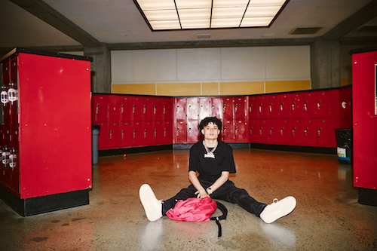
DOWNLOAD HI-RES IMAGES | PHOTO CREDIT: DANIEL PRAKOPCYK

CONNECT WITH BANKROL HAYDEN
OFFICIAL | FACEBOOK | INSTAGRAM | TIKTOK | TWITTER | YOUTUBE

PRESS CONTACT
FAIRLEY MCCASKILL | FAIRLEY.MCCASKILL@ATLANTICRECORDS.COM

# # #

