FOR IMMEDIATE RELEASE
SEPTEMBER 16, 2022

1017 GLOBAL MUSIC’S BIGWALKDOG ANNOUNCES TRICK CITY

MISSISSIPPI RAPPER REVEALS DEBUT MIXTAPE, OUT SEPTEMBER 23RD
PRE-ORDERS / PRE-SAVES AVAILABLE NOW HERE

UPCOMING LIVE SCHEDULE INCLUDES DATES SUPPORTING
KEVIN GATES’ BLOCKBUSTER “BIG LYFE TOUR”

TRICK CITY ARRIVES VIA 1017 GLOBAL MUSIC/ATLANTIC RECORDS
ON FRIDAY, SEPTEMBER 23

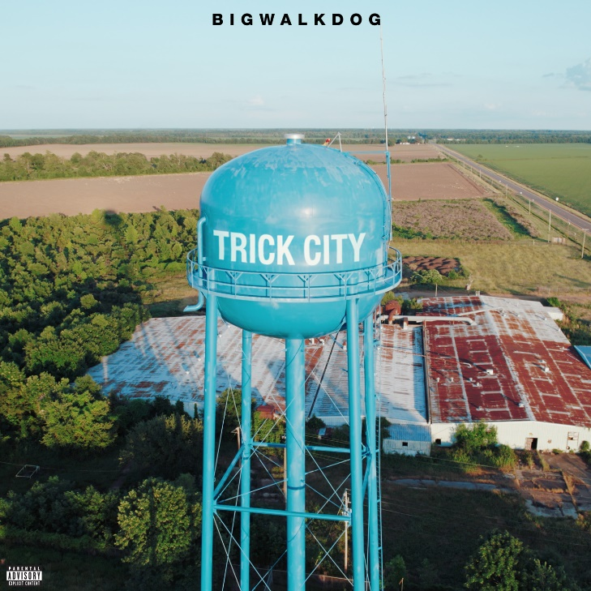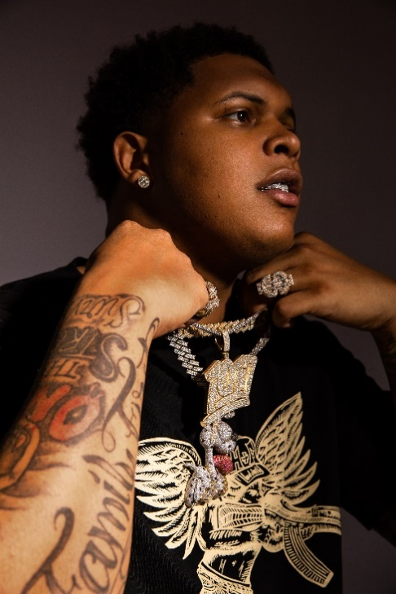
(DOWNLOAD PRESS PHOTOS HERE)
“BigWalkDog's approach is best described as relentless; he finds the pocket of every song he's on and never lets up, and does so with the vigor of a rapper who knows he's meant for this…” – XXL

Towering over any room at 6’8”, Mississippi rapper BigWalkDog bares his teeth with commanding bars and knockout hooks that prove impossible to shake. Following a series of hard-hitting singles, BigWalkDog has announced the release of his eagerly anticipated debut mixtape. TRICK CITY arrives via Gucci Mane’s 1017 Global Music in partnership with Atlantic Records on Friday, September 23, with pre-orders/pre-saves available now HERE.

TRICK CITY will include such tracks as “Uncle Tommy,” “How It Go,” “SkyWalka,” “Nino,” “Know What I Mean (Feat. Gucci Mane),” “Trap God (Feat. Gucci Mane,” “Came From Da Bottom,” and “Whole Lotta Ice (Feat. Lil Baby & Pooh Shiesty),” the latter joined by an official music video currently boasting over 20M views via YouTube after earning nearly 1 million views in its first 24 hours alone. The project also features Gucci Mane & BigWalkDog’s smash collaboration “Poppin,” accompanied by an official music video now with over 37M views after rising to #2 on YouTube’s “Trending” chart.

With over 200M worldwide streams and more than 165M video views thus far, BigWalkDog is fast proving one of the most compelling new artists on the 1017 Global Music roster. The 6’8” Magnolia State rapper will mark the arrival of TRICK CITY with a number of dates supporting Kevin Gates’ “Big Lyfe Tour,” including Nashville, TN’s Nashville Municipal Auditorium (September 30), and Birmingham, AL’s Legacy Arena at The BJCC (October 7).

Born in Tutwiler, MI, BigWalkDog moved to Memphis, TN in 2020 where he unleashed a string of independent releases that showcased commanding bars and knockout hooks that prove impossible to shake, all spiced with the rapper’s one-of-a-kind brand of Southern gusto. Tracks such as “Tyson” and “B.T.D.” soon caught catching the attention of Gucci Mane, who swiftly signed BigWalkDog to his fast-growing 1017 Global Music label.

A wide span of powerful releases followed, including striking appearances on 1017 Global Music label’s RIAA Certified Gold compilations SO ICY BOYZ and the recently released SO ICY GANG: THE REUP, all of which drew millions of streams alongside critical acclaim from such media outlets as REVOLT, which raved, “BigWalkDog is quickly becoming one of the bigger faces on the Southern rap scene.”

“Mississippi made me,” says BigWalkDog, “but I want BigWalkDog to be for the world. You can take your own feelings from it – whether they’re good or bad. I’m just being honest.”

# # #

CONNECT WITH BIGWALKDOG
BIGWALKDOFMUSIC.COM | FACEBOOK | INSTAGRAM | YOUTUBE

BIGWALKDOG + 1017 GLOBAL MUSIC PRESS CONTACT:
Ashley Kalmanowitz | Ashley.Kalmanowitz@atlanticrecords.com

