MULTI-PLATINUM SINGER-SONGWRITER GAYLE SHARES NEW COLLECTION
a study of the human experience volume two and a half
FEATURING SPECIAL ALTERNATE VERSIONS OF SELECT SONGS
FROM HER TWO BREAKTHROUGH EPS

TRIUMPHANT 2022 CONTINUES AS NOW 3X PLATINUM “abcdefu” HONORED
WITH PRESTIGIOUS GRAMMY® AWARD NOMINATION
FOR “SONG OF THE YEAR”

15-DATE RUN AS SPECIAL GUEST ON TAYLOR SWIFT’S ERAS TOUR
BEGINS MARCH 17, 2023 IN GLENDALE, AZ

STUNNING ORCHESTRAL VERSION OF FAN FAVORITE, “kiddie pool (strings),” AVAILABLE NOW - WATCH HERE

(DOWNLOAD HI-RES PHOTOS)

GRAMMY® Award-nominated, multi-platinum certified singer-songwriter GAYLE has released a study of the human experience volume two and a half, featuring alternate versions of select tracks from her two acclaimed debut EPs, available now via Atlantic Records/Arthouse Records HERE. a study of the human experience volume two and a half includes the long clamored for the orchestral rendition of “kiddie pool (strings)” following its debut earlier this year via an official visualizer, HERE.

“i had no idea what i was doing when i put out a study of the human experience volume one,” says GAYLE. “i had little to no tour experience and i was just starting to get comfortable in my writing and in my sound. through this past year i’ve had so many new experiences that made me start to figure out what i really want out of life and what i really wanted to do with my music. a study of the human experience volume two and a half is me sitting with my music and thinking about what i would change about these songs now that i have more experiences and inspirations. also i got bored and wanted to do it :)”

a study of the human experience volume two and a half continues what is proving a milestone 2022 for GAYLE, with recent highlights including a prestigious GRAMMY® Award nomination for “Song of the Year” honoring her newly 3x RIAA platinum-certified, 2 billion-streaming, worldwide #1 hit, “abcdefu.” In addition, the 18-year-old, Nashville-based artist will join Taylor Swift as special guest for 15 shows on her blockbuster “The Eras Tour,” with dates set to begin March 17, 2023 at Glendale, AZ’s State Farm Stadium and then continue through the US leg’s finale at Inglewood, CA’s So Fi Stadium on August 9, 2023. Complete tour details can be found HERE.

GAYLE’s brilliant year has already seen such highlights as the release of her critically acclaimed sophomore EP, a study of the human experience volume two. The introspective EP includes “fmk (with blackbear),” which earned over 1 million streams in the first weekend following its release, recently debuted at #36 on Top 40 radio outlets nationwide, and is currently making its way up the chart. The playfully chaotic duet – which sees GAYLE joining forces with multi-platinum singer, songwriter, and producer blackbear - arrived alongside a delightfully homicidal animated video, directed by award-winning Belgian director Chris Ullens (Rex Orange County, Poppy).

GAYLE’s GRAMMY® Award nomination for “Song of the Year” marks the latest in an ever-increasing list of global honors and international accolades, with recent achievements including an American Music Awards nomination for “New Artist Of The Year,” a People’s Choice Awards nomination for “The New Artist of 2022,” “Best New” and “Best Push” nominations from the 2022 MTV EMAs (including an electrifying performance of “abcdefu,” streaming HERE), two MTV Video Music Awards nominations, being named a Billboard Music Awards finalist, and featured placement on both Billboard’s influential “21 Under 21” list and Variety’s 2022 “Power of Young Hollywood” Impact List. GAYLE was also recently acknowledged by her hometown’s Nashville Songwriter Awards, which named “abcdefu” in its annual “10 Songs I Wish I’d Written” list.

GAYLE’s triumphant 2022 kicked off with the release of her breakthrough debut EP, a study of the human experience volume one. The EP includes the now 3x RIAA platinum-certified breakthrough hit “abcdefu.” Declared “the breakout song of 2022” by NYLON and a “gloriously caustic grunge-pop smash” by the Los Angeles Times, “abcdefu” proved a landmark debut for GAYLE, holding #1 on the Billboard Global 200 for nine consecutive weeks while peaking at #3 on the Billboard “Hot 100” in the US after three consecutive weeks atop Top 40 radio charts nationwide. “abcdefu” has since been named among the “Best Songs of 2022 So Far” by Billboard, Rolling Stone, and UPROXX.

# # #

GAYLE
a study of the human experience volume two and a half
(Atlantic Records/Arthouse Records)

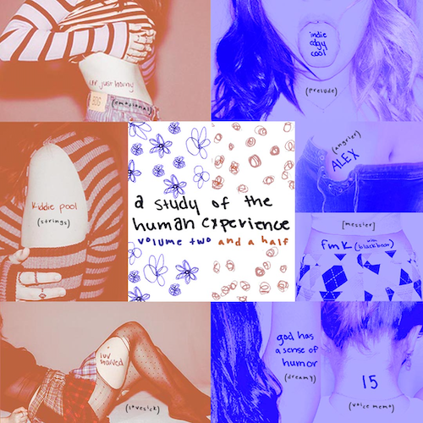
TRACKLIST
indieedgycool (prelude)
fmk (with blackbear) [messier]
luv starved (love sick)
kiddie pool (strings)
ALEX (angrier)
ur just horny (emotional)
15 (voice memo)
god has a sense of humor (dreamy)

# # #

GAYLE
ON TOUR 2023

ALL DATES WITH TAYLOR SWIFT | THE ERAS TOUR

MARCH 2023
17 – Glendale, AZ – State Farm Stadium
18 – Glendale, AZ – State Farm Stadium
24 – Las Vegas, NV – Allegiant Stadium
25 – Las Vegas, NV – Allegiant Stadium
31 – Arlington, TX – AT&T Stadium

APRIL 2023
13 – Tampa, FL – Raymond James Stadium
30 – Atlanta, GA – Mercedes–Benz Stadium

MAY 2023
6 – Nashville, TN – Nissan Stadium
12 – Philadelphia, PA – Lincoln Financial Field
13 – Philadelphia, PA – Lincoln Financial Field
19 – Foxborough, MA – Gillette Stadium
20 – Foxborough, MA – Gillette Stadium
26 – East Rutherford, NJ – MetLife Stadium

AUGUST 2023
5 – Inglewood, CA – SoFi Stadium
9 – Inglewood, CA – SoFi Stadium

# # #

CRITICAL PRAISE FOR GAYLE

“Few songs will end up being as defining for the past year in pop music as GAYLE’s breakout hit.”
– BILLBOARD

“GAYLE is on top of the world — and its charts, for that matter” – ROLLING STONE

“GAYLE’s uncensored honesty as a lyrical storyteller is what makes her music so captivating. She effortlessly parallels verses with experiences in a dynamic arrangement of sounds.”
– AMERICAN SONGWRITER

“Our favorite teen-pop rising star” – STEREOGUM

“Although she may seem young, the alt-pop singer has already lived a lifetime in music industry years.” – ALTERNATIVE PRESS

“Flexing with the kind of power notes that would make Kelly Clarkson’s eyes water, GAYLE’s strength as a vocalist is undeniable.” – THE GUARDIAN

“GAYLE’s ability to jump between the earnest, eyes-closed commitment of some songs and youthful chaos of others is irresistible.” – NME
# # #

CONNECT WITH GAYLE
GAYLEOFFICIAL.COM | FACEBOOK | INSTAGRAM |TIKTOK | TWITTER | YOUTUBE

GAYLE PRESS CONTACT
Christina.Kotsamanidis@atlanticrecords.com

