FOR IMMEDIATE RELEASE
DECEMBER 8, 2022

JAYSON CASH DROPS “OKAY OKAY”

CARSON, CA RAPPER SHARES BRAND NEW SINGLE
ALONGSIDE ONGOING INSTAGRAM SERIES OF
UNRELEASED LISTENING SESSIONS

LISTEN HERE | WATCH HERE

READ THE ROOM AVAILABLE NOW VIA ATLANTIC RECORDS

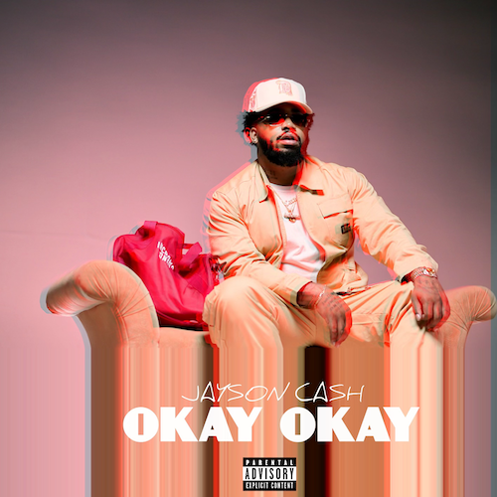
DOWNLOAD HERE

Carson, CA-based rapper Jayson Cash has shared his latest single, “Okay Okay;” produced by long-time collaborators Tha Eastie Boyz (Blxst, Schoolboy Q, Ty Dolla $ign). The melodic track arrives alongside an official visual directed by Favor Films. Watch HERE. Known for his lyricism, Jayson Cash wraps up 2022, by tapping into his harmonious side.

Cash has been lighting up Instagram in recent weeks with an ongoing series of unreleased listening sessions, showcasing an array of tracks including “Living Legend,” “Just Me (Ft. Eric Bellinger),” and the BLXST-produced “Home Sweet Home.” Additional new music drops will continue weekly via Instagram (@uknowcash) HERE.

“Okay Okay” follows the recent arrival of Cash’s Atlantic Records debut mixtape, Read The Room, available everywhere now. The project includes singles such as the Mustard-produced “Top Down,” as well as “Him (Feat. Dom Kennedy),” “Priority (Feat. BLXST)” and “Selfish (Feat. Major Myjah),” joined by an official music video; inspired by classic scenes from director John Singleton’s 2001 film, Baby Boy, streaming via YouTube HERE.

Cash lit up this fall’s BET Hip Hop Awards in Atlanta, GA with a show-stealing freestyle during the award ceremonies’ annual cypher. Highlights from the cypher – featuring Reuben Vincent, Sa-Roc, Guapdad 4000, Big Boss Vette and fellow Carson, CA native, DJ HED spinning for all the cypher moments throughout the show – can be viewed HERE.

In addition, Cash – whose label signing was announced earlier this year with an exclusive feature in Billboard – took to his socials shortly after the release of Read The Room to kick off his own version of Freestyle Fridays, dropping 14 freestyles on Instagram backed by a wide range of classic beats – spanning Kendrick Lamar, Mobb Deep, and The Notorious B.I.G. to YG, EST GEE, and The Game – all streaming now on YouTube HERE.

Other 2022 highlights include an appearance on Sway’s Universe Cypher (streaming HERE), as well as electrifying freestyles across platforms such as A Trip To The Corner Store (watch HERE), Real 92.3 LA’s Bootleg Kev & DJ Hed (watch HERE), and Power 106 Los Angeles’ LA Leakers (watch HERE), the latter of which has earned more than 32K views via YouTube and sees Cash rapping over Jermaine Dupri’s “Money Ain’t A Thang” and Snoop Dogg’s “Still A G Thang.” In addition, he’s dropped freestyles direct from his car including verses over Jack Harlow’s “First Class” (watch HERE), Buddy’s “Wait Too Long (Feat. BLXST)” (watch HERE), and Suga Free’s “I’d Rather Give You My Bitch” (watch HERE). What’s more, after local LA magazine, A Day In LA, dropped their “LA Rap Report Card” and gave Jayson a “D+,” instead of being salty about the grade, he jumped in the booth (watch HERE) forcing the Editor-In-Chief of the magazine to respond in fun. Mustard soon stepped up to stan the freestyle as a new fan and “Top Down” was created. Cash later sat down with the EIC for A Day In LA podcast to discuss the grade (watch HERE).

# # #

CONNECT WITH JAYSON CASH
INSTAGRAM | TWITTER | FACEBOOK | SNAPCHAT | YOUTUBE

PRESS CONTACT
BRITTANY.BELL@ATLANTICRECORDS.COM

# # #

