FOR IMMEDIATE RELEASE
NOVEMBER 15, 2022

SOUTH CENTRAL RAPPER KENNDOG RETURNS WITH “MEESKA MASKA”

NEW SINGLE ALREADY A VIRAL FAVORITE ON TIKTOK

LISTEN TO “MEESKA MASKA” HERE

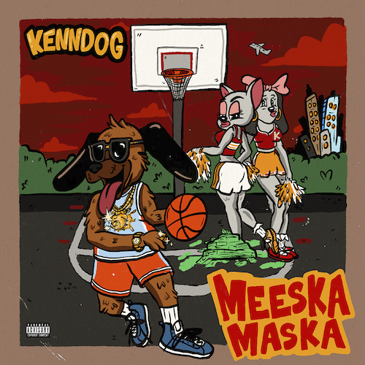
DOWNLOAD HI-RES ARTWORK

Multimillion-streaming South Central LA rapper Kenndog is back with his eagerly awaited new single, “Meeska Maska,” available now via Atlantic Records at all DSPs and streaming services HERE.

“Meeska Maska”– which Kenndog has been teasing on his hugely popular TikTok – follows such recent singles as “Fresh Prince of the Eastside” and “Doo Wop,” the latter of which was recently featured on an episode of VH1’s Love & Hip Hop: Miami. An Frankie Lymon & the Teenagers-inspired music video – directed by JakeTheShooter (Sueco, Bankrol Hayden) – is streaming now at the official Kenndog YouTube channel HERE.

At 6 feet 7 inches tall, Kenndog naturally becomes the center of attention anytime he pulls up. However, the Watts-born rapper holds that interest with a dynamic, dizzying, and deft flow punctuated by razor sharp wit and a knack for a hard-hitting hook. The youngest of four kids, Kenndog first started to rap on Facebook, inciting early buzz and building a still loyal audience. He learned how to cut hair after getting fired from his job at the 99 Cent Store, attracting a rapid customer base while continuing to drop tracks online. 2020’s “Drip Like Me” caught fire when TikTok titan Charli D’Amelio utilized the sound, unleashing a viral flurry with support from Vice President Kamala Harris, California Governor Gavin Newsom, ESPN SportsCenter, Jayda Cheaves, Clarence White, and many more.

Hailed by UPROXX as “an instant favorite,” Kenndog conceived the idea to sample Beethoven’s “Für Elise” as the foundation for his next single, “Beethoven.” The irresistible track proved his breakthrough, currently boasting over 100M global streams to date having reached Rolling Stone’s Trending 25, Spotify’s US Viral 50, and numerous viral charts worldwide. In addition, the original “Beethoven” sound on TikTok has seen over 500K video creates thus far, while also being featured in countless dance videos including Allendale, MI’s GVSU Laker Dance Team, who posted their routine to "Beethoven" via TikTok en route to winning the Dance Team Union’s 2022 College Classic National Championship.

“Beethoven” is accompanied by an official video has earned over 21M views via YouTube (where Kenndog was recently featured as a Trending Artist on the Rise). Kenndog followed up on “Beethoven” with remixes featuring rising Michigan rappers YN Jay and DDG, the latter joined by a cinematic horror parody official video directed by Ben Proulx (Chris Brown, P Diddy, J. Cole) and streaming now at YouTube HERE.

Sitting in the pocket between the South Central G-Funk of the 90s and modern internet-breaking boundlessness, Kenndog pursues a singular mission on tracks such as “Fresh Prince of the Eastside” (which samples DJ Jazzy Jeff & The Fresh Prince’s beloved Fresh Prince of Bel-Air theme) and “Meeska Maska,” with more new music due in the weeks and months to come.

# # #

CONNECT WITH KENNDOG
INSTAGRAM | TIKTOK | TWITTER | YOUTUBE | WEBSITE

PRESS CONTACT:
Brittany Bell | Brittany.Bell@atlanticrecords.com

