KEVO MUNEY DROPS “NO GRAVITY”

OFF FORTHCOMING MIXTAPE KEVO MUNEY FEAT. LIL MUNEY

ACCOMPANIED BY OFFICIAL VISUAL

DOWNLOAD/STREAM HERE

WATCH HERE

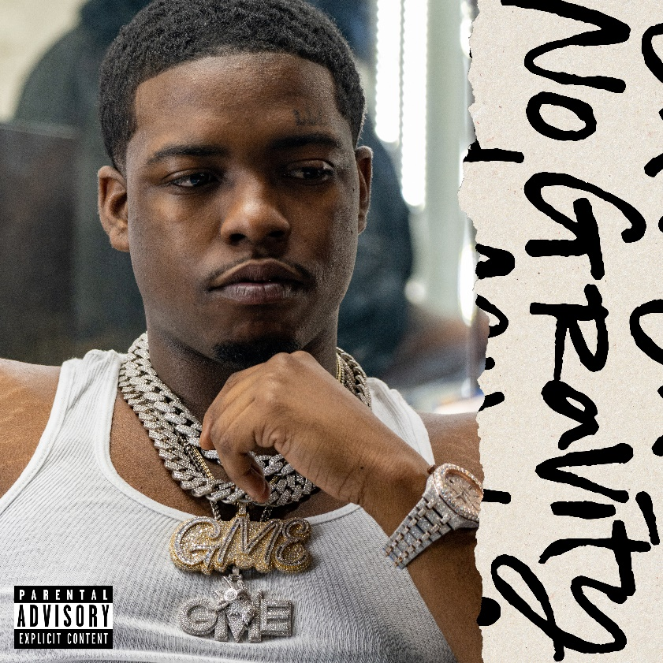
DOWNLOAD HI-RES ARTWORK HERE

Kevo Muney has released “No Gravity” off his long-awaited forthcoming mixtape, Kevo Muney Feat. Lil Muney. The new track is delivered alongside an official visual, watch HERE.

“No Gravity” is preceded by Kevo’s most recent singles, “Lil Muney Flow” and “Memphis” that both paid homage to his hometown of South Memphis. Muney tells a ruthless tale of life in Memphis, never knowing who to trust as he strives to reach the top.

Muney’s single, “Leave Some Day” has proven a true blockbuster, earning RIAA gold certification with more than 175M worldwide streams and top chart placement across Apple Music, Spotify, SoundCloud, and Shazam. In addition, the track’s official companion music video has racked up close to 15M individual views via YouTube HERE, while the stellar “Leave Some Day (Remix) [Feat. Lil Durk]” is available for streaming and download HERE.
Now with over 300M worldwide streams and counting, Kevo Muney has earned acclaim in his native Memphis for bringing soul back into hip-hop with powerful songs written from a place of truth and authenticity, some motivational and inspiring, other rooted in pain and personal struggle. The youngest child of eight siblings, Muney grew up in one of the toughest neighborhoods in South Memphis. He first tapped into his growing talent by releasing freestyles on Facebook, rapping over any random beats he found on YouTube. A string of street mixtapes drew underground attention before 2017’s “I Grind (Feat. King Arti)” proved his local breakthrough. 2018’s breakthrough project, WHO AM I, was joined the next year by 2019’s follow-up, WHO AM I: RELOADED, as well as the viral smash mixtape, BABY G.O.A.T, highlighted by the singles, “Everythang Changed,” “Crying Out Loud,” and “Oh God (Feat. BlocBoy JB),” the latter joined by an official companion video, streaming HERE following its premiere via Complex.

PRESS CONTACT
COREY BREWER |COREY.BREWER@ATLANTICRECORDS.COM

