FOR IMMEDIATE RELEASE
DECEMBER 16, 2022

CHICAGO RAPPER LIL EAZZYY ENDS THE YEAR WITH
NEW SINGLE + VIDEO “TEMPER”

LISTEN HERE | WATCH HERE

AVAILABLE NOW AT ALL DSPS AND STREAMING SERVICES

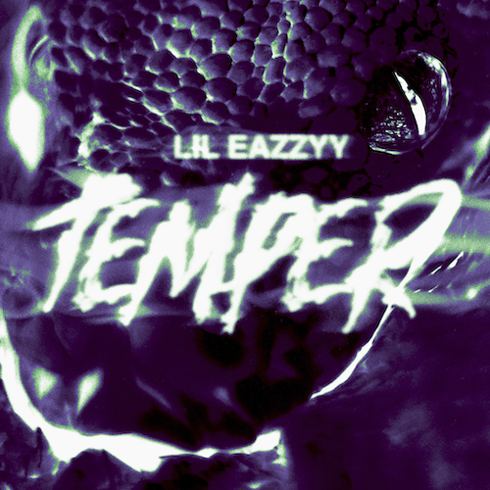
DOWNLOAD HI-RES IMAGE

Multi-million streaming Chicago rapper Lil Eazzyy wraps up 2022, with his new single “Temper.” Produced by Yakree (Roddy Ricch, NBA YoungBoy and B Wolf (Lil Durk, EST Gee) the vivacious new track is joined by an official music video directed by Killer Jack (Kodak Black and Lil Double 0). Watch HERE.

“Temper” continues a string of recent releases from Lil Eazzyy, including the heartfelt hit single, “Up There,” produced by RIAA gold certified New 1017/Atlantic recording artist Big Scarr and accompanied by an emotionally charged visual HERE.

2022, saw the arrival of Lil Eazzyy’s acclaimed new mixtape, TOO EAZZYY, highlighted by such tracks as “Hard Way (Feat. Shoebox Baby),” “Nothing Left,” and “Forever Been Steppin,” the latter recently featured on The CW’s hit series, All American: Homecoming, as well as on the official soundtrack to EA Games’ Need For Speed™ Unbound. All three tracks are accompanied by official visuals streaming now at YouTube.

In addition, Lil Eazzyy has offered up a number of live renditions of tracks from TOO EAZZYY, including a thrilling take on “Nothing Left” for THE EYE Sessions and a fiery “Forever Been Steppin” for TRSH.

This year Lil Eazzyy went on his first ever North American tour supporting NLE Choppa and performed at Rolling Loud Miami. He continued to hone his killer flow and unparalleled mic instincts with appearances including a live version of “Blitz” for 4 Shooters Only’s “From The Block” as well as a volatile “Fire In The Booth” freestyle for Apple Music’s Charlie Sloth.

With hundreds of millions of streams alongside acclaim from The FADER, UPROXX, and Complex, Lil Eazzyy has quickly made a name for himself as an unapologetic, unrelenting rhymer, reverent of old school rap’s rules of engagement yet incendiary enough to set the genre on fire in the 21st century. The Chicago-born, Los Angeles-based rapper broke into the game with such successful independent tracks as “Finesse,” “Listen Up,” and “Letter Tracy” before ascending to the forefront of hip-hop with the breakthrough hit single, “Onna Come Up,” earning more than 157M worldwide streams while reaching #6 on Spotify’s “US Viral 50,” #14 on the “Global Viral 50,” and #21 on Rolling Stone’s “Breakthrough 25” chart. At just 20 years old, Lil Eazzyy is fast proving a major force to be reckoned with, lacing ironclad flow, razor sharp wordplay, spellbinding storytelling, and no shortage of ambition into a viscerally versatile signature style.

“There aren’t really any active bar-for-bar rappers at my age,” says Lil Eazzyy. “When you hear this, I want you think, ‘He is the best bar-for-bar rapper out right now’. Somebody needs to correct me if I’m wrong.”

# # #

CONNECT WITH LIL EAZZYY
WEBSITE | FACEBOOK | INSTAGRAM | TIKTOK | YOUTUBE

