FOR IMMEDIATE RELEASE
DECEMBER 16, 2022

RIAA PLATINUM CERTIFIED RAPPER NOCAP RETURNS WITH NEW
EP THE MAIN BIRD
ACCOMPANIED BY COMPANION VISUAL FOR “RICH AND DANGEROUS”
THE 7-TRACK EP FEATURES ROB49 AND RYLO RODRIGUEZ
THE EP ALSO HAS PRODUCTION FROM DAMN DIOR, DATBOIGETRO, WHEEZY, AL’GENO, ALEK BEATS, ZNAYSHI, JAMBO, D HILL, CAMM, JUVY CATCHER, AND ROCKY
COMES ON THE HEELS OF A FLURRY OF BUZZING SINGLE RELEASES
FOLLOW-UP TO MR. CRAWFORD ALBUM RELEASED THIS PAST SPRING
DOWNLOAD/STREAM THE MAIN BIRD
WATCH/SHARE “RICH AND DANGEROUS”
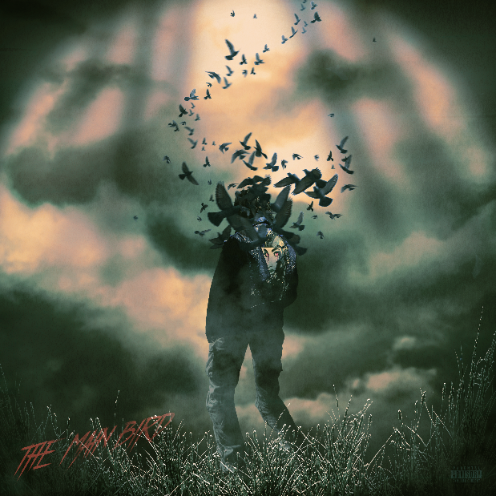
NoCap’s Jacket Artwork designed by:
Creative Director Michael Benz, @michaelbenz444
DOWLOAD HI-RES ARTWORK

RIAA platinum-certified Mobile, AL rapper NoCap has released his second body of work of the year, The Main Bird. The 7-track EP includes features a highly anticipated collaboration with Rylo Rodriguez. This will be the first collaboration with the duo in four years since “100 Years.” The Main Bird also features Rob49 and has intricate production from Damn Dior, DatBoiGetro, Wheezy, Al’Geno, Alek Beats, Znayshi, Jambo, D Hill, Camm, Juvy Catcher, and Rocky. The EP is also accompanied by a visual for “Rich And Dangerous” available for streaming now. The Main Bird comes on the heels of NoCap’s successful MR. CRAWFORD album and tour of the same name. The album and subsequent tour were followed up with a flurry of single releases and a captivating performance at this year’s Rolling Loud NYC this past September.

The Main Bird Tracklist

- Rich And Dangerous
- How It’s Going (feat. Rob49)
- Back To Basics
- Standing On Lies
- Ain’t Right
- Tight End (feat. Rylo Rodriguez)
- No Other Way

The title of the project, The Main Bird, hits close to home for NoCap. The significance of Eagles/Ravens comes from his childhood neighborhood. He grew up in Mobile, AL in a neighborhood called Birdsville where each street was named after a different bird. He uses this as inspiration on many occasions, consistently using the Eagle emoji on all his posts and even tattooing a raven on himself. The EP itself is a mix of party tracks, pain records, and more that show off NoCap’s versatility and the lyricism that he’s become known for.
# # #

By embracing the art of storytelling, NoCap narrates his life out loud. With over 100M global streams, an increasingly rapt fan following, and ecstatic praise from such outlets as Rolling Stone, Hypebeast, The FADER, Pitchfork, and more, the Mobile, AL-based rapper and singer dips in and out of turbulent and triumphant memories, all with the same careful attention to detail. 2019 saw the breakthrough release of such mixtapes as The Hood Dictionary and Steel Human, the latter highlighted by the debut single and RIAA platinum-certified anthem, “Ghetto Angels,” a YouTube favorite with views now exceeding 88M HERE. An array of high-profile projects followed, from collaborations with Lil Baby, DaBaby, YFN Lucci, and YoungBoy Never Broke Again to “Family (Feat. Quando Rondo),” featured on 2020’s smash Road To Fast 9 Mixtape. After spending half of 2021 behind bars, he unleashed his second RIAA gold-certified single, “Vaccine,” named by Pitchfork as one of “The 38 Best Rap Songs of 2021” and joined by an official music video currently boasting more than 74M views via YouTube HERE.

With the long-awaited release of MR. CRAWFORD, NoCap’s true story comes into focus like never before. MR. CRAWFORD includes tracks like “Shackles To Diamonds,” “I’ll Be Here,” “Vaccine,” “Very Special” and “Save The Day (Feat. Kodak Black).” Official music videos for these records can be found on his official YouTube channel HERE. The album also boasts notable features from YoungBoy Never Broke Again and Internet Money. Hailed by Pitchfork as “a standout voice in the Deep South,” NoCap celebrated MR. CRAWFORD with his biggest U.S. headline tour to date this past Spring. NoCap followed up on the success of MR. CRAWFORD with a string of notable releases and his stand-out performance at this year’s Rolling Loud NYC in September.

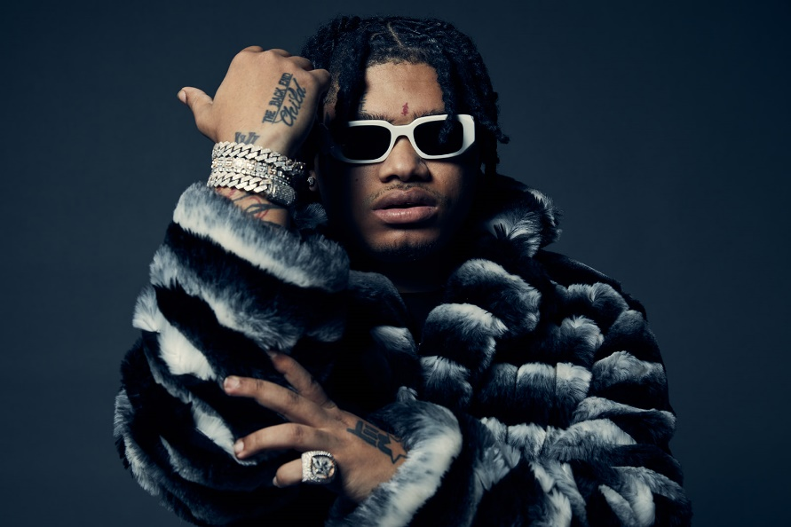

CONNECT WITH NOCAP
WEBSITE | FACEBOOK | TWITTER | INSTAGRAM | YOUTUBE

FOR ALL PRESS INQUIRIES, PLEASE CONTACT
ARIANA.WHITE@ATLANTICRECORDS.COM

