FOR IMMEDIATE RELEASE
DECEMBER 13, 2022

OHGEESY IS READY FOR “1ST DAY OF SCHOOL”

STACKED 2023 LIVE SCHEDULE INCLUDES
DIRECT SUPPORT ON YG’S THE RED CUP TOUR
AND TOP-BILLED SET AT ROLLING LOUD CALIFORNIA

LISTEN HERE | WATCH HERE

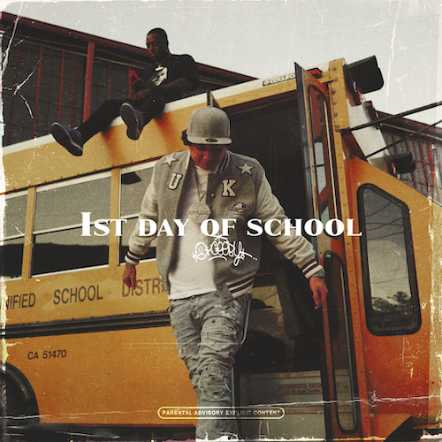
DOWNLOAD HI-RES ARTWORK HERE

RIAA platinum certified SoCal rap icon OHGEESY is wrapping up an epic 2022 with today’s premiere of his new single, “1st Day of School.” Produced by long time Shoreline Mafia collaborator Ron Ron and notable Detroit producer Stuntman (Megan Thee Stallion, Chief Keef Sada Baby) – the anthem is joined by another Kuno-directed official video Watch HERE.

The new single heralds the upcoming release of OHGEESY’s eagerly anticipated new mixtape, GEEZYWORLD 2, due to arrive in early 2023. The project – which follows the Los Angeles, CA-based rapper’s acclaimed 2021 solo debut mixtape, GEEZYWORLD – also includes such powerhouse new tracks as “Gallery,” “Knock Knock,” and “Up.”

Produced by DJ Vision, “Knock Knock” was met by applause from such outlets as HotNewHipHop, which declared it to be “a murderous and boisterous track…It wouldn’t sound out of place on any Shoreline Mafia tape, the L.A. rap collective OHGEESY helped found. Even if that Cali sound isn’t the trend of the moment, the 28-year-old is still carrying the torch for his city and keeping that sun-drenched bounce alive on playlists.”

OHGEESY will celebrate his new music and much more with a wide-ranging North American live schedule, directly supporting GRAMMY® Award-nominated rapper YG’s “The Red Cup Tour;” getting underway January 20, 2023 at Denver, CO’s Fillmore Auditorium and then traveling through late February. In addition, OHGEESY will join Future, Lil Uzi Vert, Lil Wayne and a galaxy of hip-hop superstars for a top-billed hometown performance at the upcoming Rolling Loud California, set for Sunday, March 5, 2023 at Inglewood, CA’s Hollywood Park Grounds. For complete details and remaining ticket information, please visit www.ohgeesyofficial.com.

Last month saw Shoreline Mafia – the multi-platinum hip-hop collective co-founded by OHGEESY – mark Black Friday with a fourth-anniversary vinyl edition of their RIAA gold certified 2017 debut mixtape, ShorelineDoThatShit, available exclusively via the Warner Music Store HERE.

ABOUT OHGEESY:
California never gave rise to a rapper quite like OHGEESY. The Los Angeles-born, Mexican-American, multiplatinum certified artist, entrepreneur, and visionary not only continues the legacy of his hometown, but he also puts a whole culture rarely represented in hip-hop on his back with pride, poise, and power. As such, he emerges as a trailblazer with vicious wordplay, vibrant storytelling, and a vital message. Breathing new life into the culture, OHGEESY co-founded Shoreline Mafia in 2016 and quickly locked down the group’s legacy with 2017’s RIAA gold certified ShorelineDoThatShit, the 2x platinum smash “Bands,” and such platinum certified hits as “Musty” and “Nun Major.”

OHGEESY made his smash solo debut with 2021’s acclaimed GEEZYWORLD, available now in an extended deluxe edition HERE. Hailed by Pitchfork as “a quintessential L.A. rap record,” the album includes such multimillion-streaming hit singles as “Get Fly (Feat. DaBaby),” “Big Bad Wolf (Feat YG),” “Who Else (Feat. BlueBucksClan),” “Secret Service,” “Go Fast (Feat. Eladio Carrion),” “Appetizer (Shoreline Mafia),” and “Make It Happen (Feat. Pressa & Bun Dog),” all accompanied by official visuals streaming now at YouTube.

With hundreds of millions of streams and widespread praise from GQ, Complex, UPROXX, XXL, OkayPlayer, and HotNewHipHop, OHGEESY spent his summer traveling North America on his epic GEEZYWORLD headline tour, presented by Cookies. Special guests included BlueBucksClan, with support from DJ Vision and Hawaii Slim. Further highlights came from show-stopping festival performances at Rolling Loud Miami and Rolling Loud Toronto.

OHGEESY’s still-expanding world now features exclusive merchandise with his OTXBOYZ line (sold through his GEEZYWORLD web site). He also co-owns Mexican seafood spot Sunset Mariscos inside of the famed Fred Segal store in West Hollywood. Now, with the imminent arrival of GEEZYWORLD 2 on the horizon, OHGEESY instigates a new era for West Coast rap and beyond.

# # #

OHGEESY
ON TOUR 2023

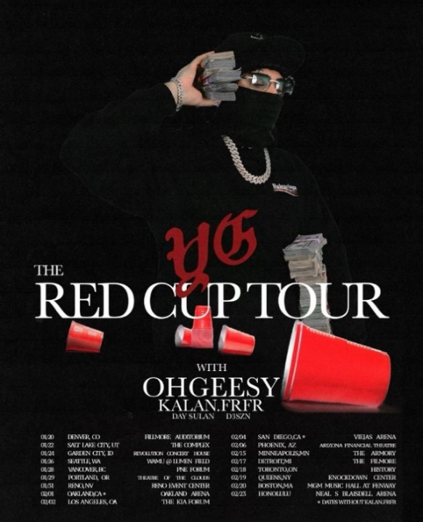

JANUARY
19 – Monterey, MX - Nandas Barrio Antiguo
20 – Guadalajara, MX – C3 Stage
20 – Denver, CO – Fillmore Auditorium *
22 – Salt Lake City, UT – The Great Saltair *
24 – Garden City, ID – Revolution Concert House & Event Center *
26 – Seattle, WA – WAMU Theater *
28 – Vancouver, BC – PNE Forum *
29 – Portland, OR – Theater of the Clouds *
31 – Reno, NV – Reno Events Center *

FEBRUARY
1 – Oakland, CA – Oakland Arena *
2 – Los Angeles, CA – Kia Forum *
4 – San Diego, CA – Viejas Arena *
6 – Phoenix, AZ – Arizona Financial Theatre *
15 – Minneapolis, MN – The Armory *
17 – Detroit, MI – The Fillmore Detroit *
18 – Toronto, ON – HISTORY *
19 – Queens, NY – The Knockdown Center *
20 – Boston, MA – MGM Music Hall at Fenway *
23 – Honolulu, HI – Neal S. Blaisdell Center *

MARCH
5 – Inglewood, CA – Rolling Loud California †

* w/ YG’s The Red Cup Tour
† Festival Appearance

# # #
CONNECT WITH OHGEESY
OHGEESYOFFICIAL.COM | FACEBOOK | INSTAGRAM | TWITTER | YOUTUBE

PRESS CONTACT:
Brittany Bell | Brittany.Bell@atlanticrecords.com

