FOR IMMEDIATE RELEASE
NOVEMBER 29, 2022

OHGEESY OPENS THE DOORS ON “GALLERY”

PIONEERING WEST COAST RAP HERO UNVEILS LATEST SINGLE
FROM UPCOMING SOPHOMORE SOLO ALBUM, GEEZYWORLD 2

JAM-PACKED 2023 LIVE SCHEDULE INCLUDES MEXICAN HEADLINE DATES,
DIRECT SUPPORT ON YG’S THE RED CUP TOUR & ROLLING LOUD CALIFORNIA

SHORELINE MAFIA CELEBRATES FIFTH ANNIVERSARY OF
RIAA GOLD CERTIFIED DEBUT MIXTAPE, SHORELINEDOTHATSHIT,
WITH OFFICIAL VINYL RELEASE AVAILABLE EXCLUSIVELY
VIA WEB STORE HERE

LISTEN TO “GALLERY” HERE | WATCH OFFICIAL MUSIC VIDEO HERE

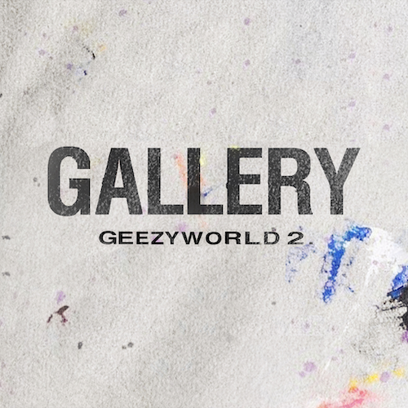
DOWNLOAD HI-RES ARTWORK HERE

Platinum certified rapper OHGEESY has shared his latest solo single, “Gallery,” available now via Atlantic Records at all DSPs and streaming services. Produced by Kasino Beats and Codax, the upbeat track comes on the heels of the previously released KUNO-directed visual, flaunting his flashy jewelry and inimitable lifestyle. Watch HERE.

“Gallery” heralds the eagerly awaited release of OHGEESY’s upcoming new mixtape, GEEZYWORLD 2, due to arrive in early 2023. The project – which follows the Los Angeles, CA-based rapper’s acclaimed 2021 solo debut mixtape, GEEZYWORLD – also includes such powerhouse new tracks as “Knock Knock” and “Up,” both available everywhere now for streaming and download. Produced by DJ Vision, the trenchant “Knock Knock” was met by applause from such outlets as HotNewHipHop, which declared it to be “a murderous and boisterous track…It wouldn’t sound out of place on any Shoreline Mafia tape, the L.A. rap collective OHGEESY helped found. Even if that Cali sound isn’t the trend of the moment, the 28-year-old is still carrying the torch for his city and keeping that sun-drenched bounce alive on playlists.” An official music video – directed by Kuno – is streaming now at YouTube HERE. In addition, the energetic “Up” – produced by ENRGY (EST Gee, Lil Yachty) – arrived alongside an official music video, filmed on the streets of London and streaming now HERE.

OHGEESY will celebrate his new music and much more with a wide-ranging North American live schedule, highlighted by a number of Mexican headline dates as well as direct support on GRAMMY® Award-nominated rapper YG’s “The Red Cup Tour,” getting underway January 20, 2023 at Denver, CO’s Fillmore Auditorium and then traveling through late February. In addition, OHGEESY will join Future, Lil Uzi Vert, Lil Wayne and a galaxy of hip-hop superstars for a top-billed hometown performance at the upcoming Rolling Loud California, set for Sunday, March 5, 2023 at Inglewood, CA’s Hollywood Park Grounds. For complete details and remaining ticket information, please visit www.ohgeesyofficial.com.

Last week saw Shoreline Mafia – the multi-platinum hip-hop collective co-founded by OHGEESY – mark Black Friday with a fifth anniversary vinyl edition of their RIAA gold certified 2017 debut mixtape, ShorelineDoThatShit, available exclusively via the Warner Music Store HERE.

ABOUT OHGEESY:
California never gave rise to a rapper quite like OHGEESY. The Los Angeles-born, Mexican-American, multiplatinum certified artist, entrepreneur, and visionary not only continues the legacy of his hometown, but he also puts a whole culture rarely represented in hip-hop on his back with pride, poise, and power. As such, he emerges as a trailblazer with vicious wordplay, vibrant storytelling, and a vital message. Breathing new life into the culture, OHGEESY co-founded Shoreline Mafia in 2016 and quickly locked down the group’s legacy with 2017’s RIAA gold certified ShorelineDoThatShit, the 2x platinum smash “Bands,” and such platinum certified hits as “Musty” and “Nun Major.”

OHGEESY made his smash solo debut with 2021’s acclaimed GEEZYWORLD, available now in an extended deluxe edition HERE. Hailed by Pitchfork as “a quintessential L.A. rap record,” the album includes such multimillion-streaming hit singles as “Get Fly (Feat. DaBaby),” “Big Bad Wolf (Feat YG),” “Who Else (Feat. BlueBucksClan),” “Secret Service,” “Go Fast (Feat. Eladio Carrion),” “Appetizer (Shoreline Mafia),” and “Make It Happen (Feat. Pressa & Bun Dog),” all accompanied by official visuals streaming now at YouTube.

With hundreds of millions of streams and widespread praise from GQ, Complex, UPROXX, XXL, OkayPlayer, and HotNewHipHop, OHGEESY spent his summer traveling North America on his epic GEEZYWORLD headline tour, presented by Cookies. Special guests included BlueBucksClan, with support from DJ Vision and Hawaii Slim. Further highlights came from show-stopping festival performances at Rolling Loud Miami and Rolling Loud Toronto.

OHGEESY’s still-expanding world now features exclusive merchandise with his OTXBOYZ line (sold through his GEEZYWORLD web site). He also co-owns Mexican seafood spot Sunset Mariscos inside of the famed Fred Segal store in West Hollywood. Now, with the imminent arrival of GEEZYWORLD 2 on the horizon, OHGEESY instigates a new era for West Coast rap and beyond.

# # #

OHGEESY
YG’S THE RED CUP TOUR 2022

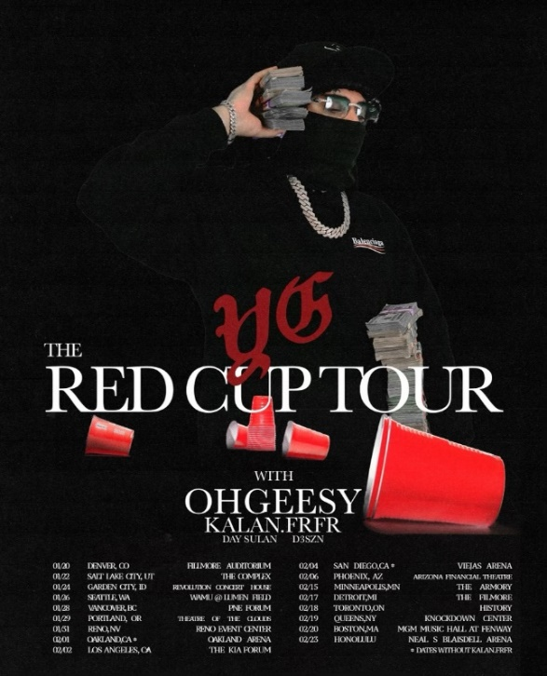
# # #
CONNECT WITH OHGEESY
OHGEESYOFFICIAL.COM | FACEBOOK | INSTAGRAM | TWITTER | YOUTUBE

PRESS CONTACT:
Brittany Bell | Brittany.Bell@atlanticrecords.com

