FOR IMMEDIATE RELEASE
DECEMBER 8, 2022

MULTI-PLATINUM SINGER-SONGWRITER VANCE JOY COMES ALIVE WITH FIRST BUNDLE FROM FORTHCOMING LIVE ALBUM LIVE AT SYDNEY OPERA HOUSE

16-TRACK ALBUM RECORDED ON THE FORECOURT OF THE WORLD FAMOUS
SYDNEY OPERA HOUSE DURING AUSTRALIA LEG OF IN OUR OWN SWEET TIME TOUR

ELECTRIFYING LIVE VERSIONS OF “CLARITY” AND “CATALONIA” OUT NOW

NORTH AMERICAN HEADLINE TOUR BEGINS FEBRUARY 7, 2023 IN PHILADELPHIA, PA

VINYL PRE-ORDERS AVAILABLE HERE

LISTEN HERE

WATCH “CLARITY” LIVE PERFORMANCE | WATCH “CATALONIA” LIVE PERFORMANCE

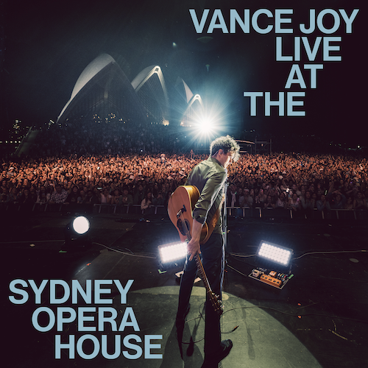
DOWNLOAD HI-RES IMAGE

Multi-platinum global superstar Vance Joy has announced the upcoming release of Vance Joy Live At The Sydney Opera House, a 16-track new album recorded last month during two very special headline performances at the world famous Sydney Opera House Forecourt in Sydney, Australia. Vance Joy Live At The Sydney Opera House arrives on limited edition vinyl and digital download next year; vinyl pre-orders are available now HERE.

Recorded November 18 and 19, 2022 during the Australia leg of Joy’s sold out In Our Own Sweet Time World Tour, Vance Joy Live At The Sydney Opera House includes electrifying new renditions of such RIAA platinum certified hits as “Georgia,” “Mess Is Mine,” and of course, the 6x platinum certified classic, “Riptide.” The album is heralded by today’s premiere of the live versions of “Clarity” and “Catalonia,” both available now at all DSPs and streaming services HERE. The live performance videos are available now at YouTube – Watch “Clarity” HERE, Watch “Catalonia” HERE.

The original studio versions of “Clarity” and “Catalonia” are among the many highlights of Joy’s acclaimed new album, In Our Own Sweet Time, available everywhere now via Atlantic Records HERE. The Australian singer-songwriter’s most personal full-length thus far, In Our Own Sweet Time includes such emotionally charged tracks as “Looking At Me Like That,” “Don’t Fade,” and the RIAA gold certified smash, “Missing Piece,” all joined by official music videos streaming now at YouTube. Currently boasting over 43.5M global streams, “Clarity” has fast proven a popular favorite around the world, ascending to the top 5 at Alternative radio outlets across America while also earning prestigious “Song of the Year” and “Best Pop Release” nominations from Australia’s 2022 ARIA Music Awards. In addition, the official music video for the album’s “Every Side of You” recently took home the ARIA for “Best Video” – Joy’s fourth ARIA Award to date.

Hailed by Rolling Stone as “a refreshing twist on the singer’s signature sound,” In Our Own Sweet Time has also been met by worldwide critical applause from such top media outlets as Billboard, V, UPROXX, NME, Guitar World, and American Songwriter, to name only a few.

Joy will continue to celebrate In Our Own Sweet Time by traversing the globe throughout 2023 on a truly epic world tour. The North American leg of the In Our Own Sweet Time Tour gets underway February 7, 2023 at Philadelphia, PA’s The Met and then continues through late March. Support throughout out comes from fellow Australian singer-songwriter Jack Botts. A number of dates – including shows in Montreal, Chicago, Seattle, Calgary, Edmonton, and more – are already sold out. For complete details and remaining ticket availability, please visit www.vancejoy.com.

VANCE JOY
IN OUR OWN SWEET TIME TOUR
NORTH AMERICA 2023

FEBRUARY 2023
7 – Philadelphia, PA – The Met Philadelphia (SOLD OUT)
8 – Boston, MA – MGM Music Hall at Fenway (SOLD OUT)
10 – Montreal, QC – MTELUS (SOLD OUT)
11 – Montreal, QC – MTELUS (SOLD OUT)
12 – Ottawa, ON – Southam Hall (SOLD OUT)
14 – Kitchener, ON – Centre In The Square (SOLD OUT)
15 – Hamilton, ON – FirstOntario Centre (SOLD OUT)
17 – Columbus, OH – KEMBA Live! (SOLD OUT)
18 – Chicago, IL – The Chicago Theatre (SOLD OUT)
19 – Minneapolis, MN – State Theatre (SOLD OUT)
21 – Winnipeg, MB – Centennial Concert Hall (SOLD OUT)
22 – Saskatoon, SK – TCU Place
23 – Calgary, AB – Jack Singer Concert Hall (SOLD OUT)
24 – Calgary, AB – Jack Singer Concert Hall (SOLD OUT)
27 – Edmonton, AB – Winspear Centre (SOLD OUT)
28 – Edmonton, AB – Winspear Centre (SOLD OUT)

MARCH 2023
3 – Seattle, WA – Paramount Theatre (SOLD OUT)
4 – Seattle, WA – Paramount Theatre
6 – Portland, OR – Keller Auditorium
9 – Oakland, CA – Fox Theater (SOLD OUT)
11 – Inglewood, CA – Hollywood Park
16 – San Diego, CA – Soma
18 – Phoenix, AZ – Arizona Federal Theatre
20 – Dallas, TX – The Factory in Deep Ellum
21 – Austin, TX – ACL Live at the Moody Theater (SOLD OUT)
23 – Atlanta, GA – Coca–Cola Roxy
24 – Charlotte, NC – The Fillmore (SOLD OUT)
25 – Washington, DC – The Anthem (SOLD OUT)

All Dates w/ Special Guest Jack Botts

# # #

(DOWNLOAD HI-RES IMAGE // PHOTO CREDIT: CELINA MARTINS)

CONNECT WITH VANCE JOY:
WEBSITE | FACEBOOK | TWITTER | INSTAGRAM | YOUTUBE

For press inquiries, please contact:
Kelly McWilliam // Kelly.McWilliam@atlanticrecords.com
Libby Kober // Libby.Kober@atlanticrecords.com

