FOR IMMEDIATE RELEASE
JANUARY 12, 2023

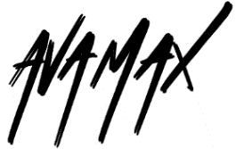
AVA MAX REVEALS POWERFUL NEW SINGLE “ONE OF US”

NEWEST SINGLE OFF RIAA MULTI-PLATINUM CERTIFIED POP STAR’S
HIGHLY ANTICIPATED SOPHOMORE ALBUM DIAMONDS & DANCEFLOORS

ALBUM DUE OUT FRIDAY, JANUARY 27, 2023

PRE-ORDER/PRE-SAVES AVAILABLE NOW HERE

LISTEN TO “ONE OF US”

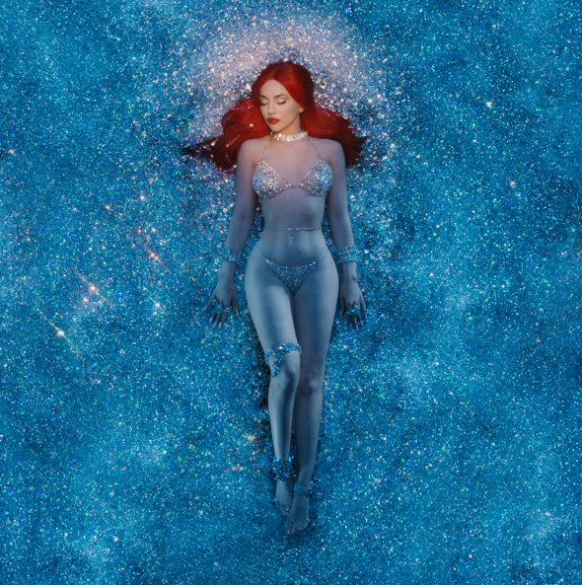
DOWNLOAD HI-RES ARTWORK

RIAA multi-platinum certified global pop sensation Ava Max has revealed another 80s dance and disco track, “One of Us,” available now via Atlantic Records at all DSPs and streaming services HERE. The vulnerable, disco-pop track tells the story of a one-sided relationship and was co-written by Ava alongside Henry Walter (Maroon 5, Miley Cyrus), Mathew James Burns (Lady Gaga, Ariana Grande), Caroline Ailin (Dua Lipa, Selena Gomez), Brett McLaughlin (Troye Sivan, Selena Gomez).

“One of Us” is the latest track from Ava’s forthcoming album, Diamonds & Dancefloors, releasing Friday, January 27, 2023 with brand new artwork - pre-orders and pre-saves are available now HERE. The album – which follows Ava’s RIAA gold certified 2020 debut, Heaven & Hell – includes current single “Million Dollar Baby,” which has already amassed 98.6M streams worldwide. Fueled by an interpolation of LeAnn Rimes’ classic “Can’t Fight The Moonlight,” the buoyantly sassy track has fast proven a fan favorite via a series of TikTok teaser videos featuring Rimes. Hailed by PAPER as “a euphoric euro dance number,” “Million Dollar Baby” is joined by an official music video, directed by Andrew Donoho (Khalid, Janelle Monae, Paul McCartney), currently boasting over 23M views – Watch HERE. The album also includes recent release “Dancing’s Done,” disco-powered “Weapons” and the passionately self-assured “Maybe You’re The Problem,” joined by an official music video now with close to 27M views – Watch HERE. In addition, Max recently released an official music video for her holiday track “Christmas Without You” – Watch HERE.

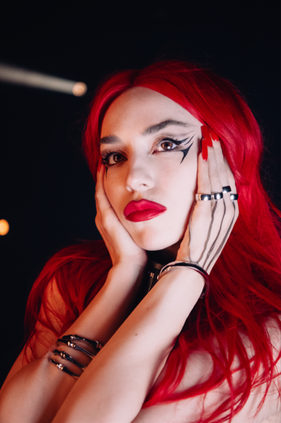
DOWNLOAD PRESS PHOTO HERE
CREDIT MARILYN HUE

ABOUT AVA MAX:
Ava Max is ready to take her already extraordinary rise to the pinnacle of pop success to even greater heights with her hit single of 2022, “Million Dollar Baby” and forthcoming sophomore album Diamonds and Dancefloors. With over 12.9B worldwide streams, an array of smash collaborations, and multiple RIAA gold and platinum certifications in the US alone, the first-generation Albanian American artist has fast proven a true pop superstar, hailed for her seismic voice, idiosyncratic high fashion mindset, and undeniable knack for cinematic, theatrical popcraft. 2018 saw Max make her explosive arrival with the blockbuster success of the RIAA 4x-platinum certified hit, “Sweet but Psycho.” Currently boasting more than 3.4B global streams, the track took the world by storm, spending three weeks in the top 10 on Billboard’s “Hot 100” while reaching #1 in more than 20 countries around the world and earning diamond certification in Brazil, France, Poland, as well as multi-platinum certification in Australia (5x), Austria (3x), Belgium (2x), Canada (6x), Denmark (3x), Germany (2x), Italy (3x), the Netherlands (2x), New Zealand, Norway (9x), Portugal (2x), Spain, Switzerland (4x), and the United Kingdom (3x). Joined by an official video that has now garnered over 828M views, “Sweet But Psycho” further earned Max a long string of international honors, including the 2019 MTV Europe Music Awards’ coveted “Best Push Artist” award, “Best New Artist” nominations at both the 2019 MTV Video Music Awards and the 2019 MTV Europe Music Awards, and an iHeartRadio Titanium Award marking over 1B spins in 2020 alone. Max kept up the pace with a series of smash singles, including the RIAA gold certified “So Am I,” “Salt,” and the Platinum “My Head & My Heart,” as well as the platinum certified title track to her acclaimed full-length debut, Heaven & Hell. The newly RIAA Platinum certified album made spectacular chart debuts around the globe, earning over 12.4B worldwide streams and gold, platinum, and multi-platinum certifications in over a dozen countries. 2021 saw Max unveil “EveryTime I Cry,” declared by PAPER as “an undeniably uplifting banger” and joined by an official music video, co-directed by Max and Charlotte Rutherford, currently boasting over 27M views via YouTube. What’s more, Tiësto & Ava Max’s worldwide hit anthem, “The Motto,” has proven an undeniable international blockbuster since its November 2021 release, reaching the top 5 on Billboard’s “Dance/Electronic Songs” chart while earning over 1B worldwide streams thus far.

Named to Forbes’ prestigious “30 Under 30” list in 2021, Ava has been feted with a wide range of media attention from such high profile outlets as VOGUE, Rolling Stone, Vanity Fair, Billboard, PAPER, to name but a few, while also delivering a long run of show-stopping performances on CBS’s The Late Late Show with James Corden, NBC’s TODAY, ABC’s Jimmy Kimmel Live!, Good Morning America, and Dick Clark’s New Year’s Rockin’ Eve with Ryan Seacrest 2020, the MTV Europe Video Music Awards, and more. A truly international artist, Max has teamed up with a stunning assortment of diverse musicians around the world, spanning Norwegian DJ/producer Alan Walker and Spanish superstar Pablo Alborán to David Guetta, Jason Derulo, AJ Mitchell (for the RIAA gold certified “Slow Dance”), and country stars Thomas Rhett & Kane Brown (the RIAA gold certified “On Me”). Now, with the upcoming arrival of Diamonds & Dancefloors, Ava Max is poised to push pop even further, setting a direct course toward the top and beyond.

CONNECT WITH AVA MAX:
OFFICIAL I INSTAGRAM I TIKTOK | TWITTER I FACEBOOK | YOUTUBE

Press Contacts:
Kelly McWilliam / Kelly.McWilliam@atlanticrecords.com
Ashley Kalmanowitz / Ashley.Kalmanowitz@atlanticrecords.com

