FOR IMMEDIATE RELEASE
NOVEMBER 16, 2022

NEW YORK’S PRINCE OF DRILL BIZZY BANKS RETURNS WITH “NO PASSES”
ACCOMPANIED BY A VISUAL SHOT BY GERARD VICTOR
FOLLOW-UP TO THE PREVIOUSLY RELEASED “I CAN’T” SINGLE
ON THE RADAR FREESTYLE NOW APPROACHING 400K VIEWS
STREAM/DOWNLOAD “NO PASSES”
WATCH/SHARE “NO PASSES”

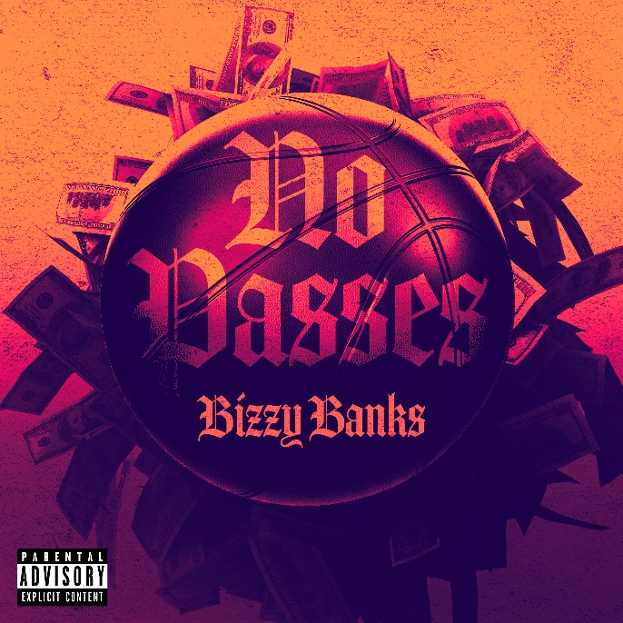
DOWNLOAD HI-RES ARTWORK

New York’s prince of drill, Bizzy Banks, returns with his latest single, “No Passes.” “No Passes” comes on the heels of, “I Can’t,” the first single since his release. “No Passes” is also accompanied by a visual directed by Gerard Victor and features Bizzy riding around NYC in a red Ferrari to complement the red aesthetic of the visual. “No Passes” was also premiered by DJ Whoo Kid on his Shade 45 Sirius XM radio show. Bizzy supported the release with his freestyle on the On The Radar podcast powered by Power 105.1. The freestyle is now approaching 400K views and proved a great follow-up to his first single of 2022, “Don’t Know How to Act,” now boasting over 567k views.

“I Can’t” marked the first official single since Bizzy’s release and was accompanied by not only the visual but also his On The Radar freestyle. “Don’t Know How To Act” was the long-anticipated follow-up to last year’s stand-out mixtape, SAME ENERGY, available now at all DSPs and streaming services HERE. SAME ENERGY includes such singles as “Bandemic,” “My Shit,” “Azul,” “Driftin’,” “City Hot,” and “Adore You (Feat. PnB Rock),” all accompanied by official music videos streaming now at YouTube HERE. Produced by D.A. Got That Dope (Megan Thee Stallion, Da Baby), “Adore You,” featuring the late PnB Rock, was met with praise from such outlets as XXL, which raved, “Bizzy can jump from flow to flow, plus his references are clever…The slow groove puts the rhymer in a prime position to keep evolving.” “Some of the best music he's released yet,” enthused Brooklyn Vegan. “(Bizzy) seems poised to be one of New York drill's biggest breakouts since the untimely death of Pop Smoke.”

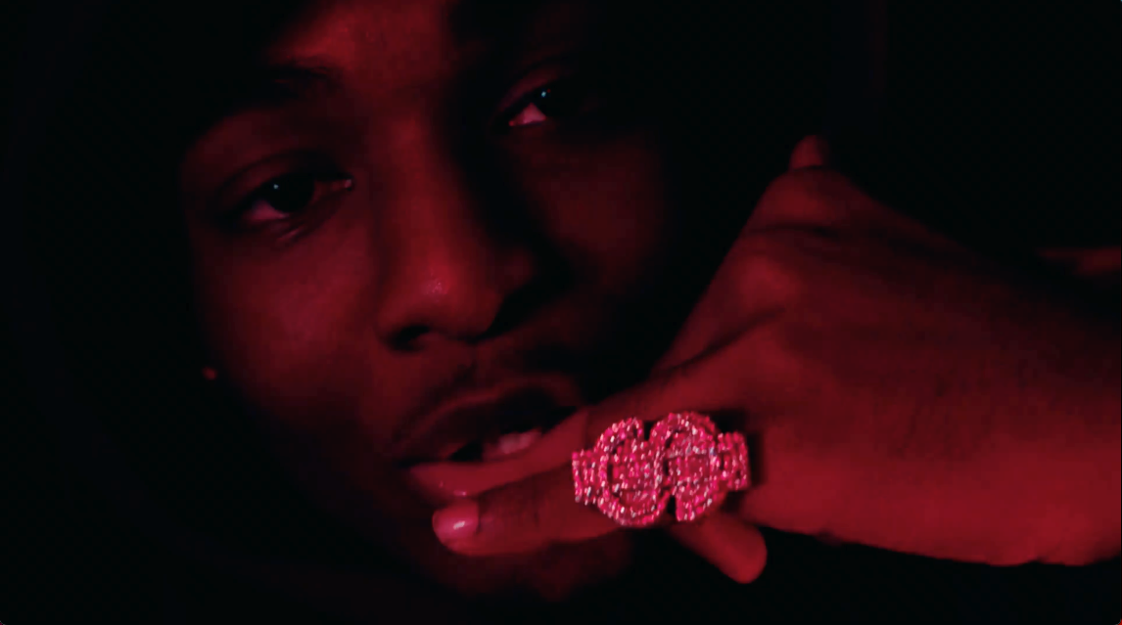

SAME ENERGY is currently boasting over 52.3 million global streams and was first heralded with the acclaimed single, “Bandemic,” which received praise from a range of national publications, including LA Weekly, which wrote, “Banks holds nothing back on the new tune…it’s representative of the material he’s currently working on.” An official video – shot and edited by Useless Films – has earned over 2.2M views via YouTube alone HERE. The mixtape also peaked at #13 on the Apple Music Top Hip Hop Albums and #20 on the overall chart.

In the short time since Bizzy emerged on the New York drill scene, he has racked up co-signs from some of the most notable names like NY heavyweights like Lil Tjay and Pop Smoke before his passing. His feature on Pop Smoke’s FAITH album, “30”, was touted by Brooklyn Vegan as the “best collab on the album” and received critical acclaim while sitting on the OCC for its 62nd week. Pitchfork named “Top 5”, a release from Bizzy’s 2020 label-debut mixtape “G.M.T.O. Vol. 1 (Get Money Take Over)” as one of “The 36 best rap songs of 2020” and is currently sitting at 5.3 million views. His single “Don’t Start Pt. 2” is a certified hit boasting over 8.1 million views on YouTube. The finesse and astute lyricism showcased on his debut mixtape won Bizzy a nomination for the XXL 2021 Freshman class as well as the #10 spot on Rolling Stone’s “Breakthrough 25” highlighting the fastest rising artists. Bizzy was also brought out on J.I.’s “Young and Restless” Tour in September.

# # #

CONNECT WITH BIZZY BANKS
INSTAGRAM | TWITTER | YOUTUBE

FOR ALL INQUIRIES, CONTACT
ARIANA.WHITE@ATLANTICRECORDS.COM

