COLDPLAY ADD EXTRA SHOWS TO
WEST COAST NORTH AMERICA RUN

Tickets For New Shows On Sale Starting Monday, January 30 at 10AM PT on Ticketmaster.com

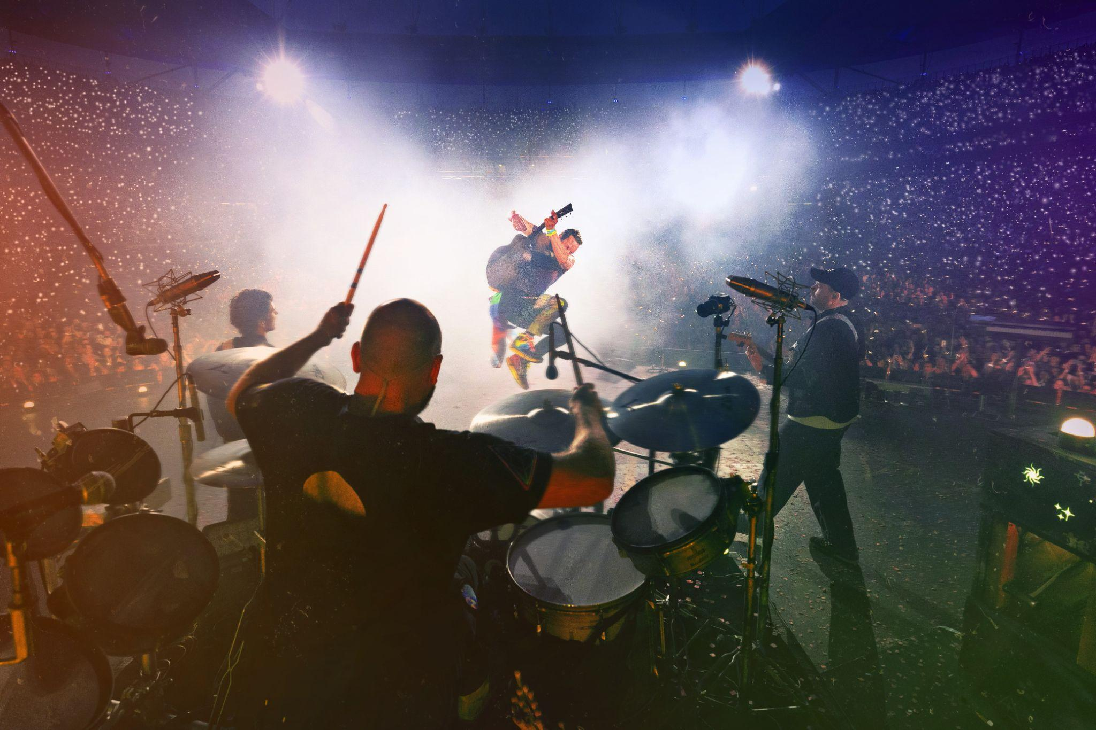
For approved artist images and hi-res tour art, please download here

‘THE GREATEST LIVE MUSIC SHOW EVER’ The Times

Due to overwhelming fan demand, Coldplay have announced additional second shows in Vancouver, San Diego, and Los Angeles for their Music Of The Spheres World Tour. The newly-added shows take place at Vancouver's BC Place on September 23, San Diego’s Snapdragon Stadium on September 28, and Los Angeles’ Rose Bowl on October 1.

TICKETS: Tickets for the newly-added dates will go on sale starting Monday, January 30 at 10AM PT on Ticketmaster.com.

Support will be provided by the multi-Grammy winning H.E.R and fast-rising New Jersey artist 070 Shake.

MUSIC OF THE SPHERES 2023 WEST COAST TOUR DATES:

SEPTEMBER
20: Seattle, WA - Lumen Field (Support: H.E.R. + 070 Shake)
22: Vancouver, BC - BC Place (Support: H.E.R. + 070 Shake)
23: Vancouver, BC - BC Place (Support: H.E.R. + 070 Shake) – NEW SHOW
27: San Diego, CA - Snapdragon Stadium (Support: H.E.R. + 070 Shake)
28: San Diego, CA - Snapdragon Stadium (Support: H.E.R. + 070 Shake) – NEW SHOW
30: Los Angeles, CA - Rose Bowl (Support: H.E.R. + 070 Shake)

OCTOBER
1: Los Angeles, CA - Rose Bowl (Support: H.E.R. + 070 Shake) – NEW SHOW

The limited west coast run comes on the heels of Coldplay’s hugely successful 2022, where the iconic band - who were crowned Favorite Touring Artist at the 2022 American Music Awards - sold more concert tickets than any other artist and broke attendance records around the world. Complete tour dates are available at coldplay.com/tour.

Last week, Coldplay helped celebrate the 20th anniversary of ABC’s Jimmy Kimmel Live - having appeared on the very first show two decades ago - by delivering an amazing rooftop performance of “Clocks”, featuring a guest appearance from Kimmel himself. The band will also perform on the upcoming episode of NBC’s Saturday Night Live on February 4.

DHL is the Official Logistics Partner of the Music Of The Spheres World Tour, supporting the band in their mission to cut tour emissions by 50%.

