COLDPLAY ANNOUNCE
WEST COAST NORTH AMERICA RUN
ON RECORD-BREAKING
MUSIC OF THE SPHERES WORLD TOUR

Tickets On Sale Starting Friday January 27 at 10AM PT on Ticketmaster.com

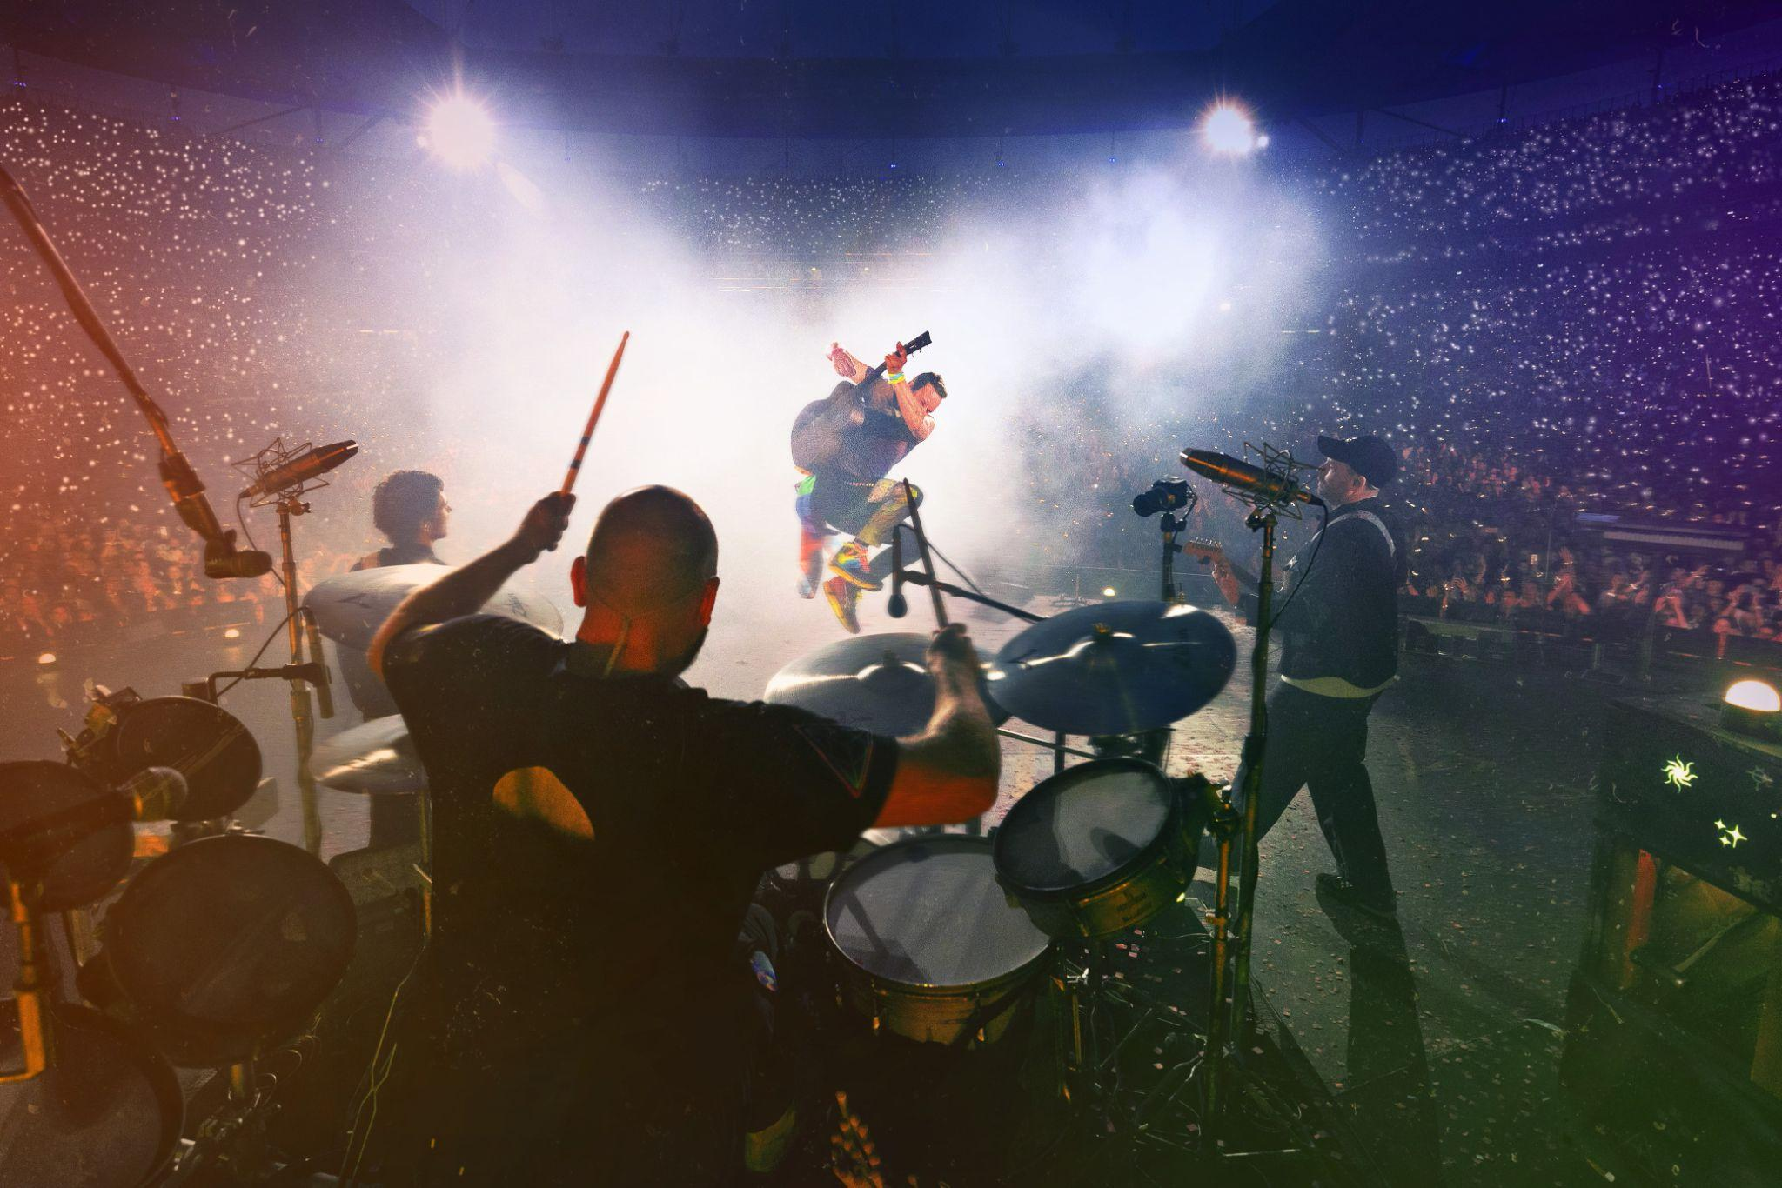
For approved artist images and hi-res tour art, please download here

‘THE GREATEST LIVE MUSIC SHOW EVER’ The Times

‘Genuinely stunning’ ‘A fantastical feel-good bonanza’
★★★★★, The Guardian ★★★★★, NME

“As good as it gets" “Nobody does it better”
★★★★★, London Evening Standard ★★★★★, The i

After a triumphant 2022 where Coldplay sold more concert tickets than any other artist and broke attendance records around the world, the band have announced their hugely-anticipated return to the U.S. and Canada with a special west coast run as part of their Music Of The Spheres World Tour.

The iconic band - who were crowned Favorite Touring Artist at the 2022 American Music Awards - will bring their spectacular stadium show to Seattle, Vancouver, San Diego and Los Angeles this September, where they will perform classic hits such as “Yellow”, “Viva La Vida”, “Clocks”, “A Sky Full Of Stars” and “My Universe” in stadiums bursting with lasers, fireworks and LED wristbands.

Support will be provided by the multi-Grammy winning H.E.R and fast-rising New Jersey artist 070 Shake. Complete tour dates are available below and at coldplay.com/tour. Stay tuned for more cities to be announced.

TICKETS: Tickets will go on sale starting Friday, January 27 at 10AM PT on Ticketmaster.com.

LA PAST PURCHASER PRESALE: Coldplay will offer an exclusive first come, first served presale to past purchasers of their previously scheduled 2022 dates in Los Angeles. Fans will receive their presale information via email, and the presale will take place on Thursday, January 26 at 10AM PT to 10PM local time. More information can be found here.

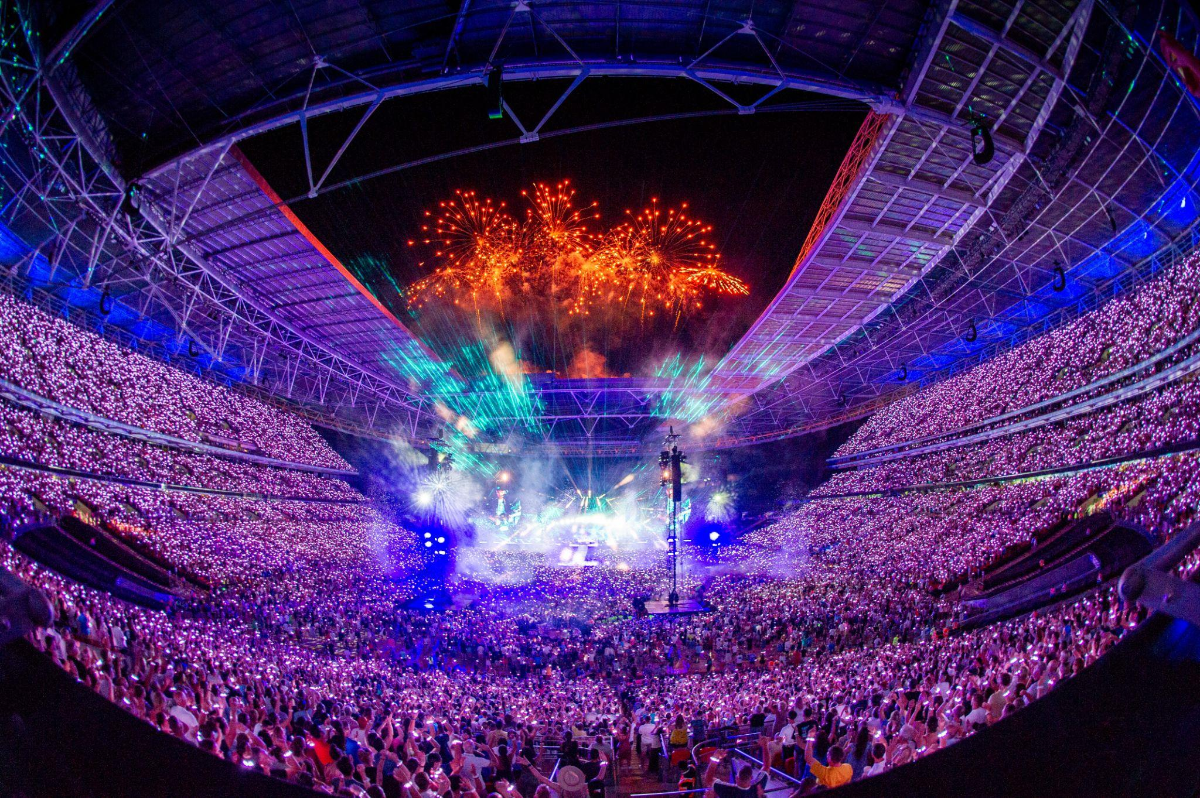

MUSIC OF THE SPHERES 2023 WEST COAST TOUR DATES:

SEPTEMBER
20: Seattle, WA - Lumen Field (Support: H.E.R. + 070 Shake)
22: Vancouver, BC - BC Place (Support: H.E.R. + 070 Shake)
27: San Diego, CA - Snapdragon Stadium (Support: H.E.R. + 070 Shake)
30: Los Angeles, CA - Rose Bowl (Support: H.E.R. + 070 Shake)

Since kicking off in March 2022, the Music Of The Spheres World Tour has sold over 6 million tickets across Europe, North America, and Latin America, receiving rave reviews from fans and critics alike, with the Dallas Observer calling the show “mind-blowing” and the Houston Chronicle describing the band’s performance as “pure joy”. The band rounded off an amazing 2022 with a leg of dates in Latin America, culminating with 10 incredible shows in Buenos Aires (one of which was live broadcast to cinemas in a record-breaking 81 countries around the world).

The tour has also made headlines for its groundbreaking sustainability initiatives which include the world’s first tourable battery system and the first ever stadium show powered by renewable energy. As part of their commitment to cut tour emissions by 50%, the band have pledged to plant one tree for every ticket sold and have offered fans incentives to travel by low-emission transport. Fans can even help to power the show by using kinetic bikes and energy-generating dance floors. Full info can be found at sustainability.coldplay.com.

DHL is the Official Logistics Partner of the Music Of The Spheres World Tour, supporting the band in their mission to cut tour emissions by 50%.

Additionally, the $20 Infinity Ticket Program will be available for the west coast shows above at a later date. These tickets allow more fans access to the Music Of The Spheres World Tour. They are restricted to a maximum of two tickets per purchaser and must be bought in pairs (which will be located next to each other).

The band are also nominated for three Grammy Awards next month, including Album of the Year for Music Of The Spheres.

MUSIC OF THE SPHERES 2023 WORLD TOUR DATES:

MARCH
10: São Paulo, BR - Estadio do Morumbi (Support: CHVRCHES)
11: São Paulo, BR - Estadio do Morumbi (Support: CHVRCHES)
13: São Paulo, BR - Estadio do Morumbi (Support: CHVRCHES)
14: São Paulo, BR - Estadio do Morumbi (Support: CHVRCHES)
17: São Paulo, BR - Estadio do Morumbi (Support: CHVRCHES)
18: São Paulo, BR - Estadio do Morumbi (Support: CHVRCHES)
21: Curitiba, BR - Estadio Couto Pereira (Support: CHVRCHES)
22: Curitiba, BR - Estadio Couto Pereira (Support: CHVRCHES)
25: Rio De Janeiro, BR - Estadio Nilton Santos Engenhão (Support: CHVRCHES)
26: Rio De Janeiro, BR - Estadio Nilton Santos Engenhão (Support: CHVRCHES)
28: Rio De Janeiro, BR - Estadio Nilton Santos Engenhão (Support: CHVRCHES)

MAY
17: Coimbra, PT - Estádio Cidade de Coimbra
18: Coimbra, PT - Estádio Cidade de Coimbra
20: Coimbra, PT - Estádio Cidade de Coimbra
21: Coimbra, PT - Estádio Cidade de Coimbra
24: Barcelona, ES - Estadi Olímpic Lluís Companys
25: Barcelona, ES - Estadi Olímpic Lluís Companys
27: Barcelona, ES - Estadi Olímpic Lluís Companys
28: Barcelona, ES - Estadi Olímpic Lluís Companys
31: Manchester, UK - Etihad Stadium

JUNE
1: Manchester, UK - Etihad Stadium
3: Manchester, UK - Etihad Stadium
4: Manchester, UK - Etihad Stadium
6: Cardiff, UK - Principality Stadium
7: Cardiff, UK - Principality Stadium
21: Naples, IT - Stadio Diego Armando Maradona
22: Naples, IT - Stadio Diego Armando Maradona
25: Milan, IT - Stadio San Siro
26: Milan, IT - Stadio San Siro
28: Milan, IT - Stadio San Siro
29: Milan, IT - Stadio San Siro

JULY
1: Zurich, CH - Stadion Letzigrund
2: Zurich, CH - Stadion Letzigrund
5: Copenhagen, DK - Parken
6: Copenhagen, DK - Parken
8: Gothenburg, SE - Ullevi
9: Gothenburg, SE - Ullevi
11: Gothenburg, SE - Ullevi
12: Gothenburg, SE - Ullevi
15: Amsterdam, NL - Johan Cruijff ArenA
16: Amsterdam, NL - Johan Cruijff ArenA
18: Amsterdam, NL - Johan Cruijff ArenA
19: Amsterdam, NL - Johan Cruijff ArenA

SEPTEMBER
20: Seattle, WA - Lumen Field (Support: H.E.R. + 070 Shake)
22: Vancouver, BC - BC Place (Support: H.E.R. + 070 Shake)
27: San Diego, CA - Snapdragon Stadium (Support: H.E.R. + 070 Shake)
30: Los Angeles, CA - Rose Bowl (Support: H.E.R. + 070 Shake)

