DEATH CAB FOR CUTIE ANNOUNCE ASPHALT MEADOWS (ACOUSTIC) –
NEW VERSION OF CRITICALLY ACCLAIMED 10TH STUDIO LP DUE OUT MARCH 10

“PEPPER (ACOUSTIC)” + COVER OF LOW’s “THE PLAN” OUT NOW – LISTEN HERE

“PEPPER” CURRENTLY #13 AT TRIPLE A & #21 AT ALTERNATIVE RADIO – AND QUICKLY RISING – AFTER DEBUTING AS #1 MOST ADDED SONG AT BOTH FORMATS

ASPHALT MEADOWS NORTH AMERICAN HEADLINE TOUR CONTINUES THROUGHOUT JANUARY + FEBRUARY; UK/EU DATES KICK OFF MARCH 5 IN COPENHAGEN

HIGHLY-ANTICIPATED CO-HEADLINE 20TH ANNIVERSARY TOUR WITH THE POSTAL SERVICE KICKS OFF SEPT ‘23 | SHOWS ADDED BY POPULAR DEMAND INCLUDE 2ND SOLD-OUT NIGHT AT MADISON SQUARE GARDEN + 2 ADD’L NIGHTS AT THE HOLLYWOOD BOWL

PRE-SAVE ASPHALT MEADOWS (ACOUSTIC) HERE
FIND ALL UPCOMING TICKETING INFO HERE
BUY/STREAM ASPHALT MEADOWS HERE

“Twenty-five years into its career, the band brings its incisive, anguished writing to a particularly 2022 brand of existential angst on its 10th album, ‘Asphalt Meadows’… an expansive album…” – THE NEW YORK TIMES

“If you haven’t heard yet, Death Cab for Cutie is back back… [their] best album in over a decade...” – VULTURE

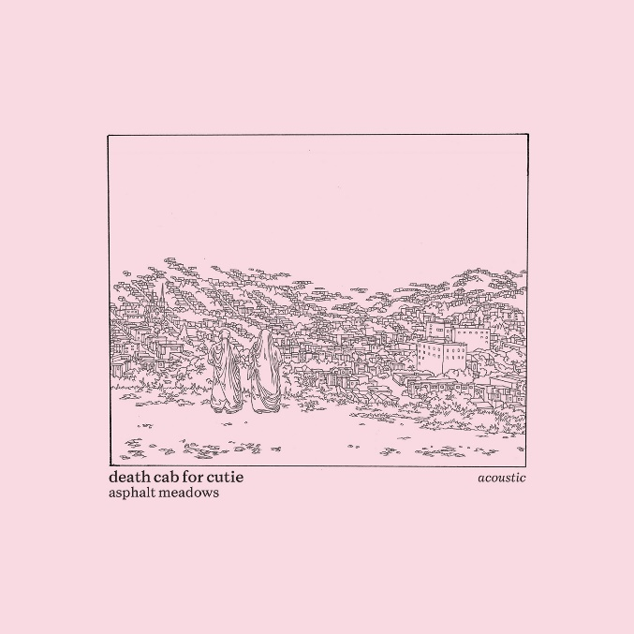
download hi-res acoustic album artwork here

8x GRAMMY® Award-nominated rock band Death Cab for Cutie has announced Asphalt Meadows (Acoustic), a new, stripped-down take on their critically acclaimed 10th studio album ‘Asphalt Meadows,’ originally released this past September via Atlantic Records. Co-produced by Andy Park (Pedro the Lion, Joseph, Noah Gunderson) and Death Cab for Cutie, the 12-track acoustic LP is due out March 10th (pre-save here).

Alongside the announcement, the band has released the first pair of tracks off the forthcoming album: a rework of standout album track “Pepper” as well as a moving cover of “The Plan” (listen here) – released in tribute to the late Mimi Parker, their close friend and drummer for the iconic band Low.

Of the cover, lead vocalist and guitarist Ben Gibbard shares:

“I first saw Low in 1994 opening for Sunny Day Real Estate at the OK Hotel in Seattle. Since then, they’ve been one of the most influential and important bands of my life. It was the fulfillment of my teenage self’s indie rock dream when our bands became friends while on tour together in 2012.

We were incredibly saddened by Mimi’s passing this past November. She was an incredible artist and an even better human being.

We believe the best way to remember the musicians we lose is to play their songs. ‘The Plan’ has always been one of our favorite Low songs and is presented here in tribute to Mimi.”

download hi-res track artwork here

Earlier this month, the five-piece shared the stunning lyric video for the original studio version of “Pepper” (watch here), directed by frequent visual collaborator Juliet Bryant (Justin Vernon, Japanese Breakfast, Laura Jane Grace).

Upon debuting at radio earlier this month, the track became the most added song at both the Alternative and Triple A formats. Since then, it has quickly ascended to #13 at Triple A and #21 at Alternative radio and continues to rise.

In addition to the acoustic album, Gibbard also recently wrote and recorded the original theme song for Apple TV+’s newest comedy series, ‘Shrinking,’ which premiered last Friday. Performed by Gibbard and co-written with award-winning composer Tom Howe, “Frightening Fishes (Main Title Theme)” (listen here) will score each episode’s opening credits. ‘Shrinking’ stars Jason Segel and Harrison Ford, and was created by Bill Lawrence (Ted Lasso, Scrubs).

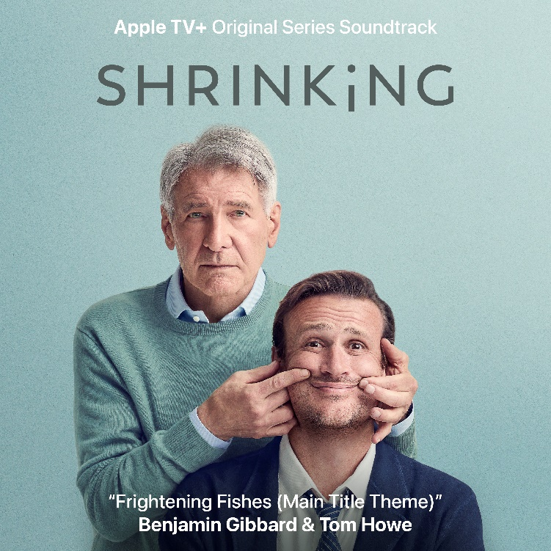
download hi-res single artwork here

Death Cab for Cutie is currently in the midst of the second leg of their Asphalt Meadows headline tour, with a Jan/Feb run of US dates culminating in a sold-out show at Nashville’s famed Ryman Auditorium on Valentine’s Day.

On March 5th, the tour’s UK/EU run will begin in Copenhagen and include stops in Berlin, Amsterdam, Dublin, and London, among many other cities. The tour’s third North American leg will commence May 31st in Indianapolis.

The band will continue to spend much of 2023 on the road, traversing the US this fall on their highly-anticipated co-headline tour with The Postal Service, celebrating the 20th anniversaries of each band’s seminal 2003 record – Transatlanticism and Give Up, respectively [full routing for all upcoming dates enclosed below].

Having been named one of GQ’s “12 Pop Culture Releases” the publication is “Most Looking Forward to in 2023” and of the “23 concerts and albums” the Los Angeles Times is “most excited for,” the tour is now almost entirely sold-out. Numerous shows were added to meet popular demand, including a second sold-out night at New York’s Madison Square Garden and two additional nights at LA’s Hollywood Bowl.

All upcoming ticketing information can be accessed here.

***

ASPHALT MEADOWS (ACOUSTIC) – TRACKLIST:
- I Don’t Know How I Survive (Acoustic)
- Roman Candles (Acoustic)
- Asphalt Meadows (Acoustic)
- Rand McNally (Acoustic)
- Here to Forever (Acoustic)
- Foxglove Through The Clearcut (Acoustic)
- Pepper (Acoustic)
- I Miss Strangers (Acoustic)
- Wheat Like Waves (Acoustic)
- Fragments From the Decade (Acoustic)
- I’ll Never Give Up On You (Acoustic)
- The Plan

***

DEATH CAB FOR CUTIE | 2023 ASPHALT MEADOWS HEADLINE TOUR DATES

JANUARY
31 – St. Petersburg, FL – Jannus Live & – SOLD OUT

FEBRUARY
2 – Orlando, FL – Hard Rock Live & – SOLD OUT
3 – New Orleans, LA – Orpheum Theater & – LOW TICKETS
4 – Little Rock, AR – The Hall & – SOLD OUT
6 – Kansas City, MO – Arvest Bank Theatre at the Midland & – SOLD OUT
7 – Tulsa, OK – Cain’s Ballroom & – SOLD OUT
9 – Austin, TX – ACL Live at The Moody Theater & – SOLD OUT
10 – Austin, TX – ACL Live at The Moody Theater & – SOLD OUT
11 – Dallas, TX – The Factory Deep Ellum & – LOW TICKETS
13 – Knoxville, TN – The Mill & Mine & – SOLD OUT
14 – Nashville, TN – Ryman Auditorium & – SOLD OUT

MARCH
5 – Copenhagen, Denmark – Den Grå Hal *
6 – Stockholm, Sweden – Filadelfia *
7 – Oslo, Norway – Sentrum Scene *
9 – Berlin, Germany – Columbiahalle *
10 – Tilburg, Netherlands – 013 *
11 – Amsterdam, Netherlands – Paradiso * – SOLD OUT
12 – Cologne, Germany – E-Werk *
14 – Antwerp, Belgium – De Roma *
15 – Luxembourg, Luxembourg – Den Atelier *
16 – Paris, France – Salle Pleyel *
18 – Nottingham, United Kingdom – Rock City *
19 – Dublin, Ireland – Bord Gáis Energy Theatre *
21 – Birmingham, United Kingdom – O2 Institute *
22 – Edinburgh, United Kingdom – Usher Hall *
23 – Glasgow, United Kingdom – Barrowland *
25 – Manchester, United Kingdom – O2 Apollo *
27 – Brighton, United Kingdom – Dome *
28 – London, UK – Roundhouse *
29 – London, United Kingdom – Royal Albert Hall * – LOW TICKETS

MAY
31 – Indianapolis, IN – TCU Amphitheater at White River State Park ^

JUNE
2 – Toronto, ON – Massey Hall ^ – LOW TICKETS
3 – Toronto, ON – Massey Hall ^ – LOW TICKETS
4 – Cleveland, OH – Agora Theatre ^ – SOLD OUT
6 – Milwaukee, WI – Riverside Theater ^
7 – Omaha, NE – The Admiral ^ – SOLD OUT
9 – Salt Lake City, UT – Venue TBA ^
10 – Missoula, MT – KettleHouse Amphitheater ^
12 – Calgary, AB – Grey Eagle Resort and Casino – Grey Eagle Event Centre ^ – SOLD OUT
14 – Vancouver, BC – Commodore Ballroom – SOLD OUT
15 – Vancouver, BC – Commodore Ballroom – SOLD OUT
16 – Troutdale, OR – McMenamins Edgefield Amphitheatre ^ – SOLD OUT
17 – Bend, OR – Hayden Homes Amphitheater ^

DEATH CAB FOR CUTIE x THE POSTAL SERVICE | 2023 CO-HEADLINE TOUR DATES

SEPTEMBER
5 – Washington, DC – The Anthem # – SOLD OUT
6 – Washington, DC – The Anthem # – SOLD OUT
8 – Portland, ME – Cross Insurance Arena # – SOLD OUT
9 – Kingston, RI – Ryan Center # – SOLD OUT
10 – New Haven, CT – Westville Music Bowl # – LOW TICKETS
12 – Boston, MA – MGM Music Hall at Fenway # – SOLD OUT
13 – Boston, MA – MGM Music Hall at Fenway # – SOLD OUT
14 – Washington, DC – Merriweather Post Pavilion # – SOLD OUT
17 – Detroit, MI – Meadow Brook Amphitheater # – SOLD OUT
19 – New York, NY – Madison Square Garden # – SOLD OUT
20 – New York, NY – Madison Square Garden # – SOLD OUT
21 – Philadelphia, PA – Mann Center for the Performing Arts # – SOLD OUT
24 – Minneapolis, MN – The Armory # – SOLD OUT
26 – Denver, CO – The Mission Ballroom # – SOLD OUT
27 – Denver, CO – The Mission Ballroom # – SOLD OUT

OCTOBER
3 – Phoenix, AZ – Arizona Financial Theatre # – SOLD OUT
4 – Las Vegas, NV – The Theater at Virgin Hotels # – SOLD OUT
6 – Seattle, WA – Climate Pledge Arena # – SOLD OUT
7 – Seattle, WA – Climate Pledge Arena # – SOLD OUT
9 – Berkeley, CA – Greek Theatre – UC Berkeley # – SOLD OUT
10 – Berkeley, CA – Greek Theatre – UC Berkeley # – SOLD OUT
11 – Berkeley, CA – Greek Theatre – UC Berkeley # – SOLD OUT
13 – Los Angeles, CA – Hollywood Bowl # – SOLD OUT
15 – Los Angeles, CA – Hollywood Bowl # – SOLD OUT
17 – Los Angeles, CA – Hollywood Bowl # – LOW TICKETS

& w/ Special Guest Momma
* w/ Special Guest Slow Pulp
^ w/ Special Guest Lomelda
# Co-Headline 20th Anniversary Tour w/ The Postal Service

***

CONNECT WITH DEATH CAB FOR CUTIE
DEATHCABFORCUTIE.COM | FACEBOOK | TWITTER | INSTAGRAM | YOUTUBE | TIKTOK

