FOR IMMEDIATE RELEASE
JANUARY 6, 2023

IGGY POP UNVEILS FEVERISHLY ANTICIPATED NEW ALBUM EVERY LOSER
LISTEN HERE

RELEASING ALONGSIDE UNPRECEDENTED AMOUNT OF EXCLUSIVE OFFERINGS
INCLUDING LIMITED-EDITION VINYL, CASSETTES AND CD
PLUS AN EXCLUSIVE RELAUNCH OF LEGENDARY FANZINE PUNK

IGGY POP AND THE LOSERS PERFORMING ON JIMMY KIMMEL LIVE! MONDAY, JANUARY 9
2023 WEST COAST DATES ON SALE HERE

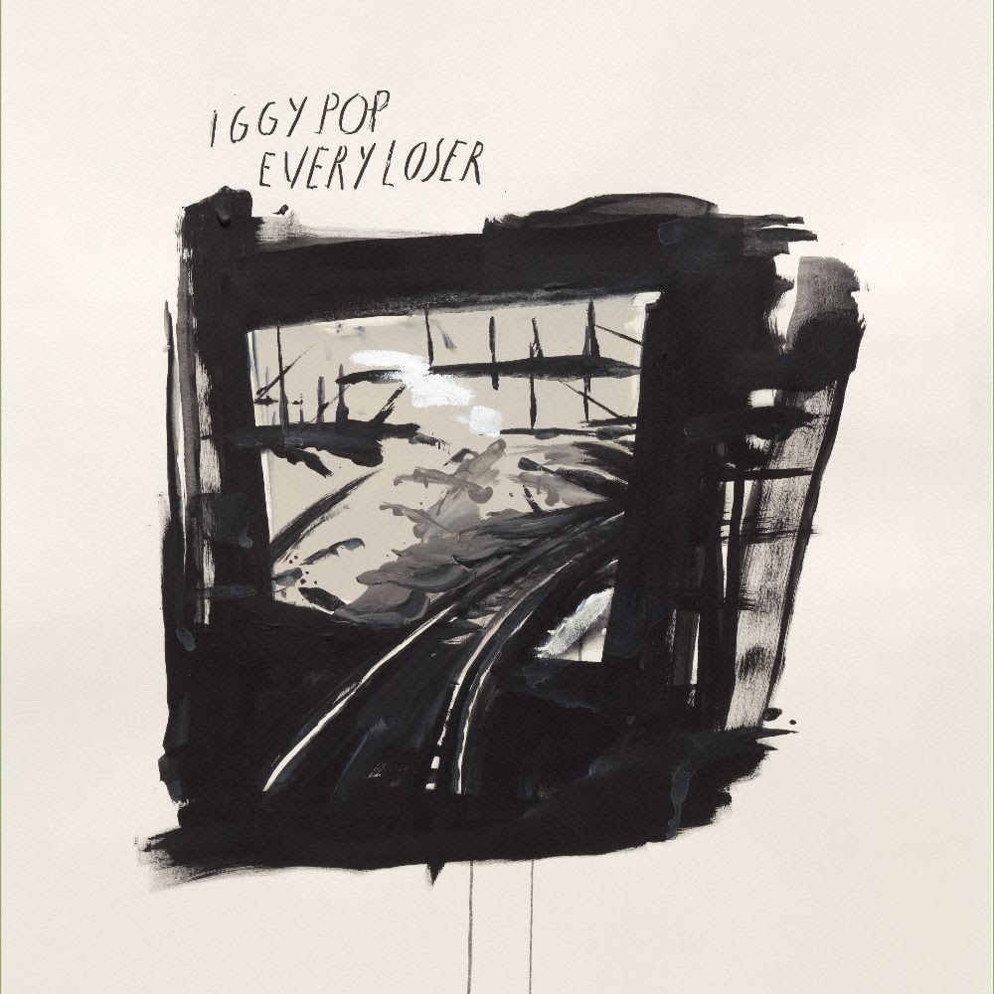
DOWNLOAD ARTWORK HERE
CREDIT RAYMOND PETTIBON

“Getting the shit beat out of you has never sounded so appealing.” – AV CLUB

“raging at age 75. ...proving that power in Pop's hands is still best delivered raw."” – ULTIMATE CLASSIC ROCK

"It’s raw, it rocks, it's Iggy at his finest." – LINCOLN JOURNAL STAR

“…Iggy has delivered his most immediate, straightforward, energetic record in years.” –STEREOGUM (Album of The Week)

"...proves that Pop not only has more to say, but continues to find exciting ways to say them." – SLANT

"Get the year started right with a pop — from Iggy Pop." – ASSOCIATED PRESS

Today marks the release of Iggy Pop’s feverishly anticipated new album EVERY LOSER on Atlantic Records/Gold Tooth Records. Hailed by the likes of NEW YORK, ESQUIRE and the ASSOCIATED PRESS as one of the new year’s most eagerly awaited releases, EVERY LOSER has been preceded by “buzz-bombing, hard-riffing rock” (NEW YORK TIMES) “Frenzy,” and more recently ”Strung Out Johnny.”

Iggy Pop has also been confirmed as musical guest on JIMMY KIMMEL LIVE! Monday, January 9th. Iggy’s return to late night TV will feature the televised debut of his new band the Losers, featuring Andrew Watt, Chad Smith, Duff McKagan and Josh Klinghoffer.

Iggy recently confirmed four live dates spanning the west coast. Kicking off in Los Angeles on April 20, the Godfather of Punk’s raw power will be in full force as he performs tracks off his 19th solo album.
These limited dates include stops at Los Angeles’ Regent Theater and Hollywood Palladium, San Francisco’s Masonic Theater, and Las Vegas’ The Pearl, and will mark the touring debut of Iggy Pop & The Losers.

Tickets are on sale now at iggypop.com. See below for all announced dates.

EVERY LOSER is Iggy’s first album to be released via the recently announced partnership between Atlantic Records and Gold Tooth Records, the new label founded by the album’s GRAMMY Award-winning, multi-platinum executive producer, Andrew Watt.

Featuring a murderers’ row of modern day rock icons including the Iggy Pop & The Losers lineup of Watt, McKagan and Smith, EVERY LOSER sets Iggy’s lyrical aggressions toward physical and existential nemeses atop a rock solid foundation provided by members of Blink 182 (Travis Barker), Foo Fighters (Taylor Hawkins), Guns N’ Roses (Duff McKagan), Jane’s Addiction (Chris Chaney, Dave Navarro, Eric Avery), Pearl Jam (Josh Klinghoffer, Stone Gossard) and Red Hot Chili Peppers (Klinghoffer, Chad Smith). The result is 11 songs by the man who refused to go gently into that good night on Free, and is once again charging fearlessly at life itself on EVERY LOSER.

IGGY POP & THE LOSERS 2023 U.S. DATES

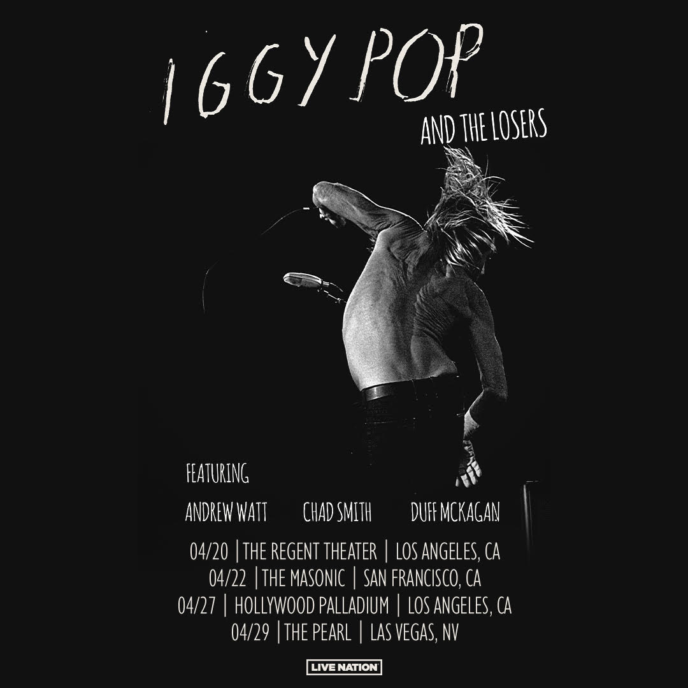

April 20, 2023 – Los Angeles, CA – The Regent Theater – Tickets HERE
April 22, 2023 – San Francisco, CA – Masonic Theater – Tickets HERE
April 27, 2023 – Los Angeles, CA - Hollywood Palladium – Tickets HERE
April 29, 2023 – Las Vegas, NV – The Pearl – Tickets HERE

The new album is available as limited-edition vinyl, cassettes and CDs – Available HERE. As part of the release of EVERY LOSER, Iggy is offering an exclusive relaunch of legendary fanzine, PUNK Magazine, from founder and legendary editor John Holmstrom with a full Iggy issue, which contains an exclusive interview with Iggy by Flea. Iggy originally graced the cover of the John Holmstrom Fanzine in July 1976.

CONNECT WITH IGGY POP
IGGYPOP.COM| FACEBOOK | INSTAGRAM | TWITTER | YOUTUBE

CONTACT FOR IGGY POP
Steve Martin & Michele Hug / Nasty Little Man
steve@nastylittleman.com / michele@nastylittleman.com

CONTACT FOR ANDREW WATT
Bianca Bianconi & Greg Cortez / 42West
Bianca.Bianconi@42West.net / Greg.Cortez@42West.net

CONTACT FOR ATLANTIC RECORDS
Kelly McWilliam / Atlantic Records
Kelly.McWilliam@AtlanticRecords.com

