NEON GOLD/ATLANTIC RECORDS SINGER-SONGWRITER JOE P
UNVEILS NEW EP FRENCH BLONDE & THE OFFICIAL PERFORMANCE VIDEO FOR TITLE TRACK

RELEASES TRAILER FOR FORTHCOMING SHORT HORROR FILM “IF WE RUN” STARRING MICHAEL GANDOLFINI , KEVIN INTERDONATO & MORE, OUT 10/19

BREAKTHROUGH SINGLE, “OFF MY MIND,” TO IMPACT
AT TRIPLE A RADIO NATIONWIDE NEXT WEEK

SOLD OUT NORTH AMERICAN TOUR SUPPORTING SPACEY JANE KICKS OFF OCTOBER 10

JOE P JOINS RECORD STORE DAY’S ‘NEW ARTIST SERIES’ CAMPAIGN
WITH AN EXCLUSIVE DELUXE VINYL & IN-STORE PERFORMANCES

STREAM/DOWNLOAD FRENCH BLONDE EP HERE
WATCH THE PERFORMANCE VIDEO FOR “FRENCH BLONDE” HERE
WATCH THE “IF WE RUN” MOVIE TRAILER HERE
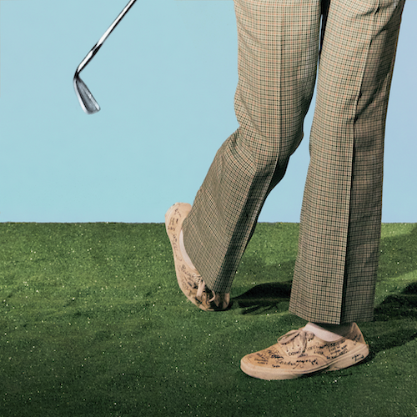
DOWNLOAD HI-RES ARTWORK

Alternative singer-songwriter joe p has shared his eagerly anticipated sophomore EP, French Blonde, available now via Neon Gold/Atlantic Records HERE. The seven-song project includes the pulse-pounding title track, “French Blonde,” joined by an official live performance video, directed by longtime visual collaborator Anthony Yebra and premiering today at YouTube HERE. The video for “French Blonde” can also be seen as part of the opening scene of joe p’s forthcoming short horror film, “If We Run,” starring Michael Gandolfini (The Many Saints of Newark), Kevin Interdonato (The Sopranos), and joe p as himself.

“If We Run” is slated for release on 10/19 and will feature live performances of several songs off of the French Blonde EP and more, intertwined with a plot inspired by 80s and 90s horror movies. The motion picture was conceived and written by Joe and longtime collaborator Anthony Yebra, who also directed the film.

Joe p says, “This EP feels like I finally got everything off my chest and out of my head that was stuck in there for way too long. I honestly have never made something that I don’t care what people think of more than this collection of songs because it doesn’t even feel like I could have made anything else other than what you hear. I recorded all of the vocals alone in my basement and I think I will always do that because it bakes in a sense of reality where the water heater could turn on at any moment and ruin everything.”

French Blonde was heralded last month by the anthemic “Happy People,” available for streaming and download HERE. The new EP – which follows joe p’s acclaimed 2021 debut EP, Emily Can’t Sing – also includes the viral hit single, “All Day I Dream About,” joined by a cinematic official music video is streaming now at YouTube HERE. First introduced as “Adidases” in a hugely popular TikTok teaser (streaming HERE), the song proved Joe’s biggest first week success to date upon its August premiere, earning over 233K streams in the US alone along with 13K pre-saves – a staggering number for a new alternative artist still in his initial ascent.

joe p
FRENCH BLONDE
(Neon Gold/Atlantic Records)

TRACKLIST
French Blonde
Happy People
Kids In The Summer
Emily Can’t Sing
All Day I Dream About
I’m On Fire
Color TV

Having spent much of the past year on the road traveling with artists such as Middle Kids and Joywave, joe p will return to the road with this fall with a North American tour opening for Spacey Jane, set to get underway this Monday, October 10, with a sold out show at The Axis Club in Toronto, ON and travel into early November. Most dates – including an eagerly awaited two-night stand at New York City’s Bowery Ballroom (October 12-13), as well as shows in Boston, Washington, DC, Chicago, Vancouver, and Los Angeles – are already sold out. For updates and remaining ticket availability, please visit joepthehyena.com.

joe p will also kick off Atlantic Records x Record Store Day’s “New Artist Series” by making stops at select independent record stores throughout the upcoming tour. A limited edition deluxe vinyl pressing of Emily Can’t Sing – featuring “All Day I Dream About” and an acoustic version of joe’s breakthrough hit single, “Off My Mind” – will be available exclusively at these intimate in-store performances and at other independent record stores. More information can be found at recordstoreday.com.

When the onset of the pandemic brought about the dissolution of the band he’d fronted since eighth grade, joe p found himself in isolation with time to step out and experiment on his own. From the refuge of his New Jersey basement studio, he threw himself into writing, recording and producing his most personal material to date. Posting homegrown ideas to TikTok, joe p watched as his raw acoustic videos drew millions of views and over 300K followers in just a few months. Among those new fans was Apple Music’s Zane Lowe, who kicked joe’s career into hyperdrive by duetting alongside his self-made “Fighting In The Car” video (streaming HERE). A deal with Neon Gold/Atlantic was quickly followed by the acclaimed release of joe p’s acclaimed debut EP, Emily Can’t Sing, highlighted by such singles as “Leaves,” “Fighting In the Car,” and “Off My Mind,” the latter of which will impact Triple A radio outlets nationwide next week.

# # #
joe p
NORTH AMERICAN TOUR 2022

OCTOBER
10 – Toronto, ON – The Axis Club (SOLD OUT)
12 – New York, NY – Bowery Ballroom (SOLD OUT)
13 – New York, NY – Bowery Ballroom (SOLD OUT)
14 – Boston, MA – Brighton Music Hall (SOLD OUT)
15 – Philadelphia, PA – Union Transfer
16 – Washington, DC – Black Cat (SOLD OUT)
18 – Chicago, IL – Lincoln Hall (SOLD OUT)
19 – Minneapolis, MN – Fine Line Music Cafe
20 – Omaha, NE – Reverb Lounge
22 – Englewood, CO – Gothic Theatre
23 – Salt Lake City, UT – Metro Music Hall
25 – Seattle, WA – Neumos
26 – Vancouver, BC – Rickshaw Theatre (SOLD OUT)
27 – Portland, OR – Doug Fir Lounge
29 – San Francisco, CA – The Chapel (SOLD OUT)
30 – Los Angeles, CA – Teragram Ballroom (SOLD OUT)
31 – Santa Ana, CA – Constellation Room (SOLD OUT)

NOVEMBER
1 – Solana Beach, CA – Belly Up Tavern
2 – Phoenix, AZ – Crescent Ballroom
4 – Dallas, TX – The Studio at the Factory
5 – Austin, TX – Parish (SOLD OUT)
6 – Houston, TX – Warehouse Live (SOLD OUT)
8 – Nashville, TN – The Basement East
9 – Atlanta, GA – Terminal West

ALL DATES w/SPACEY JANE

joe p
RSD NEW ARTIST SERIES IN-STORE PERFORMANCES 2022

OCTOBER
16 – Washington, DC – Byrdland Records @ 4pm
20 – Omaha, NE – Homers @ 4pm
24 – Boise, ID – The Record Exchange @ 5pm
25 – Seattle, WA – Silver Platters @ 4pm

NOVEMBER
2 – Tempe, AZ – Zia Records @ 4pm
5 – Houston, TX – Cactus Music @ 3pm
9 – Atlanta, GA – Criminal Records @ 4pm
27 – Red Bank, NJ – Jack’s Music Shoppe @ 3pm
28 – New York, NY – Rough Trade @ 6pm

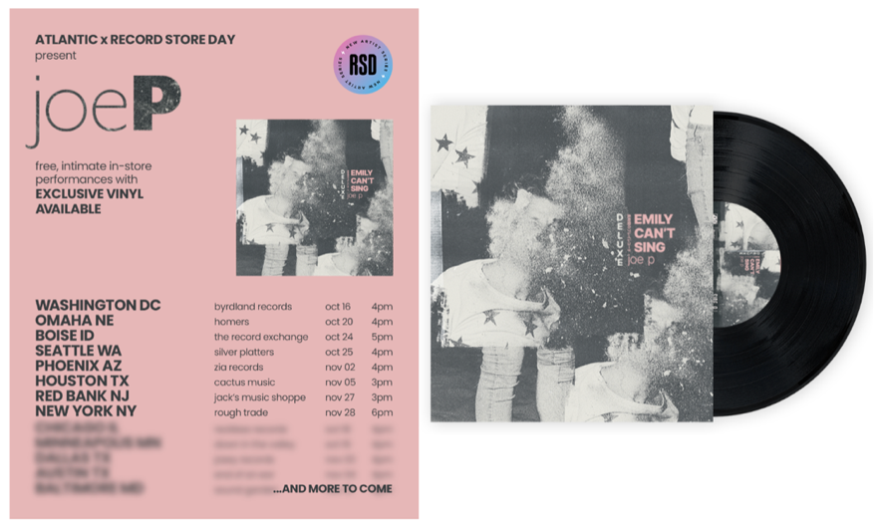

# # #

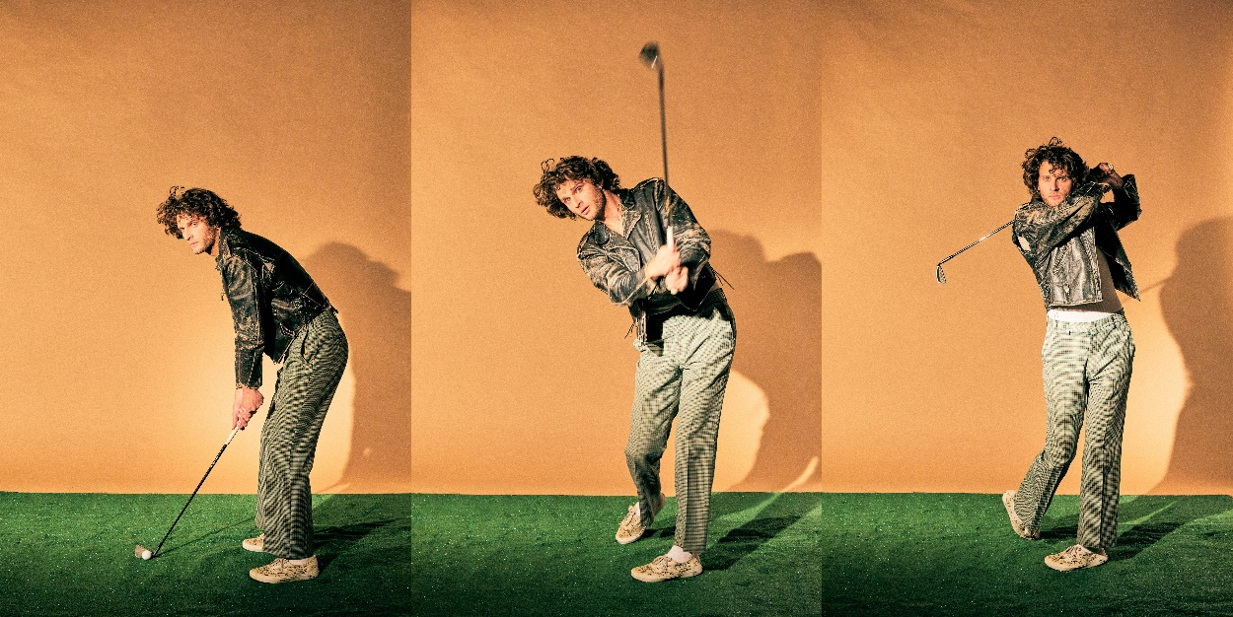
DOWNLOAD HI-RES IMAGE // PHOTO CREDIT: JIMMY FONTAINE

# # #

CONNECT WITH JOE P
WEBSITE | FACEBOOK | INSTAGRAM | SOUNDCLOUD | SPOTIFY | TIKTOK | TWITTER | YOUTUBE

PRESS CONTACTS
corey.brewer@atlanticrecords.com
gabrielle.reese@atlanticrecords.com

