NEON GOLD/ATLANTIC RECORDS SINGER-SONGWRITER JOE P RELEASES HORROR FILM IF WE RUN STARRING MICHAEL GANDOLFINI, KEVIN INTERDONATO

FEATURES LIVE PERFORMANCES FROM JOE P’S NEW EP FRENCH BLONDE & MORE

BREAKTHROUGH SINGLE “OFF MY MIND” AT TRIPLE A RADIO NATIONWIDE

CURRENTLY OPENING FOR SPACEY JANE ON THEIR SOLD-OUT US TOUR

JOE P JOINS RECORD STORE DAY’S ‘NEW ARTIST SERIES’ CAMPAIGN
WITH AN EXCLUSIVE DELUXE VINYL & IN-STORE PERFORMANCES

WATCH “IF WE RUN” HERE
STREAM/DOWNLOAD FRENCH BLONDE EP HERE

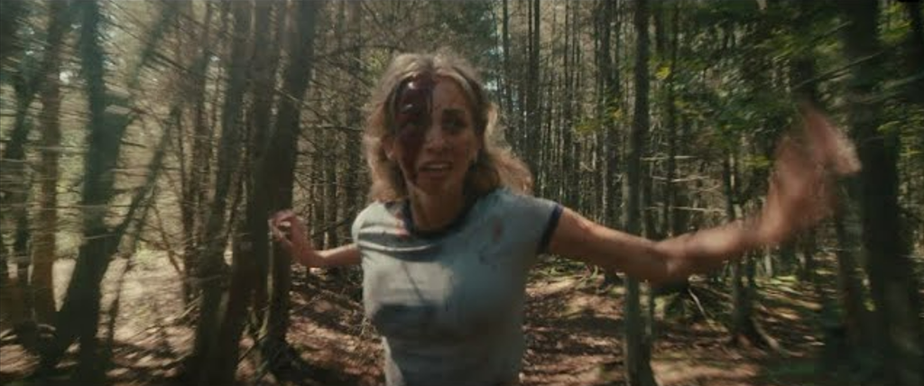

Alternative singer-songwriter Joe P has shared a short horror film, If We Run, starring Michael Gandolfini (The Many Saints of Newark), Kevin Interdonato (The Sopranos), and Joe P as himself. The film was written and produced alongside long-time collaborator, Anthony Yebra. Watch HERE!

Joe’s new single “French Blonde,” from his Sophomore EP of the same name, is featured in the opening scene along with three other live performances intertwined throughout the film that is inspired by 80s and 90s horror movies (Nightmare on Elm St, Halloween, etc). The scene is set as four friends are on their way to their first party of the summer and upon their arrival in the town of Jackson, NJ, a horrific series of events ensues, forcing the group to fight for their lives.

Joe released his eagerly anticipated sophomore EP, French Blonde (available now via Neon Gold/Atlantic Records HERE) earlier this month. The seven-song project includes the pulse-pounding title track, “French Blonde,” joined by an official live performance video, directed by longtime visual collaborator Anthony Yebra.

French Blonde was heralded last month by the anthemic “Happy People,” available for streaming and download HERE. The new EP – which follows Joe P’s acclaimed 2021 debut EP, Emily Can’t Sing – also includes the viral hit single, “All Day I Dream About,” joined by a cinematic official music video is streaming now at YouTube HERE. First introduced as “Adidases” in a hugely popular TikTok teaser (streaming HERE), the song proved Joe’s biggest first week success to date upon its August premiere, earning over 233K streams in the US alone along with 13K pre-saves – a staggering number for a new alternative artist still in his initial ascent.

Having spent much of the past year on the road traveling with artists such as Middle Kids and Joywave, Joe P is currently on the road with Spacey Jane, opening for them on their sold out North American tour. For updates and remaining ticket availability, please visit joepthehyena.com.

Joe P also kicked off Atlantic Records x Record Store Day’s “New Artist Series” by making stops at select independent record stores throughout the tour. A limited edition deluxe vinyl pressing of Emily Can’t Sing – featuring “All Day I Dream About” and an acoustic version of Joe’s breakthrough hit single, “Off My Mind” – is available exclusively at these intimate in-store performances and at other independent record stores. More information can be found at recordstoreday.com.

When the onset of the pandemic brought about the dissolution of the band he’d fronted since eighth grade, Joe P found himself in isolation with time to step out and experiment on his own. From the refuge of his New Jersey basement studio, he threw himself into writing, recording and producing his most personal material to date. Posting homegrown ideas to TikTok, Joe P watched as his raw acoustic videos drew millions of views and over 300K followers in just a few months. Among those new fans was Apple Music’s Zane Lowe, who kicked Joe’s career into hyperdrive by duetting alongside his self-made “Fighting In The Car” video (streaming HERE). A deal with Neon Gold/Atlantic was quickly followed by the acclaimed release of Joe P’s acclaimed debut EP, Emily Can’t Sing, highlighted by such singles as “Leaves,” “Fighting In the Car,” and “Off My Mind,” the latter of which recently impacted Triple A radio outlets nationwide.

# # #
Joe P
NORTH AMERICAN TOUR 2022

OCTOBER
29 – San Francisco, CA – The Chapel (SOLD OUT)
30 – Los Angeles, CA – Teragram Ballroom (SOLD OUT)
31 – Santa Ana, CA – Constellation Room (SOLD OUT)

NOVEMBER
1 – Solana Beach, CA – Belly Up Tavern
2 – Phoenix, AZ – Crescent Ballroom
4 – Dallas, TX – The Studio at the Factory
5 – Austin, TX – Parish (SOLD OUT)
6 – Houston, TX – Warehouse Live (SOLD OUT)
8 – Nashville, TN – The Basement East
9 – Atlanta, GA – Terminal West

ALL DATES w/SPACEY JANE

Joe P
RSD NEW ARTIST SERIES IN-STORE PERFORMANCES 2022

NOVEMBER
2 – Tempe, AZ – Zia Records @ 4pm
5 – Houston, TX – Cactus Music @ 3pm
9 – Atlanta, GA – Criminal Records @ 4pm
27 – Red Bank, NJ – Jack’s Music Shoppe @ 3pm
28 – New York, NY – Rough Trade @ 6pm

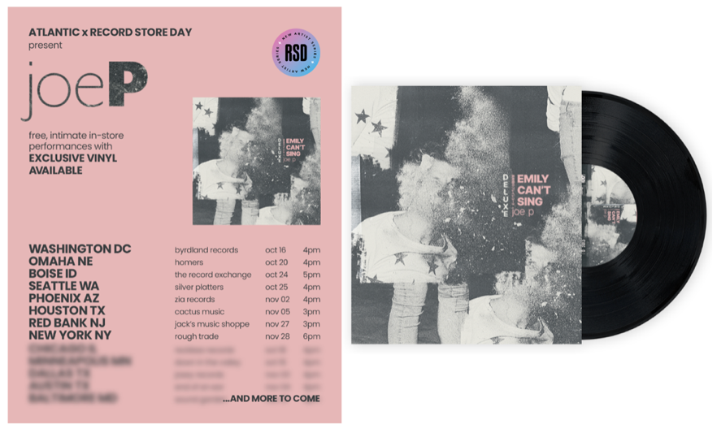

# # #

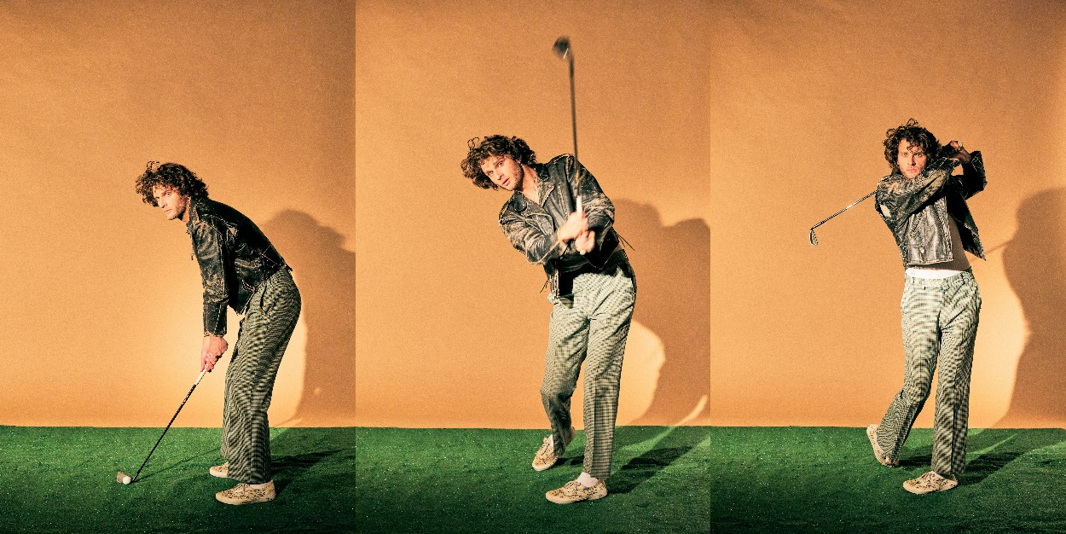
DOWNLOAD HI-RES IMAGE // PHOTO CREDIT: JIMMY FONTAINE

# # #

CONNECT WITH JOE P
WEBSITE | FACEBOOK | INSTAGRAM | SOUNDCLOUD | SPOTIFY | TIKTOK | TWITTER | YOUTUBE

PRESS CONTACTS
corey.brewer@atlanticrecords.com
gabrielle.reese@atlanticrecords.com

