FOR IMMEDIATE RELEASE
JANUARY 31, 2023

OLIVER TREE ANNOUNCES FIRST EVER HEADLINE SHOW AT
RED ROCKS AMPHITHEATRE

ONCE-IN-A-LIFETIME CONCERT EVENT WITH SPECIAL GUESTS
TAI VERDES, UPSAHL & LITTLE RICKY ZR3

SET FOR JUNE 20 AT THE ICONIC MORRISON, CO VENUE

PRESALES BEGIN WEDNESDAY, FEBRUARY 1 AT 10:00 AM (MT)
GENERAL ON-SALES FOLLOW ON FRIDAY, FEBRUARY 3 AT 10:00 AM (MT)

DELUXE ALBUM COWBOY TEARS DROWN THE WORLD IN A SWIMMING POOL OF SORROW
AVAILABLE EVERYWHERE NOW VIA ATLANTIC RECORDS – LISTEN HERE

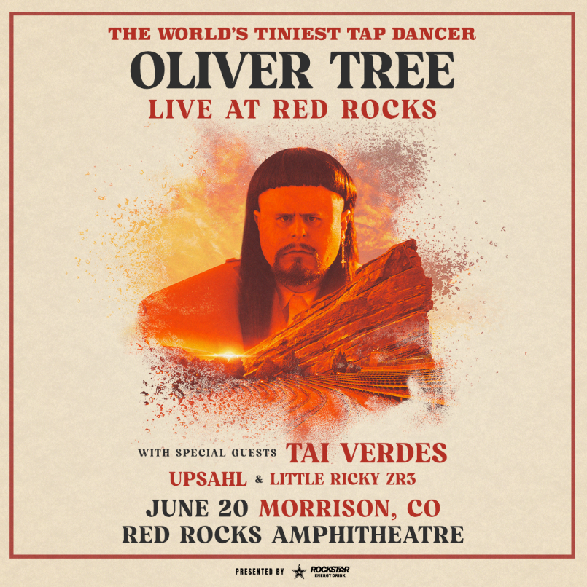
DOWNLOAD ARTWORK HERE
“With his tongue-and-cheek approach, Tree gives a larger than life performance…” – ROLLING STONE

“Oliver isn’t shy about flexing his creativity and sense of humor throughout his live performances…” – SLANT

“A can’t miss set…” – HIGH TIMES

“A music-making, meme-machine…” – VICE

Chart-topping, genre-bending, multi-platinum selling artist Oliver Tree has announced plans for a very special headline concert event with special guests Tai Verdes, UPSAHL & Little Ricky ZR3, set for June 20 at Morrison, CO’s world famous Red Rocks Amphitheatre. Artist presales begin Wednesday, February 1 at 10:00 am (MT); local presales follow on Thursday, February 2 at 10:00 am (MT). All presales conclude Thursday, February 2 at 10:00 pm (MT). General on-sales begin Friday, February 3 at 10:00 am (MT). For complete details, please see www.olivertreemusic.com.

Last week saw the release of KSI’s new single “Voices” featuring Oliver and last month saw the long awaited release of Cowboy Tears Drown the World in a Swimming Pool of Sorrow, an expanded deluxe edition of Oliver’s acclaimed sophomore LP, Cowboy Tears, available now via Atlantic Records at all DSPs and streaming services HERE. Cowboy Tears Drown the World in a Swimming Pool of Sorrow extends the original track listing with 11 additional songs including four co-produced by Oliver with Travis Barker (Machine Gun Kelly, jxdn, WILLOW) and Nick Long (Machine Gun Kelly, The Chainsmokers, 5SOS). Highlights include such recent favorites as “I Hate You,” produced by Oliver with longtime collaborators Whethan (The Chainsmokers, Dua Lipa, Tom Morello, Ugly God) and childhood friend Casey Mattson, available for streaming and download HERE. This summer saw the arrival of “Placeholder,” produced by Oliver, Barker, and Long, available for streaming and download HERE. In addition, an official video for the original album’s “Suitcase Full Of Cash” – featuring guest appearances from viral stars Alissa Violet, Tana Mongeau, Viking Barbie, and Melissa Ong – is streaming now at Oliver’s YouTube channel HERE.

With more than 4B global streams to date, over 1B YouTube views, more than 14.7M TikTok followers, and an overall social reach of over 20M, Oliver also recently scored yet another smash with “Miss You,” his new collaboration with GRAMMY® Award-nominated producer Robin Schulz. The high-energy single – which swiftly amassed over 300M global streams following its spectacular top 10 debut on Billboard’s “Hot Dance/Electronic Songs” chart – is accompanied by a deliriously quirky official music video, directed by Oliver and currently boasting more than 100M views via YouTube HERE.

Released February 18, 2022, Cowboy Tears includes such hit singles as “Swing & A Miss,” “Freaks & Geeks,” and “Cowboys Don’t Cry,” all joined by official music videos streaming now at YouTube. Tracks from the album have collectively reeled in tens of millions of worldwide streams, with “Cowboys Don’t Cry” proving a true multi-media sensation. Oliver premiered the track with a typically memorable performance on ABC’s Jimmy Kimmel Live! (streaming HERE) that also featured a rendition of his RIAA gold certified viral favorite, “Life Goes On.”

Oliver celebrated Cowboy Tears with his biggest international live run to date, culminating late last year with his One Last Ride Across Europe Tour for headline shows in London, Italy, Serbia, Turkey, the Netherlands, France, Spain, Sweden, Denmark, Germany, and Ireland. The epic, nearly year-long trek – which included sold-out headline tours in North America and Australia/New Zealand, plus show-stealing festival sets at San Francisco, CA’s Outside Lands Music & Arts Festival, Grand Rapids, MI’s Breakaway Music Festival, Toronto, ON’s Rolling Loud Toronto, Las Vegas, NV’s Life Is Beautiful, Austin, TX’s two-weekend Austin City Limits Music Festival, and Queens, NY’s Rolling Loud New York.

# # #

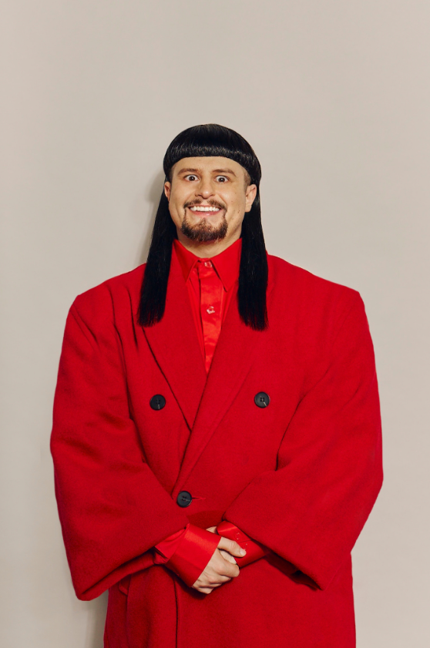
DOWNLOAD PRESS PHOTO
CREDIT: GRAY BRAME

CONNECT WITH OLIVER TREE
WEBSITE | FACEBOOK | INSTAGRAM | SPOTIFY | TIK TOK | TWITTER | YOUTUBE

CONTACT
Jessica Nall // Jessica.Nall@AtlanticRecords.com

