HAYLEY KIYOKO ANNOUNCES “THE PANORAMA TOUR”

GLOBAL HEADLINE RUN CELEBRATES CRITICALLY ACCLAIMED ALBUM PANORAMA

DATES KICK OFF APRIL 5TH WITH TICKETS ON SALE FRIDAY, FEBRUARY 3RD HERE

DEBUT NOVEL GIRLS LIKE GIRLS OUT MAY 30TH

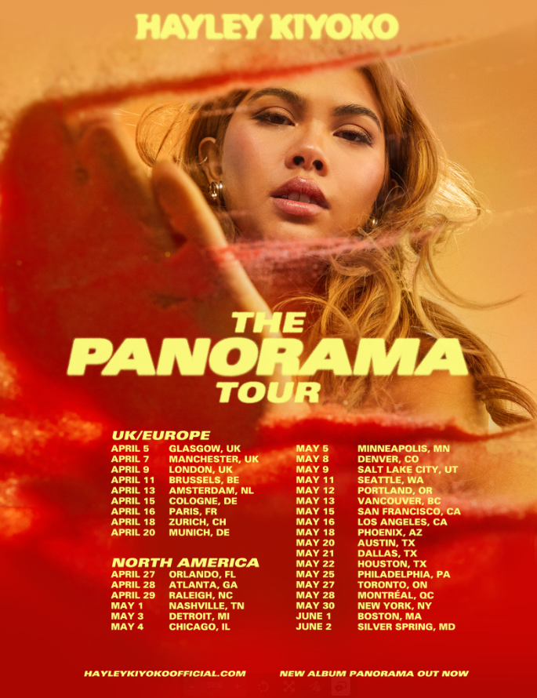
DOWNLOAD HI-RES PRESS PHOTOS AND TOUR ART

Celebrating her critically acclaimed sophomore album, PANORAMA, trailblazing pop star Hayley Kiyoko will embark on The PANORAMA Tour this spring. Produced by Live Nation, the global headline run kicks off overseas on April 5th and travels through June 2nd with 24 North American stops including The Wiltern in Los Angeles on May 16th and Irving Plaza in New York City on May 30th. With all details now available, Kiyoko first teased the exciting news on Friday via her socials HERE. Full routing is copied below with tickets on sale this Friday, February 3rd at 10 AM Local HERE.

PRESALE: Citi is the official card of The PANORAMA Tour. Citi cardmembers will have access to presale tickets in the U.S. beginning Wednesday, February 1st at 10 AM local time until Thursday, February 2nd at 10 PM local time through the Citi Entertainment program. For complete presale details visit www.citientertainment.com.

Co-written by Hayley and produced by Kiyoko, Danja (Beyoncé, Britney Spears) and Pat Morrisey & Kill Dave, the transformative 12-track album, highlighted by lead singles, “For The Girls,” “Chance” and “Found My Friends,” received rave reviews from The New York Times, FADER, Billboard, SPIN, PAPER, V Magazine, Variety, Entertainment Weekly and more. The trailblazing musician, adoringly called “Lesbian Jesus” by her legion of fans, also graced the cover of Teen Vogue’s Music issue and was declared “Artist Of The Year” by Out Magazine as she covered the esteemed Out100 issue.

Kiyoko has become one of the most celebrated pop artists since releasing her debut album EXPECTATIONS, which — according to Rolling Stone, placed her “at the forefront of an unapologetically queer pop movement.” In #20GAYTEEN, the multi-hyphenate performer was nominated for two VMAs and won “Push Artist Of The Year.” Since her 2015 debut, Hayley has amassed over 1B global streams and over 2.28M YouTube subscribers, accrued over 840M lifetime YouTube views, and sold-out numerous venues across the country and abroad. Lauded as one of “The 21st Century's Most Influential Women Musicians” by NPR, Hayley inspires her community through nuanced storytelling and lyricism, encouraging hope as her resounding message.

This year, Hayley will debut her first novel, a coming-of-age romance based on her breakthrough hit song and viral video, GIRLS LIKE GIRLS, available for pre-order now and arriving on May 30th. Her first-ever gender-inclusive fragrance, Hue, which became a 2022 finalist for the Fragrance Foundation’s “Universal Prestige Award,” is also available to order at huebyhayley.com.

PRAISE FOR PANORAMA

“‘PANORAMA’ reasserts that Kiyoko is more than meets the eye. Much like the humanitarian inclinations of Jesus in classic Bible tales, Kiyoko is more than an actress, pop star or lesbian icon: She's a vessel of love and kindness, mirroring the fuel that has kept her going in even the darkest and loneliest of times.”
– PAPER

“From the delicious takedown of opener ‘Sugar at the Bottom’ to the intimate confessions of the lush closer ‘PANORAMA,’ Kiyoko’s sophomore LP is the sound of an artist ready soar higher in the mainstream.”
– BILLBOARD

“’PANORAMA’ is a careful balancing act of mining the past without getting stuck in it, while also taking time to celebrate Kiyoko in her current state of physical and mental revitalization – a joyous celebration of showing up for yourself.”
– FADER

“Hayley Kiyoko’s new album ‘PANORAMA’ is here, and it’s bop after bop”
– TEEN VOGUE

THE PANORAMA TOUR DATES:

APRIL
5 — Glasgow, UK — Galvanizers SWG3
7 — Manchester, UK — Manchester Academy 2
9 — London, UK — KOKO
11 — Brussels, BE — Ancienne Belgique
13 — Amsterdam, NL — Melkweg Max
15 — Cologne, DE — Carlswerk Victoria
16 — Paris, FR — Élysée Montmartre
18 — Zurich, CH — Komplex 457
20 — Munich, DE — TonHalle
27 — Orlando, FL — House of Blues Orlando
28 — Atlanta, GA — Buckhead Theatre
29 — Raleigh, NC — The Ritz

MAY
1 — Nashville, TN — Marathon Music Works
3 — Detroit, MI — Saint Andrew's Hall
4 — Chicago, IL — House of Blues Chicago
5 — Minneapolis, MN — Varsity Theater
8 — Denver, CO — Summit
9 — Salt Lake City, UT — The Depot
11 — Seattle, WA — Neptune Theatre
12 — Portland, OR — McMenamins Crystal Ballroom
13 — Vancouver, BC — Commodore Ballroom
15 — San Francisco, CA — The Fillmore
16 — Los Angeles, CA — The Wiltern
18 — Phoenix, AZ — The Van Buren
20 — Austin, TX — Emo's Austin
21 — Dallas, TX — The Echo Lounge & Music Hall
22 — Houston, TX — House of Blues Houston
25 — Philadelphia, PA — Brooklyn Bowl Philadelphia
27 — Toronto, ON — The Danforth Music Hall
28 — Montreal, QC — Théâtre Corona
30 — New York, NY — Irving Plaza

JUNE
1 — Boston, MA — House of Blues Boston
2 — Silver Spring, MD — The Fillmore Silver Spring

DOWNLOAD HI-RES PRESS PHOTOS AND TOUR ART // CREDIT: TREVOR FLORES

CONNECT WITH HAYLEY KIYOKO:
WEBSITE | FACEBOOK | TWITTER | INSTAGRAM | TIKTOK | YOUTUBE | PRESS ASSETS

PRESS CONTACT:
Andrew George / Atlantic Records
andrew.george@atlanticrecords.com

