FOR IMMEDIATE RELEASE
JANUARY 25, 2023

will corook get the dog?

quirky alt-pop singer-songwriter celebrates birthday with
heartbreakingly beautiful new single and video

joining Maddie Zahm as special guest on sold-out
“You Might Not Like Her” tour kicking off february 27th

listen to “the dog” | watch official music video

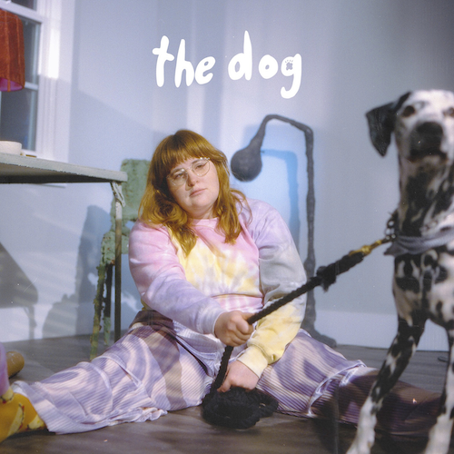
download hi-res artwork

“Even at her most low-key, alt-pop songwriter corook brings a unique quirk to everything she does. From goofy, upbeat tunes like ‘snakes’ to the more somber ‘it’s ok!’, her songs bring detailed textures that immediately identify the track as one of hers.”
– CONSEQUENCE

“If specificity is the soul of narrative, then corook is one of the most naturally gifted storytellers in the game.”
– BILLBOARD

Self-described “singer, songwriter, producer, multi-instrumentalist, and huge f*ckin dork” corook [pronounced ‘co-rook’] is celebrating her 28th birthday with her first single of the new year. “the dog” is available now at all DSPs and streaming services along with a heartbreakingly beautiful music video starring corook and her actual girlfriend – watch HERE.

“Two years ago on my girlfriend's birthday I offered to buy her a cat,” says corook. “She immediately asked ‘Why not a dog?’ I explained that we had spoken about how our house didn't have enough space and we both were iffy on whether that was a commitment we wanted to make. We decided to go to the shelter and play with some animals for her birthday but instead we left with our dog, Cubby. This song is an exaggeration of the ‘What if we break up question?’ through the lens of who would take the dog.”

corook – who spent much of this past year on the road for her first-ever US live runs supporting K.Flay and then NYC-based piano pop/rock trio Jukebox the Ghost as well as making her debut festival performance at Bonnaroo where she was featured in Rolling Stone – has announced she will be joining Maddie Zahm as special guest on her sold-out “You Might Not Like Her” tour with dates kicking off in San Diego on February 27th with stops at NYC’s Bowery Ballroom on March 20th and The Troubadour in LA on April 11th. See full routing below and for more tour related information, please visit www.corook.com.

“the dog” follows recent releases including the “soft and vulnerable” “realistic,” which is joined by an inventive stop-motion music video that premiered exclusively via PEOPLE, along with her incredible cover of Fountains of Wayne’s classic, “Stacy’s Mom,” delivered through her refreshing and uniquely queer perspective. Originally performed as part of Salt Lick Sessions, the innovative rendition is available now at all DSPs and streaming services HERE.

Named as one of The Advocate’s “7 Queer Artists For Your Fall Playlist,” the genre-busting, Nashville-based musician tackles deeply personal themes in her music and visuals through a humorous lens. Last spring, she blessed the world with her debut achoo! EP, which features surprising and insightful tracks including “idk god,” “degree,” “bad friend,” and “sims,” in addition to the fan favorite, “snakes”. Since release, corook has shared her viral adult lullaby, “it’s ok!,” the unrestrained single “BDSM,” super-hot “hell yeah,” heartfelt “your mom,” and ode to self-worth, “smoothie”. corook also got vulnerable in front of the camera, reflecting on their mental health journey in the latest episode of Out Magazine’s “Love, Me” video series now streaming HERE.

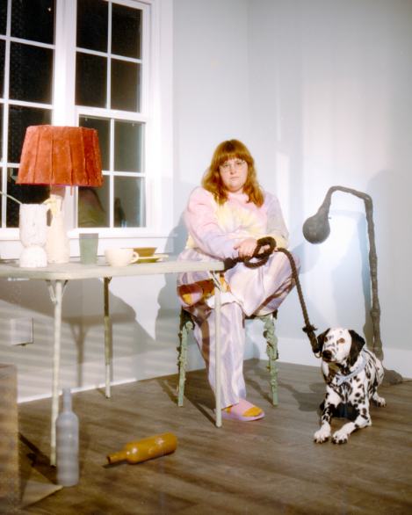
download hi-res press photos
Photo Credit: Kirsten Barnett

corook by corook
corook aka Corinne Savage (yes that’s her real last name) is a singer, songwriter, producer, multi-instrumentalist and a huge fuckin dork. No but seriously. She can solve a Rubix cube in under a minute (depending on how she’s feeling that day.) This ~freckled chubby babe~ was born and raised just outside of downtown Pittsburgh, Pennsylvania, where they grew up listening to Drake, Gwen Stefani and Mac Miller (RIP). She went to a performing arts high school (yes, just like Victorious) where she came out as QUEERAF her senior year. She then went to Berklee College of Music (wow – Owen Wilson voice) and graduated with TWO degrees (barely.) corook currently resides in Nashville, Tennessee (howdy.) She spends most of her time writing and producing music for her artist project “corook” (boop!) locked away in her room, alone (she blames it on Coronavirus but she’s actually just anti-social.) She’s 28 and VERY cute.

corook on tour

FEBRUARY
27 – San Diego, CA – House of Blues, Voodoo Room
28 – San Francisco, CA – The Chapel

MARCH
2 – Seattle, WA – Neumos
4 – Boise, ID – Knitting Factory
5 – Salt Lake City, UT – complex
7 – Denver, CO – Marquis Theater
9 – Omaha, NE – Slowdown
10 – Kansas City, MO – Encore
12 – Minneapolis, MN – Amsterdam Bar & Hall
13 – Chicago, IL – SPACE
15 – Toronto, ON – Allied Music Center
17 – Boston, MA - Café 939 at Berklee
18 – Philadelphia, PA – World Café Live
20 – New York, NY – Bowery Ballroom
22 – Washington, DC – Union Stage
24 – Atlanta, GA – The Loft
27 – Nashville, TN – The Basement East

APRIL
11 – Los Angeles, CA – The Troubadour

connect with corook:
corook.com | instagram | tiktok | press assets

press contact:
andrew.george@atlanticrecords.com

