SKRILLEX RELEASES NEW SINGLE AND HIS FIRST MUSIC VIDEO OF THE YEAR

GLOBETROTTING DJ & PRODUCER LINKS UP WITH DRAIN GANG CEO BLADEE ON “REAL SPRING”

LISTEN TO THE NEW SINGLE HERE.

WATCH VIDEO HERE.

OUT NOW ON OWSLA / ATLANTIC RECORDS

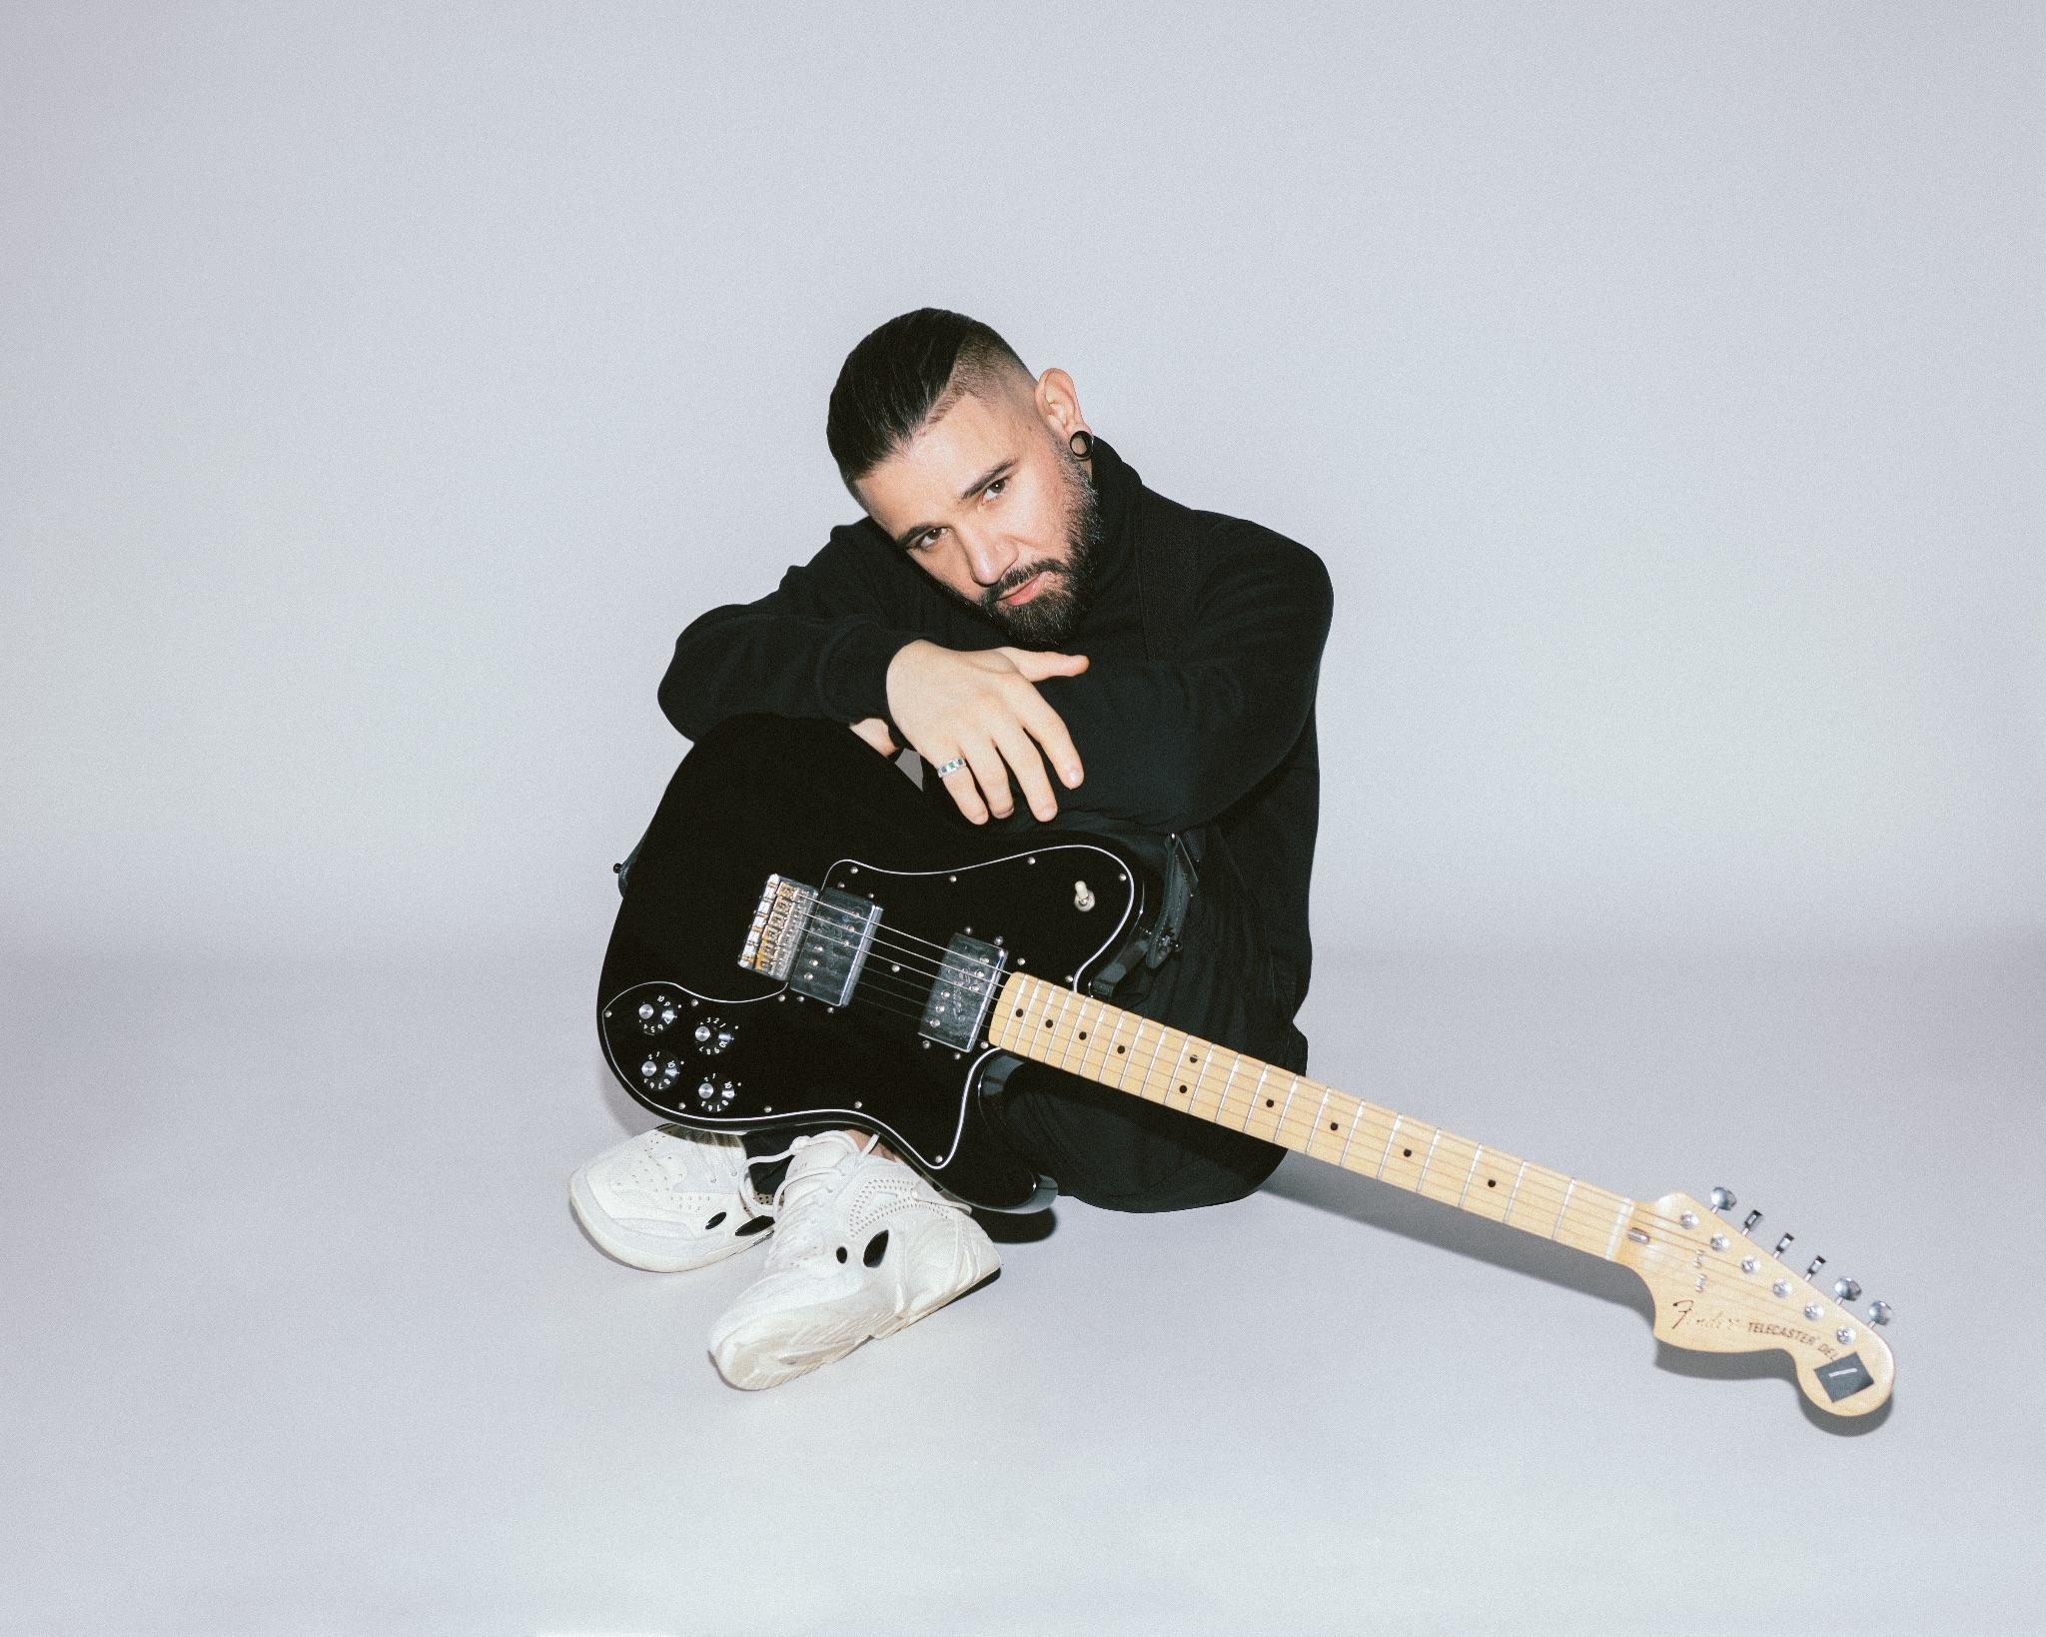
Photo Credit: Marilyn Hue

Skrillex teams up with fellow genre-defying producer and Drain Gang CEO Bladee to drop their new single “Real Spring” and also debuts his first music video of the year. The song and video are out now on OWSLA / Atlantic Records. This new song drops just a week after his previous single “Leave Me Like This” featuring rapper and producer Bobby Raps. Much fan excitement has ensued as he has recently been sharing his travels on social media amongst a string of impromptu shows as he travels across continents making music and shooting videos while dipping in for surprise moments and playing in front of sold out crowds, all while collaborating with some of the most innovative names in music along the way. The release of “Real Spring'' comes after Skrillex was seen hanging out with Yung Lean, Bladee and fellow Drain Gang member Thaiboy Digital before doing another surprise performance in Bangkok. Skrillex’s previous pop-up shows in England alongside Fred again.., Four Tet & Flowdan earlier this month around the releases of “Rumble” & “Way Back” which featured Trippie Redd & PinkPantheress, have already garnered great reception from the press and his fanbase alike.

Listen to Skrillex’s new single “Real Spring” featuring Bladee here.

