FOR IMMEDIATE RELEASE
JANUARY 25, 2023

RISING R&B PHENOMENON TRAETWOTHREE KICKS OFF 2023 WITH
NEW SINGLE “OUTSIDE LIKE THIS” + VISUAL

JOINS NICK CANNON’S “NEXT SUPERSTAR TOUR 2023,”
BEGINNING FEBRUARY 25TH IN LOS ANGELES, CA

LISTEN TO “OUTSIDE LIKE THIS” | WATCH OFFICIAL MUSIC VIDEO

South Central R&B sensation TRAETWOTHREE has officially shared his first single and visual of the new year “Outside Like This,” out now via Ncredible / Art@War / Atlantic Records. Listen HERE. The narrated-single tells a vivid story of one wild GRAMMY® weekend, which consisted of TRAE running into his ex, catching feelings, almost choosing smoke, but opting not to— all because he had no idea that she “be outside like this”. The Keoni-directed visual, picture-perfectly captures the eventful storyline from that GRAMMY® weekend. Watch HERE.

“When it comes to my music, I like for it to feel like an experience,” says TRAETWOTHREE. “To create an experience, you have to tell a story. That is exactly what ‘Outside Like This’ is. It’s a story of a time I was out with my bros one GRAMMY® weekend and I saw my ex. I couldn’t help but wonder why she was at the party when she don't even make music! Moral of the story, this is for all the people that think they got a good one at home. STAY WOKE!”

“Outside Like This” follows last year’s release of TRAETWOTHREE’s debut project, OUT THE DISTRICT, available for streaming and download HERE. The project includes such tracks as “710 (Feat. DW Flame),” “Stuck In My Ways (Feat. Blueface),” “Done Done,“ “Worth It (Feat. DDG), and “Keep Doing You,” the latter of which is joined by a Okezie Kenneth Nobuisi-directed official music video HERE.

What’s more, the R&B rising star will join as a special guest on Nick Cannon’s “Next Superstar Tour 2023.” The 24-city tour begins February 25th in LA at The Wiltern making stops across the U.S. before wrapping on April 8th in NY at the Hammerstein Ballroom at Manhattan Center. Purchase tickets HERE.

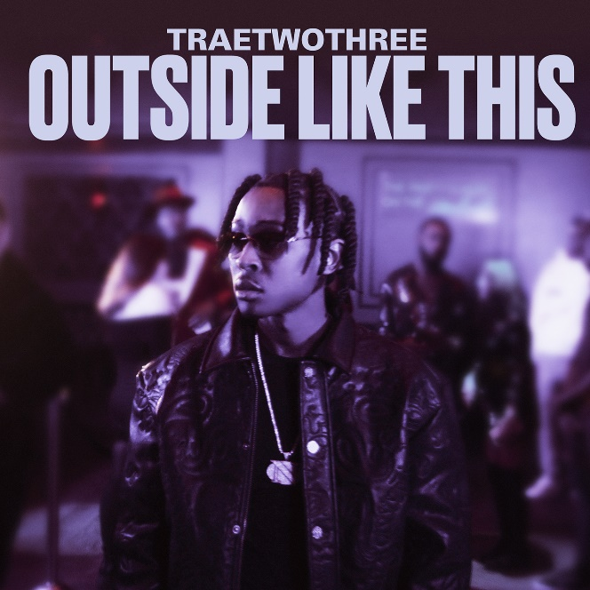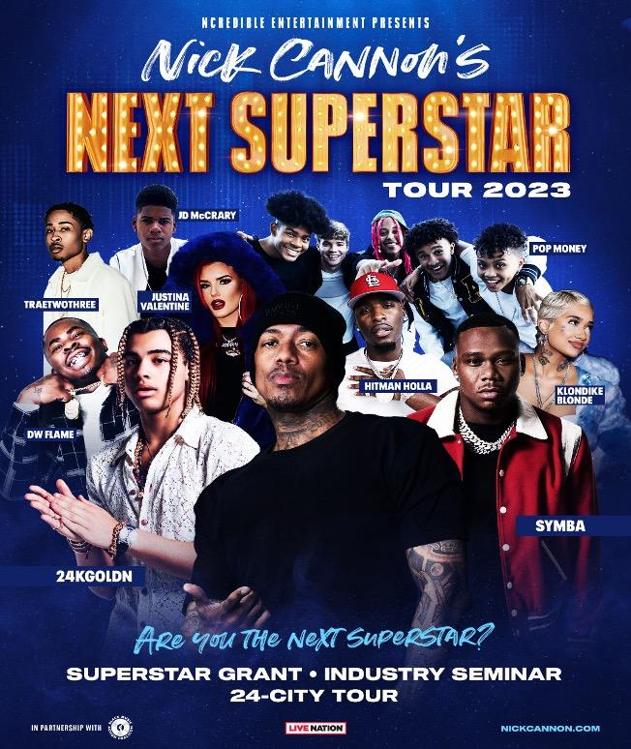
DOWNLOAD HIGH-RES ARTWORK

ABOUT TRAETWOTHREE:
Calm falls over South Central, Los Angeles when the sun goes down. Under the glow of streetlights, the city provides the backdrop for friendship, romance, and growth. It’s a dimension of this neighborhood rarely if ever, depicted in movies, television series, video games, and books, but it’s reality for TRAETWOTHREE. The Crenshaw-raised singer and songwriter invite listeners to sit in the passenger seat as he cruises the place, he proudly calls home and experiences trials, tribulations, and triumphs after dark. As the story goes, he rotated between homes, living with his mom, dad, and grandma. Brought up in a Nigerian-American household, and his parents being Jehovah’s Witnesses, TRAE absorbed faith and a love for a variety of musical genres. He initially found his love of music through his Nigerian roots and today he credits Afrobeat artists Davido, Wizkid and Mufasa among others, for his rich musical influence. Growing up he played saxophone throughout middle school and spun records by the likes of Gerald Albright, David Sanborn, Candy Dulfer, Tank, Tyrese, Erykah Badu, and The Isley Brothers. Embracing Drake, J. Cole, and Nipsey Hussle, he wrote and recorded music in his bedroom at the age of sixteen, fashioning a fresh and fiery perspective on R&B. He serendipitously linked up with Ncredible when team members bought sneakers from him during his part-time gig at Dick’s Sporting Goods. Nick Cannon heard his music and signed him. “TRAETWOTHREE is a fresh new voice in R&B. I have the same feeling about him as I did when I found Kehlani.”
Last year, TRAETWOTHREE also teamed up with Nick Cannon on his THE EXPLICIT TAPE: RAW & B album and embarked on “Nick Cannon Presents: Wild 'N Out” North American arena tour, showing the world a different side of the South Central story with his music. Following the releases of “4am In The District” and “High Tec,” he put up numbers on “Drownin” [feat. Hitman Holla], collecting 650K Spotify streams and close to 500K YouTube views to date. With millions of streams and views under his belt as well as acclaim from The Source and more. After introducing himself and his hometown with the release of his debut project, Out The District [Ncredible/Art@War/Atlantic Records], the R&B Phenomenon is gearing up to take over 2023.
# # #
CONNECT WITH TRAETWOTHREE
FACEBOOK | INSTAGRAM | TWITTER | YOUTUBE

PRESS CONTACT
FAIRLEY MCCASKILL | FAIRLEY.MCCASKILL@ATLANTICRECORDS.COM

