FOR IMMEDIATE RELEASE
FEBRUARY 17, 2023

“FOR WHAT IT’S WORTH”: BRELAND RELEASES STRIKING DUET VERSION OF CHART-CLIMBING SINGLE FEATURING ALANA SPRINGSTEEN

PERFORMING NATIONAL ANTHEM AHEAD OF DAYTONA 500 THIS SUNDAY (2/19)

RETURNING TO C2C COUNTRY TO COUNTRY FESTIVAL IN MARCH

LISTEN HERE

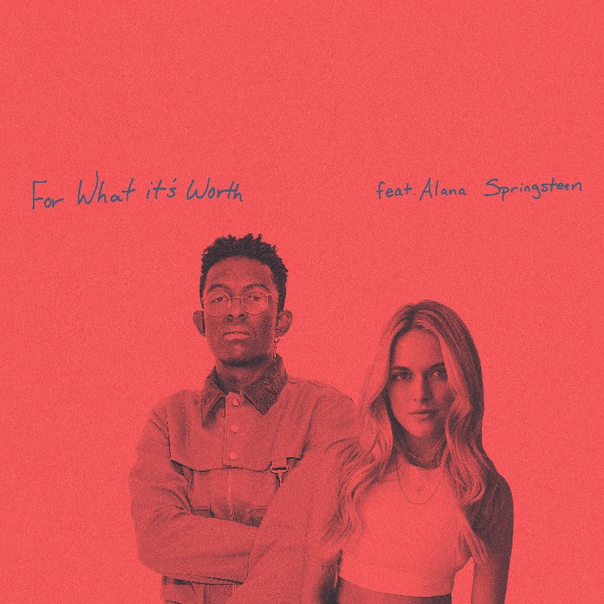
DOWNLOAD HERE
cOURTESY OF bAD REALM RECORDS / ATLANTIC RECORDS / WARNER MUSIC NASHVILLE
ART DESIGN | NADA TAHA (GOOD COP BAD COP)

LOS ANGELES, CA. ( (February 17, 2023) – Bad Realm Records/Atlantic Records/Warner Music Nashville PLATINUM-seller BRELAND and Columbia Records NY/Sony Music Nashville artist-songwriter Alana Springsteen have teamed up for a striking new duet version of BRELAND’s “For What It’s Worth,” adding emotional depth to a too-little-too-late standout. Listen HERE.

The regret-filled track was originally written by BRELAND with Rocky Block, Jacob Durrett and Greylan James for his 2022 album debut, CROSS COUNTRY, but now gets a fresh perspective and a brand-new verse co-written by Springsteen alongside GRAMMY Award-winner Liz Rose that captures the other side of the what-could-have-been anthem.

Featuring gorgeous new harmonies that invoke a once-easy connection, plus an updated Pop-Country sound with tender guitars and subdued drums, the track perfectly expresses the numb feeling when a relationship ends – and the realization it was all your fault. With heavy hearts, the two emerging stars share a moment over what they once had, but ultimately find out you can’t turn back time.

“When I first put out ‘For What It’s Worth,’ the overwhelming response came from women who wished their exes would own up to their mistakes in this way,” BRELAND explains. “I immediately knew a woman’s perspective would take the song to another level. Alana Springsteen is a newer face in Country music, but one that I believe people will be seeing for a long time. She sings some of my favorite breakup songs, and it felt like a natural fit to bring her in on ‘For What It’s Worth.’ Unsurprisingly, she delivered an amazing verse and added the flavor that was needed. Hopefully people appreciate our take on the song the way I do.”

Following the release, BRELAND will supercharge the DAYTONA 500 this Sunday (2/19) as he performs the National Anthem before the 65th running of NASCAR’s premiere event – “The Great American Race.”

Meanwhile, tickets are on sale now for the hit-maker’s second annual “BRELAND & Friends” concert to benefit the Oasis Center on April 4 at Nashville’s Ryman Auditorium. Helping support local at-risk youth, BRELAND will be joined by a star-studded cast including Springsteen, Ashley Cooke, Avery Anna, Danielle Bradbery, Gary Levox, Ingrid Andress, K. Michelle, Nate Smith, Temecula Road, Tenille Townes, X Ambassadors and more.

Looking ahead, BRELAND will continue on a busy tour schedule as he returns to C2C Country to Country Festival in London to play The 02 Arena on March 10, and then support tours for both Walker Hayes and Shania Twain with high-profile festival stops on deck such as Stagecoach Festival, Gulf Coast Jam, Country Fest and Boots and Hearts Music Festival. Check out all of BRELAND’s tour dates here.

ABOUT BRELAND:
With PLATINUM breakout “My Truck,” singer/songwriter/producer BRELAND has emerged as a bold new force on today’s music landscape. The Amazon Music Breakthrough Spotlight Artist first popped off when the Hip-Hop and Country hybrid hit #1 on Spotify’s Global Viral 50 in 2019, and a remix featuring Sam Hunt landed on best-of-the-year lists from NPR to The New York Times. Adding to his 1 BILLION+ career streams, BRELAND’s debut album CROSS COUNTRY is out now and features current chart-climbing single “For What It’s Worth,” plus “Told You I Could Drink (feat. Lady A),” “Natural,” GOLD-certified “Praise The Lord (feat. Thomas Rhett),” GOLD-certified “Throw It Back (feat. Keith Urban)” and title track (feat. Mickey Guyton). Hailed as the “symbol of Country music’s ongoing evolution” (Rolling Stone), the Bad Realm Records/Atlantic Records/Warner Music Nashville artist has scored high profile looks on ABC’s Good Morning America, ABC’s Jimmy Kimmel Live!, CBS Mornings, CBS’ New Year’s Eve Live: Nashville’s Big Bash, CMT Crossroads, NBC’s The Voice, NBC’s TODAY, The Kelly Clarkson Show, plus performances on the ACM, CMT, and CMA Awards. BRELAND has a stacked tour schedule with coveted slots on Walker Hayes' DUCK BUCK TOUR, Stagecoach Festival, and Shania Twain’s QUEEN OF ME TOUR.

ABOUT ALANA SPRINGSTEEN:
Columbia Records NY/Sony Music Nashville artist-songwriter Alana Springsteen is TWENTY SOMETHING. Making her anticipated debut as a three-part album, her first installment, TWENTY SOMETHING: Messing It Up, delivers a bold introduction with “you don’t deserve a country song.” Hailed by Billboard as possessing “a classic female voice packed with angst and determination,” E! News praises “one of Nashville's most buzzworthy emerging artists,” as PEOPLE applauds Springsteen as representing “the future of country music.” Quickly nearing 100 MILLION streams, the 22-year-old is among the Class of 2023 for CMT’s Next Women of Country and MusicRow’s Next Big Thing; Billboard’s January Country Rookie of the Month; a Celebrity Ambassador for the Ryan Seacrest Foundation; and previously named a Country Artist to Watch by Pandora. Next supporting Adam Doleac’s ‘BARSTOOL WHISKEY WONDERLAND’ TOUR, and Luke Bryan’s ‘COUNTRY ON’ TOUR, she’s appeared at the Grand Ole Opry and has already been spotted on the road with Mitchell Tenpenny and LANY.

CONNECT WITH BRELAND
WEBSITE | INSTAGRAM | FACEBOOK | TWITTER | YOUTUBE | SOUNDCLOUD | AMAZON MUSIC

BRELAND PR CONTACTS
Fairley McCaskill / Fairley.McCaskill@atlanticrecords.com
Jensen Sussman / jensen@sweettalkpr.com
Mary Catherine Rebrovick / MaryCatherine@wmg.com

