FOR IMMEDIATE RELEASE
JANUARY 25, 2023

2X GRAMMY AWARD-NOMINATED RAPPER CORDAE KICKS OFF 2023 WITH NEW SINGLE “TWO TENS (FEAT. ANDERSON .PAAK)” WITH PRODUCTION BY J. COLE
ACCOMPANIED BY A COMPANION VISUAL AVAILABLE FOR STREAMING NOW
DOWNLOAD/STREAM “TWO TENS”
WATCH/SHARE “TWO TENS”
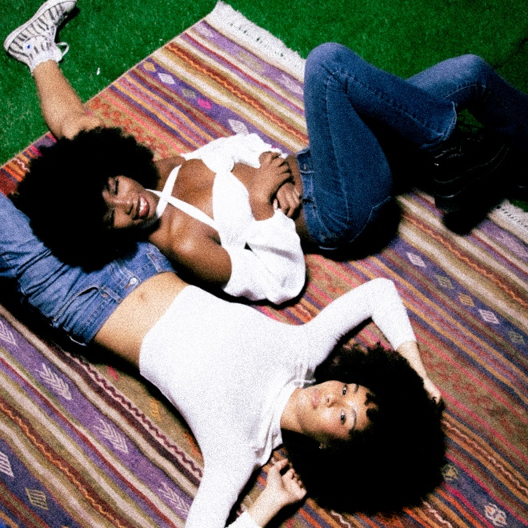
DOWNLOAD HI-RES ARTWORK

2x GRAMMY® Award-nominated rapper Cordae kicks of 2023 with the release of his Anderson .Paak assisted single “Two Tens” with production by the notable J. Cole. The single is accompanied by a companion visual available for streaming now. “Two Tens” is the second collaboration from the rap duo, with their first collab single, “RNP,” certified platinum by the RIAA. “Two Tens” also serves as the follow up to the visual release for “Checkmate” for the Madden NFL 23 Soundtrack. Cordae also recently performed at Juice WRLD Day Festival on 12/8 in Chicago, alongside Trippie Redd, Lil Tecca, and G Herbo.
ABOUT CORDAE
Cordae knows exactly what he wants to say. He chooses his words and phrases carefully. He speaks from a place of truth. That’s why the two-time GRAMMY® Award-nominated gold-selling Maryland-raised rapper has quietly become one of the modern generation’s most trusted narrators. A remarkable life has given him a lot to say. He went from trailer parks and public housing with his mom to stratospheric success. After a series of buzzing singles, he reached critical mass with his 2019 full-length debut, The Lost Boy. It bowed in the Top 15 of the Billboard Top 200 and included four gold-certified singles— “RNP” [feat. Anderson .Paak], “Have Mercy,” “Broke As Fuck,” and “Kung Fu.” Beyond unanimous praise from Billboard, Complex, High Snobiety, New York Times, Pitchfork, and Stereogum, he garnered a pair of GRAMMY® Award nominations in the categories of “Best Rap Album” for The Lost Boy and “Best Rap Song” for “Bad Idea” [feat. Chance the Rapper]. He’s the rare artist whose presence can be felt on-screen in a Super Bowl commercial alongside legendary Academy® Award-winning director Martin Scorsese and among XXL’s coveted “Freshman Class.” Along the way, he linked up with Roddy Ricch and Ant Clemons for “Gifted” as well as joining forces with Eminem for “Killer.” Absorbing wisdom from a life-changing trip to Africa, enduring the loss of a friend gone too soon, and evolving as an artist and a man, he tells this story in widescreen technicolor on his 2022 second full-length offering, From A Birds Eye View [ART@WAR/Atlantic Records]. Cordae followed up the release of his sophomore album with the Facebook exclusive premiere of his visual only, From A Birds Eye View (Live) album. As a follow up, Cordae released the collaborative single “Checkmate” with Hit-Boy from the official EA Sports Madden NFL 23 Soundtrack.

ABOUT ANDERSON .PAAK
Born Brandon Paak Anderson in Oxnard, California, as a teen he played drums in his church Band. His transformation into Anderson .Paak, with his debut album Venice and a sophomore release, 2016's Malibu met with universal rave reviews. .Paak is now an 8x GRAMMY Award winner, producer, songwriter, artist & director. Anderson released his highly regarded 2020 single “Lockdown” on Juneteenth. Inspiration for the song came from .Paak’s participation in a Los Angeles protest against police brutality. .Paak won the GRAMMY Award for Best Melodic Rap Performance of “Lockdown” and the politically charged video directed by Dave Meyers, garnered .Paak a GRAMMY nom for Best Music Video. “Lockdown” was featured on a multitude of “Best Of” 2020 lists from NPR, The FADER, Complex and President Barack Obama’s annual “Favorite Music” list. In October 2020, .Paak was named as Vans’ first ever Global Music Ambassador. The artist has an ongoing partnership with the iconic brand that includes exclusive footwear and accessory collections inspired by .Paak’s Southern California roots. His directing credits now include being named BET’s 2022 Video Director of the Year along with having directed the highly regarded Bonnie and Clyde-esque music video for Leon Bridges’ “Motorbike.” Most recently, .Paak has joined fellow artist Bruno Mars as one half of the R&B superduo, Silk Sonic. The album’s November 12, 2021 release received worldwide critical acclaim and earned the duo 4 Grammy Awards. Anderson .Paak is a multi-hyphenate superstar who will now use his platform to propel new talent into the spotlight with the creation of his very own label APESHIT teaming with UMG.
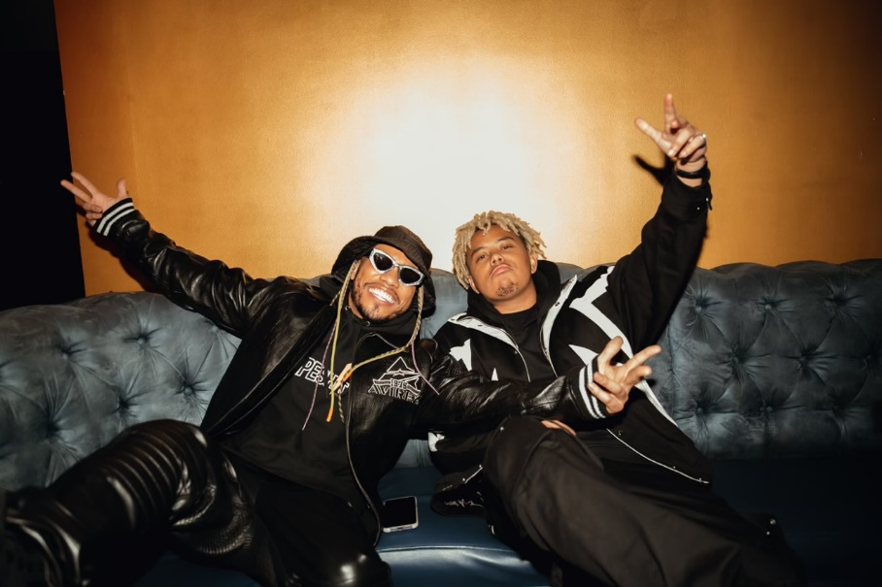
CONNECT WITH CORDAE
INSTAGRAM | YOUTUBE | TWITTER | FACEBOOK

FOR PRESS INQUIRIES
FOR CORDAE SYDNEY.MARGETSON@ATLANTICRECORDS.COM

