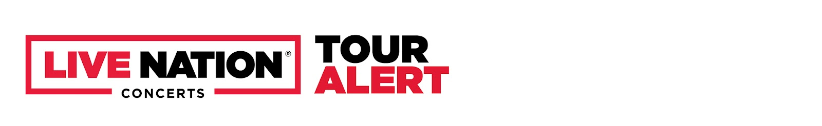
CHARLIE PUTH ANNOUNCES 2023 TOUR
“THE CHARLIE LIVE EXPERIENCE” TO HIT THE U.S. AND CANADA THIS SUMMER

Tickets Available Starting Wednesday, February 15 with Artist Presale

General On Sale Begins Friday, February 17 at 10AM Local Time on LiveNation.com

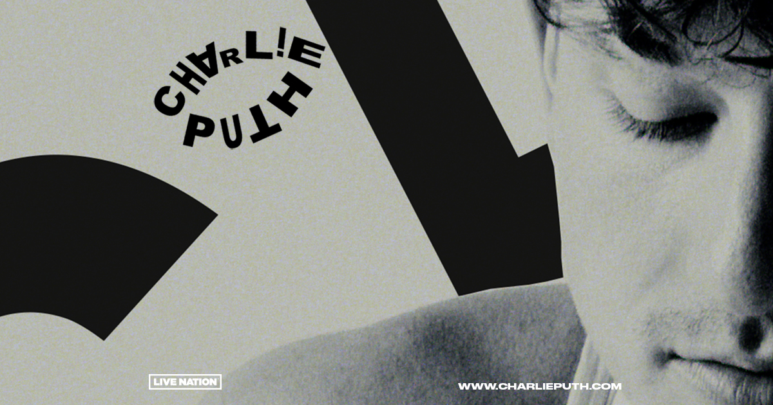
Press Photos

WHO: Charlie Puth
WHAT: Charlie Puth Presents The "Charlie" Live Experience

Today, 4x Grammy-nominated hitmaker Charlie Puth announced he will be embarking on a 2023 tour. Produced by Live Nation, Charlie Puth Presents The "Charlie" Live Experience kicks off on May 24th at The Pavilion at Toyota Music Factory in Dallas making stops across the U.S. and Canada in Atlanta, Miami, New York and more before wrapping up in Los Angeles at The Greek Theatre on July 11th.

TICKETS: Tickets and select VIP packages will be available starting with an Artist Presale beginning Wednesday, February 15th. The general onsale for The “Charlie” Live Experience will start Friday, February 17th at 10AM local time on LiveNation.com.

MORE:
Charlie Puth has proven to be one of the industry’s most consistent hitmakers and sought-after collaborators. Puth has amassed eight multi-platinum singles, four GRAMMY nominations, three Billboard Music Awards, a Critic’s Choice Award, and a Golden Globe nomination. His 2018 GRAMMY-nominated LP, Voicenotes, was RIAA Certified Gold only four days after its release and has logged over 5.6 billion streams worldwide. Recently, Puth released his highly anticipated third studio album CHARLIE via Atlantic Records. Featuring hit singles “Left and Right [feat. Jung Kook of BTS],“That’s Hilarious” and “Light Switch,” the “expertly crafted collection” (ROLLING STONE) has surpassed 1 billion global streams and received critical praise around the world. Following the release of his CHARLIE, Puth set out for his ‘One Night Only’ tour, welcoming fans around the world up close and personal as he shares his latest album and his greatest hits. In 2020, Puth’s collaboration with Gabby Barrett on their “I Hope” Remix earned him his fourth top 10 track on the Billboard Hot 100, hit number one on the Billboard “Adult Pop Songs” chart, and won a 2021 Billboard Music Award for “Top Collaboration.” Puth also co-wrote and produced The Kid Laroi and Justin Bieber’s record-breaking single, “Stay,” which quickly become one of the biggest songs of 2021 and holds the title for the longest-reigning No. 1 on the Billboard Global 200 chart and the first to lead it for double-digits - spending a total of eleven weeks at the top of the chart.

CHARLIE PUTH PRESENTS THE "CHARLIE" LIVE EXPERIENCE TOUR DATES:
* Not a Live Nation Date # On-Sale at Later Date

Saturday, May 20th, 2023 – Tlajomulco de Zúñiga, MEX – Corona Capital Guadalajara*
Wednesday, May 24th, 2023 – Dallas, TX – The Pavilion at Toyota Music Factory
Thursday, May 25th, 2023 – Austin, TX – Moody Amphitheater
Saturday, May 27th, 2023 – Nashville, TN – Ascend Amphitheater
Sunday, May 28th, 2023 – Atlanta, GA – Cadence Bank Amphitheatre at Chastain Park
Wednesday May 31st, 2023 – Miami, FL – FPL Solar Amphitheater at Bayfront Park
Thursday, June 1st, 2023 – Jacksonville, FL – Daily's Place Amphitheater
Saturday, June 3rd, 2023 – Holmdel, NJ – PNC Bank Arts Center
Sunday, June 4th, 2023 – Washington, DC – Wolf Trap*
Tuesday, June 6th, 2023 – Boston, MA – Leader Bank Pavilion
Wednesday, June 7th, 2023 – Gilford, NH – Bank of New Hampshire Pavilion
Friday, June 9th, 2023 – Toronto, ON, CAN – Budweiser Stage
Saturday, June 10th, 2023 – Mashantucket, CT – Premier Theater at Foxwoods Resorts Casino*
Monday, June 12th, 2023 – Charlottesville, VA – Ting Pavilion
Tuesday, June 13th, 2023 – Philadelphia, PA – The Mann Center for the Performing Arts
Thursday, June 15th, 2023 – New York, NY – Radio City Music Hall
Sunday, June 18th, 2023 – Detroit, MI – Meadow Brook Amphitheatre
Monday, June 19th, 2023 – Cincinnati, OH – PNC Pavilion at Riverbend Music Center
Wednesday, June 21st, 2023 – Indianapolis, IN – TCU Amphitheater at White River State Park
Thursday, June 22nd, 2023 – St. Louis, MO – Saint Louis Music Park
Saturday, June 24th, 2023 – Highland Park, IL – Ravinia Festival*#
Sunday, June 25th, 2023 – Minneapolis, MN – The Armory
Tuesday, June 27th, 2023 – Denver, CO – Bellco Theatre
Wednesday, June 28th, 2023 – Salt Lake City, UT – USANA Amphitheatre
Friday, June 30th, 2023 – Ridgefield, WA – RV Inn Style Resorts Amphitheater
Saturday, July 1st, 2023 – Seattle, WA – Venue TBA #
Monday, July 3rd, 2023 – Vancouver, BC, CAN – Doug Mitchell Thunderbird Sports Centre
Thursday, July 6th, 2023 – Berkeley, CA – The Greek Theatre at UC Berkeley*
Saturday July 8th, 2023 – Las Vegas, NV – The Chelsea at the Cosmopolitan*
Sunday, July 9th, 2023 – San Diego, CA – The Rady Shell at Jacobs Park*
Tuesday, July 11th, 2023 – Los Angeles, CA – The Greek Theatre

About Live Nation Entertainment
Live Nation Entertainment (NYSE: LYV) is the world’s leading live entertainment company comprised of global market leaders: Ticketmaster, Live Nation Concerts, and Live Nation Sponsorship. For additional information, visit www.livenationentertainment.com.

MEDIA CONTACTS:

Press Contacts for Charlie Puth:
ID PR, Kelly Bush Novak, Macy Rivet, Amy Morse, Elif Mamak, and Kate Trapani | TeamPuth@id-pr.com

Atlantic Records, Sheila Richman (sheila.richman@atlanticrecords.com) and Ted Sullivan (ted.sullivan@atlanticrecords.com)

Live Nation Concerts
Monique Sowinski | moniquesowinski@livenation.com

To apply for media credentials for show coverage:
livenation.com/pressrequests

