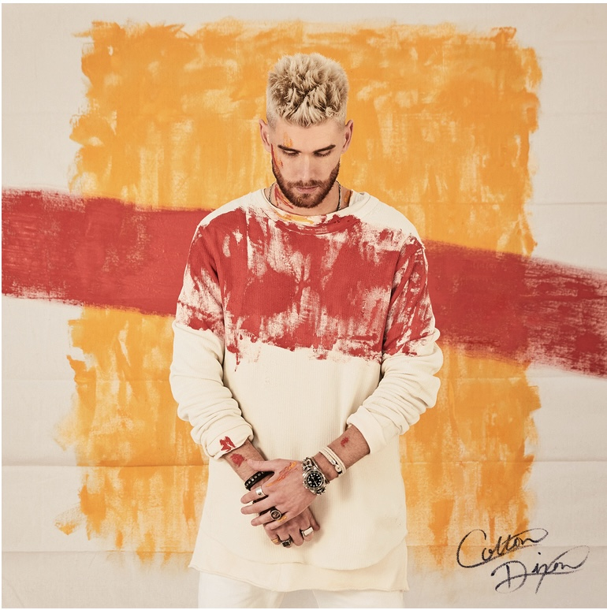

|  |  |
| --- | --- |
| |  | | --- | | **AMERICAN IDOL'S COLTON DIXON TO RELEASE *CANVAS*EP APRIL 28, WITH NEW SINGLE, "MY LIGHT" AVAILABLE TODAY**    **CANVAS *and new track* *follow***  ***"Build A Boat," the longest running No. 1 Mediabase Christian AC song of 2022  Dixon's "Build A Boat Tour" launches March 9th with sold out shows featuring Jordan St. Cyr and special guest Apollo LTD*** | |

|  |  |
| --- | --- |
| |  | | --- | | NASHVILLE, TN... February 24, 2022 - American Idol's Colton Dixon has announced the April 28th release of his 7-song EP, *CANVAS* (Atlantic), for which [pre-orders/pre-saves](https://nam04.safelinks.protection.outlook.com/?url=https%3A%2F%2Ft.e2ma.net%2Fclick%2Fcjpkoh%2Fok245s6b%2F8bxmktb&data=05%7C01%7Ckaty.carmichael%40atlanticrecords.com%7Cf3abc6f436e44c449d0008db1677ffb3%7C8367939002ec4ba1ad3d69da3fdd637e%7C0%7C0%7C638128476871271354%7CUnknown%7CTWFpbGZsb3d8eyJWIjoiMC4wLjAwMDAiLCJQIjoiV2luMzIiLCJBTiI6Ik1haWwiLCJXVCI6Mn0%3D%7C3000%7C%7C%7C&sdata=CK52afaWXzkg%2B3CNp5OnVSkUgKcFHLCsIyC%2BsRnI6nE%3D&reserved=0) are now available. The EP's highly-anticipated new single, ["My Light,"](https://nam04.safelinks.protection.outlook.com/?url=https%3A%2F%2Ft.e2ma.net%2Fclick%2Fcjpkoh%2Fok245s6b%2Fo4xmktb&data=05%7C01%7Ckaty.carmichael%40atlanticrecords.com%7Cf3abc6f436e44c449d0008db1677ffb3%7C8367939002ec4ba1ad3d69da3fdd637e%7C0%7C0%7C638128476871271354%7CUnknown%7CTWFpbGZsb3d8eyJWIjoiMC4wLjAwMDAiLCJQIjoiV2luMzIiLCJBTiI6Ik1haWwiLCJXVCI6Mn0%3D%7C3000%7C%7C%7C&sdata=v0s9s1%2BjWXNFqN%2BArm2wwIOtI1FBPMk%2FTb5QcfLBVgM%3D&reserved=0) launches across all DSPs today along with a [lyric video](https://nam04.safelinks.protection.outlook.com/?url=https%3A%2F%2Ft.e2ma.net%2Fclick%2Fcjpkoh%2Fok245s6b%2F4wymktb&data=05%7C01%7Ckaty.carmichael%40atlanticrecords.com%7Cf3abc6f436e44c449d0008db1677ffb3%7C8367939002ec4ba1ad3d69da3fdd637e%7C0%7C0%7C638128476871271354%7CUnknown%7CTWFpbGZsb3d8eyJWIjoiMC4wLjAwMDAiLCJQIjoiV2luMzIiLCJBTiI6Ik1haWwiLCJXVCI6Mn0%3D%7C3000%7C%7C%7C&sdata=s0vZ8TB6VXfcTNuAwdTVXxa9IbXZ%2BufSGXsGfr2k4%2F0%3D&reserved=0), and will impact radio March 24th.  *CANVAS* and "My Light" follow the biggest song of Dixon's career to-date "Build A Boat," which, at 10 weeks became the longest running No. 1 Mediabase Christian AC song of 2022, also spawning "Build A Boat (feat. Gabby Barrett)," with MULTI-PLATINUM and award-winning Country star Gabby Barrett.  "My Light," was penned by the team behind "Build A Boat," Swedish songwriting team Robin Sternberg and Johan Lindbrant, along with Dixon, Pete Becker, Dan Caplan and Seth Mosley. Produced by Lindbrant and Stjernberg, the track is one Dixon reflects on personally:  “*Over the last couple of years, we’ve all been in a dark place,” he admits. “It was like, ‘Man, I’m not sure if the world will come back’. In my case, I didn’t know if I’d ever tour again. The twins were born in the same year I lost my main source of income—which is touring. It was scary. If I’ve ever been afraid, I know there’s someone who loves me and will guide me through – God is my light, but we all can relate to people in our lives that help strengthen us as well and keep us going.  It’s such a fun song but its message is what I love most about it.*”  In addition to "My Light" and both versions of "Build A Boat," *CANVAS* features four other tunes (full track-listing below), including the anthemic “Giants,” written and produced by Grammy-nominee Joe London (Jason Derulo, Lizzo, Thomas Rhett), the piano-driven “Hold Onto Hope," a fire-filled vocal performance on “Unbreakable," and the delicate title-track, “Canvas."  Speaking of the *CANVAS* EP, Dixon notes how “*Life is all about perspective - how we view the various seasons that life has to offer. The twins are such a blessing, and when they came, we realized how precious life is. One thing I’ve noticed is that life is better lived with others.  Finding someone who brings out the best in you.  Someone who will turn your mess into something beautiful. For me, God has been that constant reminder for our family that we don’t have to walk through this life alone. Every day is a blank canvas to live life to the fullest, and to view the world and the people around us in a new light.*”   Dixon will be touring across the U.S. this spring on his "Build A Boat Tour" featuring Jordan St. Cyr and special guest Apollo LTD.  Hitting approximately 35 cities, several of which are already sold out, the tour will kick off March 9th in Meadville, PA. Initial tour dates are listed below, with more being added soon.  Tickets are now on sale at [ColtonDixon.com](https://nam04.safelinks.protection.outlook.com/?url=https%3A%2F%2Ft.e2ma.net%2Fclick%2Fcjpkoh%2Fok245s6b%2Fkpzmktb&data=05%7C01%7Ckaty.carmichael%40atlanticrecords.com%7Cf3abc6f436e44c449d0008db1677ffb3%7C8367939002ec4ba1ad3d69da3fdd637e%7C0%7C0%7C638128476871271354%7CUnknown%7CTWFpbGZsb3d8eyJWIjoiMC4wLjAwMDAiLCJQIjoiV2luMzIiLCJBTiI6Ik1haWwiLCJXVCI6Mn0%3D%7C3000%7C%7C%7C&sdata=E3xCGCWwY2J7cUw1ZALxWcv4ltBBH7bt9T9p2QGfLqQ%3D&reserved=0).    *CANVAS* Track Listing:  1. *Build a Boat*  2.*My Light*  3. *Giants*  4. *Canvas*  5.*Hold on to Hope*  6. *Unbreakable*  7. *Build a Boat ft. Gabby Barrett* | |

|  |  |
| --- | --- |
| |  | | --- | | **Colton Dixon: "Build a Boat Tour" (*all dates subject to change):**  3/9/23             Meadville, PA  3/10/23           Bedford, NH  **SOLD OUT**  3/11/23           Williston, VT  **SOLD OUT**  3/12/23           North Attleborough, MA  3/14/23           Colonial Beach, VA ^*  3/16/23           Myrtle Beach, SC *  3/17/23           Rustburg, VA *  3/18/22           Laurinburg, NC *  3/22/23           Independence, MO  3/23/23           Steelville, MO  3/24/23           Willow Springs, MO  **SOLD OUT**  3/25/23           Fayetteville, AR  3/26/23           McKenzie, TN  **SOLD OUT**  3/30/23           Eustis, FL  3/31/23           Sebastian, FL  **SOLD OUT**  4/1/23             Milton, FL **  4/2/23             Buford, GA  4/13/23           West Lebanon, IN  4/14/23           Marshalltown, IA  4/15/23           Mora, MN  4/16/23           Quincy, IL  4/20/23           Port Huron, MI ^  4/21/23           Toledo, OH  4/22/23           Perry Hall, MD  4/23/23           Clarksburg, WV ^  4/27/23           Ringgold, GA **  4/28/23           Anderson, IN  4/30/23           Oak Ridge, TN  5/5/23             Mt. Pleasant, TX ***  5/6/23             Graham, TX ***  5/7/23             Andrews, TX ***  5/9/23             Montrose, CO  5/10/23           Pueblo, CO  5/11/23           Santa Fe, NM ^  5/13/23           Mansfield, TX               ^tickets coming soon               *Apollo LTD not on this date               **Jordan St Cyr not on this date                     ***Alexander Pappas filling in for Jordan St Cyr | |

|  |  |
| --- | --- |
| |  | | --- | | **ABOUT COLTON DIXON:**  Colton Dixon turns personal truths, stories, and experiences into universal anthems. He first emerged as a phenomenon after finishing in the top seven on Season 11 of Fox’s American Idol. Delivering a series of fan favorite albums, 2013’s *A Messenger*achieved “the biggest first-week sales by a new solo Christian act” and catapulted into the Top 15 of the *Billboard* 200 and #1 on the *Billboard*Christian Albums Chart, not to mention, joining the iconic company of Harry Connick, Jr. and Billy Joel as a Steinway & Sons artist. A year later, *Anchor* yielded his third and fourth #1 hits on Christian Hot AC with “More of You” and “Through It All.” In 2017, he returned to #1 on the Christian Albums Chart for the third time. He has collected a pair of Dove Awards in the categories of “Rock/Contemporary Album” and “Recorded Music Packaging.”  Following an invite from the White House, he also shined at the 2019 National Christmas Tree Lighting Ceremony in addition to performing on *Good Morning America*, *Entertainment Tonight*and in the pages of *People*magazine. During 2020, he embarked on a new chapter with Atlantic Records ignited by the self-titled *Colton Dixon EP* and runaway hit “Miracles”—one of his most popular tracks to date. 2022 saw him make his show-stopping debut at the Grand Ole Opry in the midst of kicking off another era, and experiencing a creative breakthrough with “Build A Boat.” Between the original and duet version with multiplatinum country songstress Gabby Barrett, it reeled in over 20 million streams. It stood out as “the longest running Mediabase Christian AC #1 song of 2022” and locked down #1 on the *Billboard* Hot Christian Songs Chart and Christian AC Airplay Chart. *People*premiered the accompanying music video and hailed it as “inspiring” for its depiction of the work of medical charity Mercy Ships. Now, Dixon captivates once again on his 2023 EP, *Canvas* [Atlantic Records], introduced by the single “My Light.”  GET CONNECTED WITH COLTON DIXON: [WEBSITE](https://nam04.safelinks.protection.outlook.com/?url=https%3A%2F%2Ft.e2ma.net%2Fclick%2Fcjpkoh%2Fok245s6b%2F0h0mktb&data=05%7C01%7Ckaty.carmichael%40atlanticrecords.com%7Cf3abc6f436e44c449d0008db1677ffb3%7C8367939002ec4ba1ad3d69da3fdd637e%7C0%7C0%7C638128476871271354%7CUnknown%7CTWFpbGZsb3d8eyJWIjoiMC4wLjAwMDAiLCJQIjoiV2luMzIiLCJBTiI6Ik1haWwiLCJXVCI6Mn0%3D%7C3000%7C%7C%7C&sdata=Hq31R7Diaz7IX4og0Z%2B9rni6sL1VbPlFmqBfMhaM95o%3D&reserved=0)| [TWITTER](https://nam04.safelinks.protection.outlook.com/?url=https%3A%2F%2Ft.e2ma.net%2Fclick%2Fcjpkoh%2Fok245s6b%2Fga1mktb&data=05%7C01%7Ckaty.carmichael%40atlanticrecords.com%7Cf3abc6f436e44c449d0008db1677ffb3%7C8367939002ec4ba1ad3d69da3fdd637e%7C0%7C0%7C638128476871271354%7CUnknown%7CTWFpbGZsb3d8eyJWIjoiMC4wLjAwMDAiLCJQIjoiV2luMzIiLCJBTiI6Ik1haWwiLCJXVCI6Mn0%3D%7C3000%7C%7C%7C&sdata=5X6Ff0yAguN%2FgiqduLFaut8VaJlCR5oqdabrOt0gLPk%3D&reserved=0)| [FACEBOOK](https://nam04.safelinks.protection.outlook.com/?url=https%3A%2F%2Ft.e2ma.net%2Fclick%2Fcjpkoh%2Fok245s6b%2Fw21mktb&data=05%7C01%7Ckaty.carmichael%40atlanticrecords.com%7Cf3abc6f436e44c449d0008db1677ffb3%7C8367939002ec4ba1ad3d69da3fdd637e%7C0%7C0%7C638128476871271354%7CUnknown%7CTWFpbGZsb3d8eyJWIjoiMC4wLjAwMDAiLCJQIjoiV2luMzIiLCJBTiI6Ik1haWwiLCJXVCI6Mn0%3D%7C3000%7C%7C%7C&sdata=ILTOK8H17x3C4OhKXZgKiAfbALagfa3L238i%2FBDLeAY%3D&reserved=0)| [YOUTUBE](https://nam04.safelinks.protection.outlook.com/?url=https%3A%2F%2Ft.e2ma.net%2Fclick%2Fcjpkoh%2Fok245s6b%2Fcv2mktb&data=05%7C01%7Ckaty.carmichael%40atlanticrecords.com%7Cf3abc6f436e44c449d0008db1677ffb3%7C8367939002ec4ba1ad3d69da3fdd637e%7C0%7C0%7C638128476871271354%7CUnknown%7CTWFpbGZsb3d8eyJWIjoiMC4wLjAwMDAiLCJQIjoiV2luMzIiLCJBTiI6Ik1haWwiLCJXVCI6Mn0%3D%7C3000%7C%7C%7C&sdata=ybb0MSzuXQTatK%2F6O%2FKnInAMf0l5olH7E3gApdGrQ50%3D&reserved=0)| [TIKTOK](https://nam04.safelinks.protection.outlook.com/?url=https%3A%2F%2Ft.e2ma.net%2Fclick%2Fcjpkoh%2Fok245s6b%2Fsn3mktb&data=05%7C01%7Ckaty.carmichael%40atlanticrecords.com%7Cf3abc6f436e44c449d0008db1677ffb3%7C8367939002ec4ba1ad3d69da3fdd637e%7C0%7C0%7C638128476871427589%7CUnknown%7CTWFpbGZsb3d8eyJWIjoiMC4wLjAwMDAiLCJQIjoiV2luMzIiLCJBTiI6Ik1haWwiLCJXVCI6Mn0%3D%7C3000%7C%7C%7C&sdata=2Y7ct1OG2wWNGEgIThPozsJ8dmjz%2BIV9Lr1pzu2eLGw%3D&reserved=0)| [INSTAGRAM](https://nam04.safelinks.protection.outlook.com/?url=https%3A%2F%2Ft.e2ma.net%2Fclick%2Fcjpkoh%2Fok245s6b%2F8f4mktb&data=05%7C01%7Ckaty.carmichael%40atlanticrecords.com%7Cf3abc6f436e44c449d0008db1677ffb3%7C8367939002ec4ba1ad3d69da3fdd637e%7C0%7C0%7C638128476871427589%7CUnknown%7CTWFpbGZsb3d8eyJWIjoiMC4wLjAwMDAiLCJQIjoiV2luMzIiLCJBTiI6Ik1haWwiLCJXVCI6Mn0%3D%7C3000%7C%7C%7C&sdata=mW07SpjJFRhaCV8PNo5IfoV9mnb3ZI5Mzo1HDBK9Dqc%3D&reserved=0) | |

|  |  |
| --- | --- |
| |  | | --- | | **Media Collective Contact:**  Velvet Kelm  the media collective [velvet@themcollective.com](mailto:velvet@themcollective.com) (615) 591-7989 [www.themcollective.com](http://www.themcollective.com) | |