FOR IMMEDIATE RELEASE
FEBRUARY 17, 2023

DON TOLIVER ANNOUNCES NEW ALBUM LOVE SICK
DUE TO RELEASE FEBRUARY 24TH
+
DROPS SECOND NEW TRACK OF THE WEEK
“LEAVE THE CLUB (FEAT. LIL DURK & GLORILLA)”

ANNOUNCEMENT FOLLOWS THE ARRIVAL OF “4 ME (FEAT. KALI UCHIS)”
RELEASED EARLIER THIS WEEK

EAGERLY AWAITED NEW PROJECT
WILL ARRIVE WITH SPECIAL SHORT FILM VIA AMAZON PRIME VIDEO

WATCH TRAILER HERE | PRE-SAVE LOVE SICK HERE

US LIVE SCHEDULE INCLUDES SALT LAKE CITY, UT’S CACTUS JACK NBA ALL-STAR WEEKEND CONCERT SERIES AND INGLEWOOD, CA’S ROLLING LOUD CALIFORNIA

“LEAVE THE CLUB (FEAT. LIL DURK & GLORILLA)” AND “4 Me (FEAT. KALI UCHIS)”
BOTH AVAILABLE NOW VIA CACTUS JACK/ATLANTIC

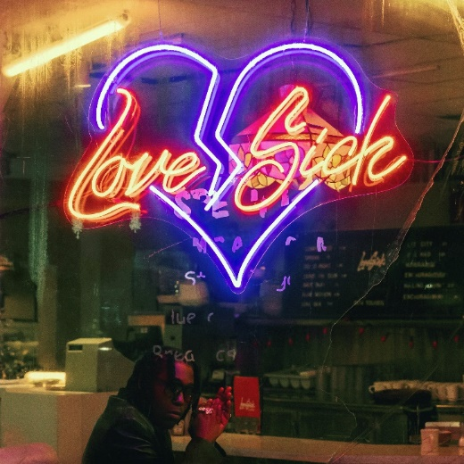
DOWNLOAD ALBUM ARTWORK

Hip-hop soul singer Don Toliver is continuing to kick off his new era with today’s arrival of his latest single, “Leave The Club (Feat. Lil Durk & GloRilla),” available now via Cactus Jack/Atlantic at all DSPs and streaming services. Digging back into his soulful upbringing, Don displays his artistic evolution with the announcement of his upcoming album, Love Sick. Directed by Alexandre Moors, the track is paired alongside a short film trailer.

“Leave The Club (Feat. Lil Durk & GloRilla)” marks Don Toliver’s second new release of the week following the Valentine’s Day celebratory single “4 Me (Feat. Kali Uchis),” highlighted by a sample from Beenie Man’s “Girls Dem Sugar (Feat. Mya).” Both “Leave The Club” and “4 Me” herald the hip-hop crooner’s hugely anticipated new project, Love Sick, illustrated through a short film via Amazon Prime Video. Watch the trailer HERE.

Don Toliver will celebrate his new music with festival appearances at such upcoming events as the Cactus Jack NBA All-Star Weekend Concert Series (set for this Saturday, February 18 at Salt Lake City, UT’s The Depot) and Inglewood, CA’s Rolling Loud California (Saturday, March 4).

Last year saw Don Toliver earn internationally applause with “Do It Right.” Hailed by CLASH as “a ready-made anthem, it’s bouncy funk fueled by a sample of the S.O.S Band’s classic ‘Take Your Time (Do It Right),’” the track is joined by glitterball-powered official visual, presented by Cactus Jack/Amazon Music/Rotation, directed by award-winning French filmmaker Alexandre Moors (Kendrick Lamar, Juice WRLD, Miley Cyrus) and now boasting close to 9M views at YouTube HERE.

In addition, Don Toliver was featured in Rihanna’s Savage X Fenty Show Vol. 4, performing a scintillating medley of “Do It Right” and “Way Bigger,” the latter of which originally appears on his critically acclaimed sophomore album, 2021’s Life of a DON. The star-studded annual fashion experience can be viewed exclusively on Prime Video HERE.

Indeed, 2022 marked a landmark year for Don Toliver, with high profile features including SZA’s “Used,” Justin Bieber’s “Honest,” Kid Cudi’s “Somewhere To Fly” and “Burrow,” Baby Keem’s “Killstreaks,” Trippie Redd’s “Ain’t Safe,” and Wizkid’s “Special,” to name just a few. Released October 2021, Life of a DON made a spectacular chart debut upon its arrival, landing at #2 on Billboard’s “Top R&B/Hip-Hop Albums” and the Billboard 200 – Toliver's second US top 10 debut on the overall chart and highest charting album to date. Life of a DON includes such hit singles as “Drugs N Hella Melodies (Feat. Kali Uchis),” “Way Bigger,” “Flocky Flocky (Feat. Travis Scott),” and the RIAA gold certified “What You Need,” all of which are joined by dramatic visuals that have earned a combined 60M+ views via the official Don Toliver YouTube channel HERE.

ABOUT DON TOLIVER:
Soul singer, songwriter, and artist Don Toliver has earned worldwide attention for a unique sound that calls out his myriad musical influences of hip-hop, smoked-out R&B, ambitious pop, and even a bit of rock ‘n’ roll, creating a genre-bending lane of his own. After the 2018 mixtape Donny Womack, the Houston, TX native assembled his full-length debut, Heaven Or Hell, which claimed spots on mid-year and year-end lists by Complex and XXL, while Rolling Stone championed him among the “10 Biggest Breakthrough Artists of 2020.” Don then joined forces with Internet Money, NAV, and Gunna for the 4x platinum banger “Lemonade,” which they also performed on NBC’s The Tonight Show Starring Jimmy Fallon. 2021 saw Don team with Lil Durk and Latto for “Fast Lane,” the lead track on Atlantic Records’ F9: The Fast Saga (Original Motion Picture Soundtrack), followed by the blockbuster release of Life of a DON, once again showcasing his fluid ability to exist in multiple soundscapes and featuring production by Mike Dean, Hit-Boy, Mustard, and more. Through it all, he has gathered billions of streams, scored platinum plaques, and received praise courtesy of everybody from such media outlets as V MAN, W Magazine, Interview, and more. 2023 now marks a spectacular new era for Don and his fans around the world as he embarks on his most exciting musical journey thus far. Stay tuned…

DON TOLIVER 2023
Live Performances

FEBRUARY
18 – Salt Lake City, UT – Cactus Jack NBA All–Star Weekend Concert Series

MARCH
4 – Inglewood, CA – Rolling Loud California

# # #
CONNECT WITH DON TOLIVER
OFFICIAL I INSTAGRAM| TWITTER |FACEBOOK |YOUTUBE

PRESS CONTACT:
Brittany Bell, Brittany.Bell@atlanticrecords.com

