FOR IMMEDIATE RELEASE
FEBRUARY 22, 2023

rising alt-pop star daniel leggs shares runaway

long-awaited debut EP wraps up acclaimed series of monthly new music releases

highlights include the brand new “parasite”
alongside fan favorites “gatsby,” “runaway” and viral smash, “crutches”

runaway available now via Overall Recordings/Atlantic Records
listen to runaway here
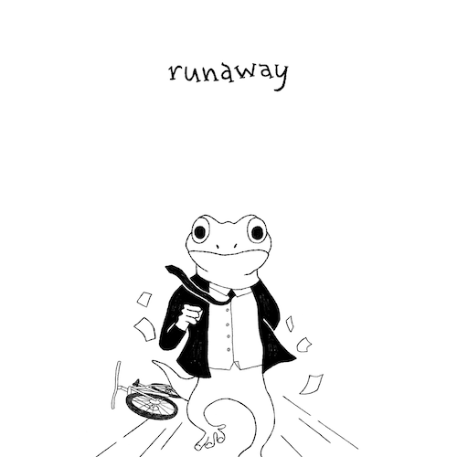
DOWNLOAD HI-RES ARTWORK

Rising alt-pop singer-songwriter-producer Daniel Leggs is celebrating his signing to Overall Recordings/Atlantic Records with today’s release of his long-awaited debut EP, runaway, available now at all DSPs and streaming services.

The final installment in a remarkable series of new releases unveiled on the 22nd of each month, runaway collects warm-hearted tracks like the previously unheard “parasite” alongside such fan favorites as “sausalito,” “gatsby,” “stay in my dreams,” “ticket home” (co-written with 6x RIAA platinum-certified singer-songwriter Garrett Nash), and the viral favorite, “crutches,” the latter of which is joined by a whimsical animated music video streaming HERE.

“This project is super honest,” says Daniel Leggs. “For me, the music is about relating to people and then entertaining them with the quirky storybook we’ve created. It’s like Harold and the Purple Crayon…but if it wasn’t a kid’s book. One thing I love about ‘parasite,’ ‘crutches,’ and the EP as a whole is that there are wild ups and downs. Sometimes the music feels sad, but then there’s always this general feeling of hope. That’s just how being young and figuring things out is. Sometimes things aren’t so hot, and sometimes you feel like the world is yours. Hope everyone enjoys listening through!”

In a world of emotional uncertainty, music is the only thing Daniel Leggs is sure of. Growing up as a concert-trained pianist too shy to express himself in daily life beyond gratitude and kindness, the 23-year-old tunesmith has found himself via a series of intimate, ingenious pop ditties which expertly capture the ups, the downs, the heartbreak, and longing for something more of a gifted young artist making his way in 21st Century New York City. Written, recorded, mixed, and mastered in a central Rhode Island basement studio, Leggs’ budgeted studio model produces a distinctive sound that combines relatable lyrics with experimental imperfections to manifest something beautiful and all his own.

Leggs kicked off 2023 with his most tender track to date, “last one standing,” joined by an official live performance video – filmed in Daniel’s kitchen – streaming now at YouTube HERE. Now, with the arrival of his Overall/Atlantic debut EP, Daniel Leggs is telling the runaway story of his daydreams, one perfect pop song at a time.

# # #

Daniel Leggs - runaway
(Overall Recordings/Atlantic Records)

TRACKLIST:
1. sausalito
2. runaway
3. different man
4. crutches
5. stay in my dreams
6. parasite
7. ticket home

# # #

DOWNLOAD HI-RES IMAGE
PHOTO CREDIT: AUDREY BERGERON
CONNECT WITH DANIEL LEGGS
OFFICIAL | INSTAGRAM | SOUNDCLOUD | TIKTOK | TWITTER | YOUTUBE

For press inquiries, please contact:
Jessica Nall // Jessica.Nall@atlanticrecords.com

