DEATH CAB FOR CUTIE RELEASES “FOXGLOVE THROUGH THE CLEARCUT (ACOUSTIC)” – LISTEN HERE

ASPHALT MEADOWS (ACOUSTIC) DUE OUT MARCH 10

“PEPPER” CLIMBING RADIO CHARTS – #3 AT TRIPLE A & #15 AT ALTERNATIVE – AFTER DEBUTING AS #1 MOST ADDED AT BOTH FORMATS

20TH ANNIVERSARY CO-HEADLINE TOUR WITH THE POSTAL SERVICE KICKS OFF SEPT. 5 – THIRD NIGHT ADDED IN DENVER + DATES ADDED THROUGHOUT TEXAS

BUILT TO SPILL + IRON & WINE WILL EACH OPEN ONE OF THE HOLLYWOOD BOWL SHOWS (OCT 15 + 17)

WARPAINT + THE BETHS SET TO SUPPORT ON OTHER SELECT DATES

UK/EU ASPHALT MEADOWS TOUR KICKS OFF MARCH 5 IN COPENHAGEN; NORTH AMERICAN DATES CONTINUE MAY-JUNE

PRE-SAVE ASPHALT MEADOWS (ACOUSTIC) HERE
PRE-ORDER ASPHALT MEADOWS (ACOUSTIC) ON VINYL HERE
BUY/STREAM ASPHALT MEADOWS HERE

“Twenty-five years into its career, the band brings its incisive, anguished writing to a particularly 2022 brand of existential angst on its 10th album, ‘Asphalt Meadows’… an expansive album…” – THE NEW YORK TIMES

“If you haven’t heard yet, Death Cab for Cutie is back back… [their] best album in over a decade...” – VULTURE

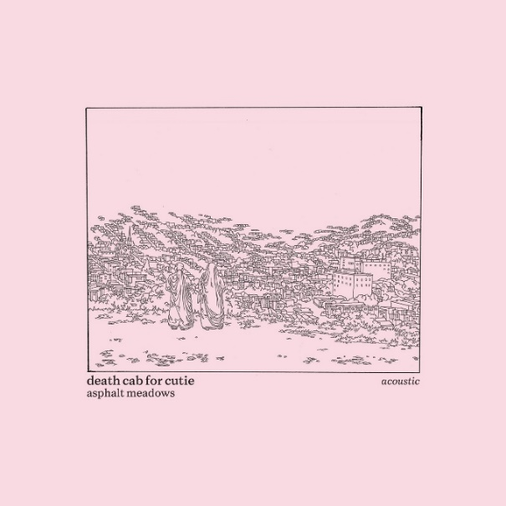
download hi-res acoustic album artwork here

8x GRAMMY® Award-nominated rock band Death Cab for Cutie has released “Foxglove Through The Clearcut (Acoustic)” (listen here), the latest offering from their forthcoming LP, Asphalt Meadows (Acoustic). The new record – due out March 10th (pre-save here) – is a stripped-down take on the band’s critically acclaimed 10th studio album ‘Asphalt Meadows,’ released this past September via Atlantic Records.

Co-produced by Andy Park (Pedro the Lion, Joseph, Noah Gunderson) and Death Cab for Cutie, Asphalt Meadows (Acoustic) is now available to pre-order on vinyl here.

The original iteration of “Foxglove Through The Clearcut” was released to immediate critical acclaim last August, with Vulture declaring the semi-spoken word opus as one of “The Best Songs of 2022 (So Far)” and The Daily Beast expounding upon this idea, sharing, “The consensus… about ‘Foxglove Through The Clearcut’ is that it may already be one of Death Cab’s best songs.”

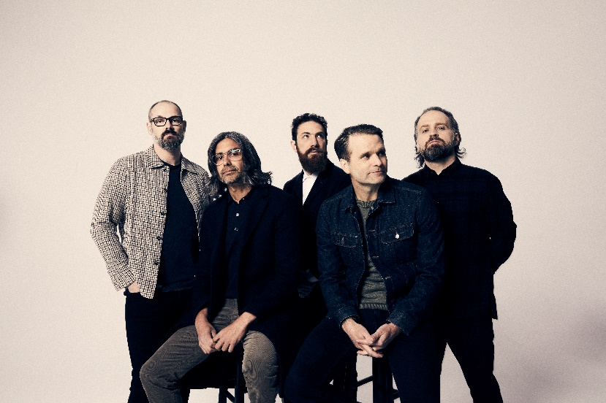
download hi-res press photo here; credit: Jimmy Fontaine

Today, Death Cab for Cutie and The Postal Service have also announced three new dates on their highly-anticipated co-headline tour, celebrating the 20th anniversaries of each band’s seminal 2003 record – Transatlanticism and Give Up, respectively – and set for September-October 2023.

The iconic bands, both fronted by lead vocalist and guitarist Ben Gibbard, have added a third night in Denver, CO at Mission Ballroom, as well as brand new dates in Austin, TX and Grand Prairie, TX. Pre-sales for these three shows will begin on Wednesday, March 1st at 10am (local); general onsale will begin on Friday, March 3rd at 10am (local) – sign up for early access to tickets here.

Additionally, Warpaint and The Beths have been added as support on select dates, while Built to Spill is set to support the second LA show at the Hollywood Bowl [October 15th] and Iron & Wine – known for their beloved rendition of The Postal Service’s “Such Great Heights” – will kick off the third and final Hollywood Bowl date [October 17th], which will also mark the culmination of the historic tour.

Having been named one of GQ’s “12 Pop Culture Releases We’re Most Looking Forward to in 2023” and of the “23 concerts and albums” the Los Angeles Times is “most excited for in 2023,” the previously-announced co-headline tour dates are almost entirely sold-out [full routing for all upcoming dates enclosed below].

All upcoming ticketing information can be accessed here – including Death Cab for Cutie’s UK/EU run in support of Asphalt Meadows, which begins March 5th in Copenhagen and includes stops in Berlin, Amsterdam, Dublin, and London, among many other cities. The third North American leg of the Asphalt Meadows tour will commence May 31st in Indianapolis.

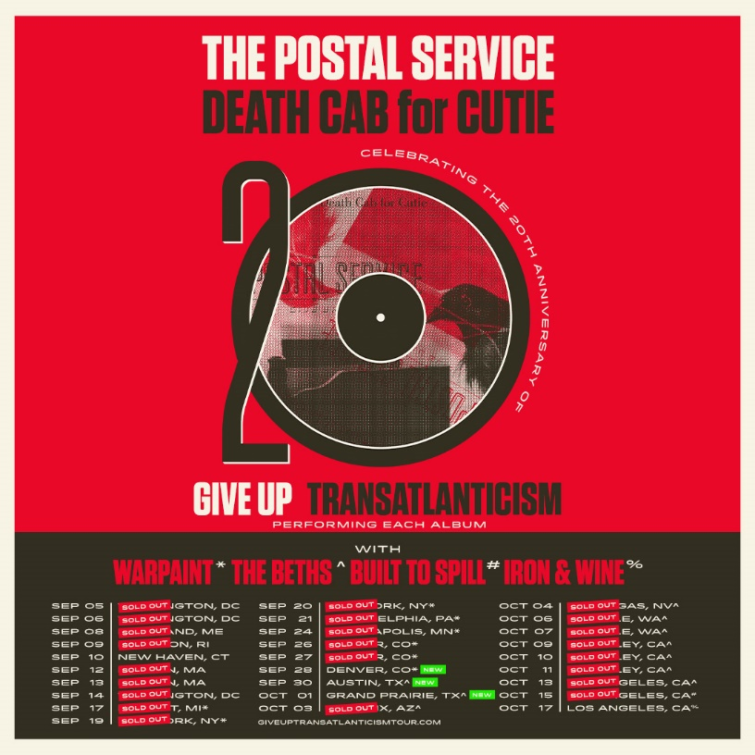
download hi-res admat here

Alongside last month’s announcement of the 12-track acoustic LP, Death Cab for Cutie shared a rework of standout album track “Pepper” as well as a moving cover of “The Plan” (listen here) – released in tribute to the late Mimi Parker, their close friend and drummer for the iconic band Low.

Also last month, the five-piece shared the stunning lyric video for the original studio version of “Pepper” (watch here), directed by frequent visual collaborator Juliet Bryant (Justin Vernon, Japanese Breakfast, Laura Jane Grace). And upon debuting at radio in mid-January, the track became the most added song at both the Alternative and Triple A formats. Since then, it has quickly ascended to #3 at Triple A and #15 at Alternative radio and continues to rise.

In addition to Death Cab for Cutie’s acoustic album and the band’s latest touring news, Gibbard recently wrote and recorded the original theme song for Apple TV+’s newest comedy series, ‘Shrinking.’ Performed by Gibbard and co-written with award-winning composer Tom Howe, “Frightening Fishes (Main Title Theme)” (listen here) will score each episode’s opening credits. ‘Shrinking’ stars Jason Segel and Harrison Ford, and was created by Bill Lawrence (Ted Lasso, Scrubs).

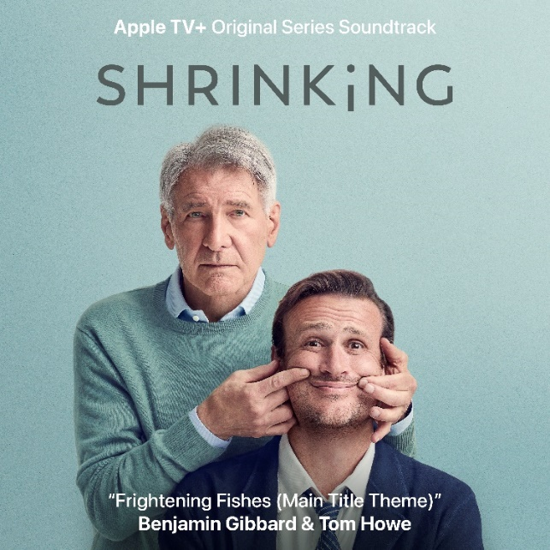
download hi-res single artwork here

***

ASPHALT MEADOWS (ACOUSTIC) – TRACKLIST:
- I Don’t Know How I Survive (Acoustic)
- Roman Candles (Acoustic)
- Asphalt Meadows (Acoustic)
- Rand McNally (Acoustic)
- Here to Forever (Acoustic)
- Foxglove Through The Clearcut (Acoustic)
- Pepper (Acoustic)
- I Miss Strangers (Acoustic)
- Wheat Like Waves (Acoustic)
- Fragments From the Decade (Acoustic)
- I’ll Never Give Up On You (Acoustic)
- The Plan

***

DEATH CAB FOR CUTIE | 2023 ASPHALT MEADOWS HEADLINE TOUR DATES

MARCH
5 – Copenhagen, Denmark – Den Grå Hal *
6 – Stockholm, Sweden – Filadelfia * – LOW TICKETS
7 – Oslo, Norway – Sentrum Scene *
9 – Berlin, Germany – Columbiahalle *
10 – Tilburg, Netherlands – 013 *
11 – Amsterdam, Netherlands – Paradiso * – SOLD OUT
12 – Cologne, Germany – E-Werk * – LOW TICKETS
14 – Antwerp, Belgium – De Roma * – LOW TICKETS
15 – Luxembourg, Luxembourg – Den Atelier *
16 – Paris, France – Salle Pleyel *
18 – Nottingham, United Kingdom – Rock City * – LOW TICKETS
19 – Dublin, Ireland – Bord Gáis Energy Theatre * – LOW TICKETS
21 – Birmingham, United Kingdom – O2 Institute *
22 – Edinburgh, United Kingdom – Usher Hall *
23 – Glasgow, United Kingdom – Barrowland * – LOW TICKETS
25 – Manchester, United Kingdom – O2 Apollo *
27 – Brighton, United Kingdom – Dome *
28 – London, UK – Roundhouse * – LOW TICKETS
29 – London, United Kingdom – Royal Albert Hall * – LOW TICKETS

MAY
31 – Indianapolis, IN – TCU Amphitheater at White River State Park ^

JUNE
2 – Toronto, ON – Massey Hall ^ – LOW TICKETS
3 – Toronto, ON – Massey Hall ^ – LOW TICKETS
4 – Cleveland, OH – Agora Theatre ^ – SOLD OUT
6 – Milwaukee, WI – Riverside Theater ^
7 – Omaha, NE – The Admiral ^ – SOLD OUT
9 – Salt Lake City, UT – Venue TBA ^
10 – Missoula, MT – KettleHouse Amphitheater ^
12 – Calgary, AB – Grey Eagle Resort and Casino – Grey Eagle Event Centre ^ – SOLD OUT
14 – Vancouver, BC – Commodore Ballroom – SOLD OUT
15 – Vancouver, BC – Commodore Ballroom – SOLD OUT
16 – Troutdale, OR – McMenamins Edgefield Amphitheatre ^ – SOLD OUT
17 – Bend, OR – Hayden Homes Amphitheater ^

DEATH CAB FOR CUTIE x THE POSTAL SERVICE | 2023 CO-HEADLINE TOUR DATES

SEPTEMBER
5 – Washington, DC – The Anthem – SOLD OUT
6 – Washington, DC – The Anthem – SOLD OUT
8 – Portland, ME – Cross Insurance Arena – SOLD OUT
9 – Kingston, RI – Ryan Center – SOLD OUT
10 – New Haven, CT – Westville Music Bowl – LOW TICKETS
12 – Boston, MA – MGM Music Hall at Fenway – SOLD OUT
13 – Boston, MA – MGM Music Hall at Fenway – SOLD OUT
14 – Washington, DC – Merriweather Post Pavilion – SOLD OUT
17 – Detroit, MI – Meadow Brook Amphitheater # – SOLD OUT
19 – New York, NY – Madison Square Garden # – SOLD OUT
20 – New York, NY – Madison Square Garden # – SOLD OUT
21 – Philadelphia, PA – Mann Center for the Performing Arts # – SOLD OUT
24 – Minneapolis, MN – The Armory # – SOLD OUT
26 – Denver, CO – Mission Ballroom # – SOLD OUT
27 – Denver, CO – Mission Ballroom # – SOLD OUT
28 – Denver, CO – Mission Ballroom #
30 – Austin, TX – Germania Insurance Amphitheater &

OCTOBER
1 – Grand Prairie, TX – Texas Trust CU Theatre &
3 – Phoenix, AZ – Arizona Financial Theatre & – SOLD OUT
4 – Las Vegas, NV – The Theater at Virgin Hotels & – SOLD OUT
6 – Seattle, WA – Climate Pledge Arena & – SOLD OUT
7 – Seattle, WA – Climate Pledge Arena & – SOLD OUT
9 – Berkeley, CA – Greek Theatre – UC Berkeley & – SOLD OUT
10 – Berkeley, CA – Greek Theatre – UC Berkeley & – SOLD OUT
11 – Berkeley, CA – Greek Theatre – UC Berkeley & – SOLD OUT
13 – Los Angeles, CA – Hollywood Bowl & – SOLD OUT
15 – Los Angeles, CA – Hollywood Bowl % – SOLD OUT
17 – Los Angeles, CA – Hollywood Bowl @

* w/ Special Guest Slow Pulp
^ w/ Special Guest Lomelda
# w/ Special Guest Warpaint
& w/ Special Guest The Beths
% w/ Special Guest Built to Spill
@ w/ Special Guest Iron & Wine

***

CONNECT WITH DEATH CAB FOR CUTIE
DEATHCABFORCUTIE.COM | FACEBOOK | TWITTER | INSTAGRAM | YOUTUBE | TIKTOK

CONNECT WITH THE POSTAL SERVICE
POSTALSERVICEMUSIC.NET | FACEBOOK | TWITTER | INSTAGRAM | YOUTUBE | TIKTOK

