FOR IMMEDIATE RELEASE
FEBRUARY 3, 2023

ENCHANTING RELEASES “LOVE SHIT”

LATEST TRACK OFF DEBUT R&B MIXTAPE LUV SCARRED COMING FEBRUARY 10TH

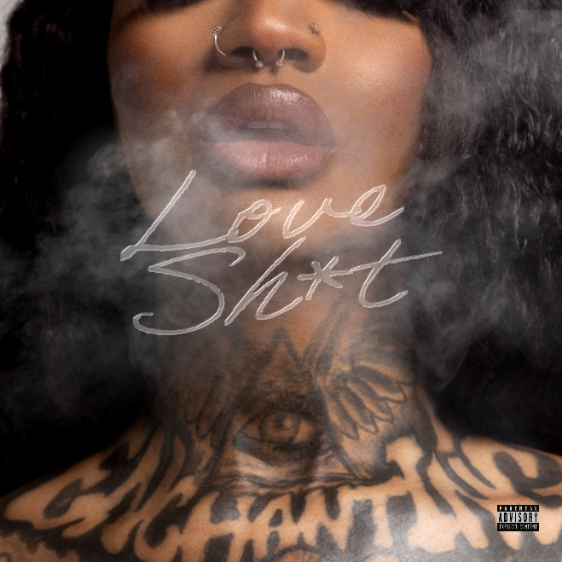
DOWNLOAD ARTWORK/HIGH-RES IMAGES HERE

STREAM “LOVE SHIT”: LINK
WATCH “LOVE SHIT” OFFICIAL MUSIC VIDEO: LINK

1017 Global Music’s rap and R&B princess Enchanting releases her second single of the year, “Love Shit” off her forthcoming debut R&B mixtape, Luv Scarred, dropping next Friday. “Love Shit” follows her recently released R&B track “Tell Me Why,” and Enchanting’s debut full length rap release No Luv, which featured the likes of Gucci Mane, Big Scarr, Kali, Coi Leray & more.

No Luv housed standout singles, “Against The Law” featuring KenTheMan and “O.P.P” featuring JDot & Whoppa wit Da Choppa. Now embracing her R&B side, Chant explores a sound in line with her 2022 singles “Keep It Playa” and “What I Want” with Jacquees, the latter of which has amassed over 1m YouTube views since release.

Hailing from Fort Worth, TX the singer and rapper has emerged as both a sheer vocal dynamo and a tried-and-true empath, delivering what she dubs “Trap-n-Blues.” With a style as stone cold as the stare from her Medusa tattoo, she has generated over 120 million global streams and counting. Enchanting has appeared alongside her 1017 Global Music labelmates on Gucci Mane’s compilation tape Gucci Mane Presents: So Icy Summer, So Icy Christmas, So Icy Gang: The ReUp and more.

DOWNLOAD ARTWORK/HIGH-RES IMAGES HERE

###

CONNECT WITH ENCHANTING
TWITTER
INSTAGRAM
YOUTUBE

PRESS CONTACTS
Ted Sullivan | Ted.Sullivan@atlanticrecords.com
Ashley Kalmanowitz | Ashley.Kalmanowitz@atlanticrecords.com

