FOR IMMEDIATE RELEASE
FEBRUARY 10, 2023

ENCHANTING DROPS LUV SCARRED

DEBUT R&B PROJECT AVAILABLE NOW VIA 1017 GLOBAL MUSIC/ATLANTIC RECORDS

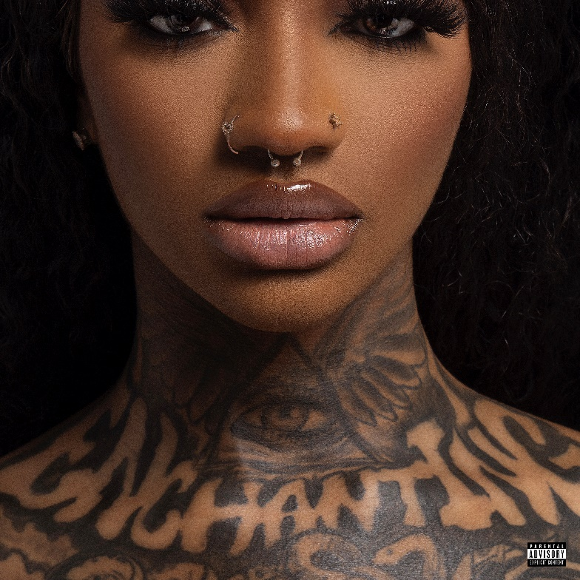
DOWNLOAD ARTWORK/HIGH-RES IMAGES HERE

STREAM LUV SCARRED: LINK

Rap and R&B princess Enchanting embraces her softer side on new project Luv Scarred – available now via 1017 Global Music/Atlantic Records. The 17-track collection includes standout track “Needy” alongside dynamic collaborations with Baby Tate (“Heaux Things”), Seddy Hendrix (“Shoulda Known”) & more.

Enchanting previewed her knack for smooth vocals and throwback vibes on her fan-favorite single “What I Want” featuring Jacquees, which has amassed over 1 million YouTube views since release. Luv Scarred also includes previously released cuts “Keep It Playa” (praised by NPR for “[advancing] another facet of her style”), “Large Amounts” featuring Gucci Mane, “Take It Back” & more. The project features production by J. White Did It (Cardi B, Megan Thee Stallion), Bizness Boi (Lil Nas X, Teyana Taylor), JetsonMade (Jack Harlow, Roddy Ricch) & more.

Luv Scarred follows her 2022 debut full length rap release No Luv, which housed Chant’s hottest rap singles including “No Luv” with Gucci Mane featuring Big Scarr & Key Glock (boasting over 40 million collective global streams), “Track & Field” featuring Kali, “Freaky Deaky” featuring Coi Leray, “Want Sum” and “Issa Photoshoot” with Gucci Mane (a revamp of the 1017 founder’s iconic 2009 single).

Hailing from Fort Worth, TX, Enchanting has emerged as both a sheer vocal dynamo and a tried-and-true empath, delivering what she dubs “trap-n-blues.” Exuding Neo-Soul depth and flexing a skyscraper-size vocal range, she channels raw passion, only to lean into hills and valleys of heartbreak with just the right amount of trap intensity. Introduced to Gucci Mane via producer J. White Did It, she signed to The New 1017 in 2020 and dropped music at a prolific pace. She contributed “Way Back” to Starz original P-Valley: Season 2 and lent her vocals to choice cuts from a string of compilations including SoIcyBoyz, So Icy Christmas, Gucci Mane Presents: So Icy Summer, So Icy Boyz 22, So Icy Boyz The Finale, and So Icy Gang: The ReUp. Praised as “a smooth operator” by Essence, “wicked” by Pitchfork & “a standout” by Uproxx, Chant has generated over 120 million global streams and has only just begun her rise to the top.

Luv Scarred track list:
1. Tell Me Why
2. IDKS (Skit)
3. Hopeless Romantic
4. Love Shit
5. Take It Back
6. They’re the Problem (Skit)
7. Shoulda Known (feat. Seddy Hendrinx)
8. Heaux Things (feat. Baby Tate)
9. La La La
10. Needy
11. What I Want (feat. Jacquees)
12. 4321
13. I Feel Way Better (Skit)
14. Large Amounts (feat. Gucci Mane)
15. Keep It Playa
16. Evil Aries (Skit)
17. Love Scars

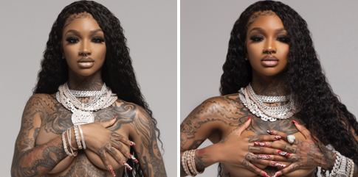
DOWNLOAD ARTWORK/HIGH-RES IMAGES HERE

CONNECT:
TWITTER | INSTAGRAM | YOUTUBE | PRESS ASSETS

CONTACT:
Ted Sullivan | Ted.Sullivan@atlanticrecords.com
Ashley Kalmanowitz | Ashley.Kalmanowitz@atlanticrecords.com

