FOR IMMEDIATE RELEASE
JANUARY 27, 2023

ENCHANTING DROPS “TELL ME WHY”

ACCOMPANIED BY OFFICIAL MUSIC VIDEO

DEBUT R&B MIXTAPE LUV SCARRED COMING SOON VIA 1017 GLOBAL MUSIC/ATLANTIC RECORDS

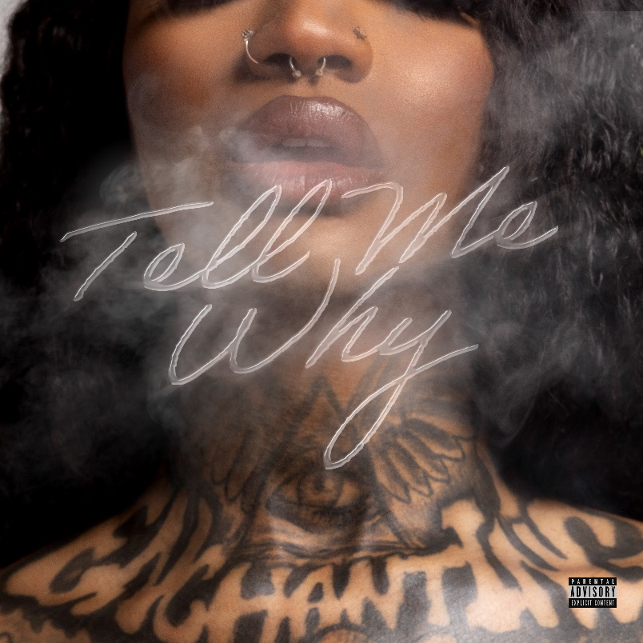
DOWNLOAD ARTWORK/HIGH-RES IMAGES HERE

STREAM “TELL ME WHY”: LINK
WATCH “TELL ME WHY” OFFICIAL MUSIC VIDEO: LINK

1017 Global Music’s rap and R&B princess Enchanting drops “Tell Me Why,” a taste of what’s to come on her forthcoming debut R&B mixtape, Luv Scarred. The track follows Enchanting’s debut full length rap release No Luv, which featured the likes of Gucci Mane, Big Scarr, Kali, Coi Leray & more.

No Luv housed standout singles, “Against The Law” featuring KenTheMan and “O.P.P” featuring JDot & Whoppa wit Da Choppa. Now embracing her R&B side, Chant explores a sound in line with her 2022 singles “Keep It Playa” and “What I Want” with Jacquees, the latter of which has amassed over 1m YouTube views since release.

Hailing from Forth Worth, TX, the 24-year-old songstress defines her style as something chill with a dash of neo-Soul, a twinge of old school R&B, with some modern trap flavor sprinkled in. Enchanting has appeared alongside her 1017 Global Music labelmates on Gucci Mane’s compilation tape Gucci Mane Presents: So Icy Summer, So Icy Christmas, So Icy Gang: The ReUp and more. The rising star has garnered over 120 million combined global streams, over 17 million YouTube views and over 2 million social media followers to date.

DOWNLOAD ARTWORK/HIGH-RES IMAGES HERE

###

CONNECT WITH ENCHANTING
TWITTER
INSTAGRAM
YOUTUBE

PRESS CONTACTS
Ted Sullivan | Ted.Sullivan@atlanticrecords.com
Ashley Kalmanowitz | Ashley.Kalmanowitz@atlanticrecords.com

