FOR IMMEDIATE RELEASE
FEBRUARY 16, 2023

JANELLE MONÁE RETURNS WITH NEW SINGLE “FLOAT” FEAT. SEUN KUTI + EGYPT 80

AWARD-WINNING SINGER-SONGWRITER-ACTRESS HERALDS NEW ERA WITH HIGHLY-ANTICIPATED SINGLE

“FLOAT” AVAILABLE NOW VIA WONDALAND ARTS SOCIETY/ATLANTIC RECORDS
LISTEN TO “FLOAT”

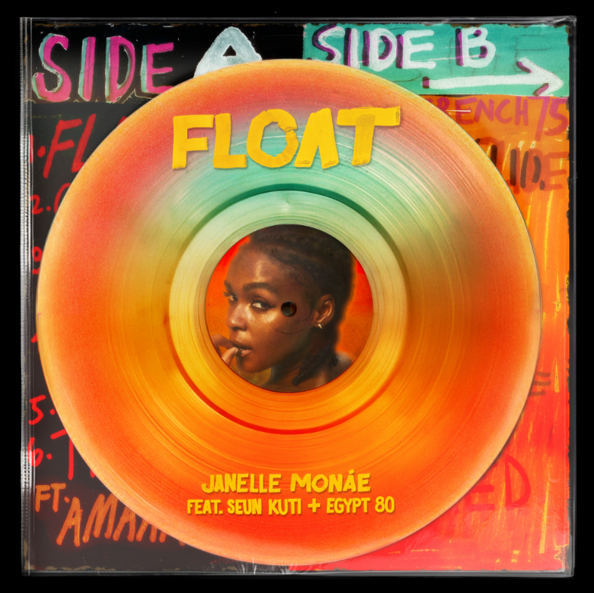
DOWNLOAD HI-RES ARTWORK

Janelle Monáe, music’s foremost freeassmuthafucka, is back in action with the release of her highly-anticipated single, “Float”, featuring horns by Seun Kuti + Egypt 80. “Float” is available now via Wondaland Arts Society/Atlantic Records HERE.

According to sources closest to Monáe, “Float” is inspired by Muhammed Ali talking shit in Zaire, 1974, Jane’s evolution, Mary Poppins’ umbrella, Aladdin’s magic carpet, Ja Morant’s flotation to the rim while dunking on his ops, Sara Elise’s ropes, excerpts from Paramahmsa Nithyananda’s talks on levitation, Raul’s toast on Dec 1, and Bruce Lee’s mighty philosophy on being “shapeless, formless,” and becoming one with your surroundings, to be like water…

“Float” – which Monáe recently teased on her hugely popular Instagram – was first heard late last year as the official anthem of ABC/ESPN’s NBA Saturday Primetime campaign, with Janelle contributing voiceover narration to promo spots highlighting the biggest matchups and stars in the league. The track will be used extensively throughout all NBA coverage through mid-March, spanning promos, Primetime matchups, in-game placement, social media, and more. Most recently, “Float” was featured in an animated piece marking Los Angeles Lakers superstar LeBron James surpassing Kareem Abdul-Jabbar for the # 1 spot on the NBA’s all-time regular-season scoring list, shared across ESPN’s socials and James’ Instagram to reach more than 275M combined followers.

Monáe will further celebrate her partnership with ABC/ESPN and the NBA by, appearing on ESPN’s wildly popular, NBA Today show to discuss the new single and more on February 17 (*check local listings for airtime) and playing in this weekend’s 2023 Ruffles NBA All-Star Celebrity Game, competing as part of “Team Dwayne Wade” alongside former MLB and NFL athletes as well as rapper 21 Savage, actor Simu Liu, comedian Hasan Minhaj, Latin global music icon Nicky Jam, and others. The 2023 Ruffles NBA All-Star Celebrity Game airs live from Salt Lake City, UT’s Jon M. Huntsman Center on Friday, February 17 at 7:00 pm (ET), exclusively on ESPN and streaming via the ESPN app.

Janelle Monáe is without question one of the most celebrated artists of the modern era, an 8x GRAMMY® Award-nominated singer, songwriter, producer, performer, and fashion icon known worldwide for her inimitable style and visionary sound. Her genre-bending debut album, THE ARCHANDROID, arrived in 2010 and immediately ascended to the top 20 on the Billboard 200 while also earning two GRAMMY® Award nominations including “Best Contemporary R&B Album” and “Best Urban/Alternative Performance” for the RIAA Gold-certified single, “Tightrope (Feat. Big Boi).”

THE ELECTRIC LADY entered the SoundScan/Billboard 200 at #5 upon its 2013 release, fueled by collaborations with such like-minded artists as Solange, Esperanza Spalding, and Monáe’s lifelong hero, the one and only Prince, as well as hit singles/music videos like the MTV Video Music Award-winning “Q.U.E.E.N. (Feat. Erykah Badu).” 2018’s DIRTY COMPUTER – which received a coveted GRAMMY® Award-nomination as “Album Of The Year” – features the RIAA Gold-certified hit singles “Make Me Feel” and “I Like That” and was accompanied by a groundbreaking “Emotion Picture” incorporating a number of the album’s visually stunning music videos.

Undoubtedly among the 21st Century’s most inventive and creative live performers, Monáe has traveled the globe for sold out headline tours, a range of festival appearances, and special guest runs alongside Bruno Mars, Amy Winehouse, No Doubt, Katy Perry, Erykah Badu, and Red Hot Chili Peppers. An in-demand collaborator, Monáe is featured on tracks by an incredibly diverse group of artists including Outkast, Big Boi, Kelly Clarkson, Sérgio Mendes, Of Montreal, The Coup, Grimes, Estelle, Paolo Nutini, The Internet, Chic, Duran Duran, Goodie Mob, and of course fun., whose “We Are Young (Feat. Janelle Monáe)” proved the biggest single of 2012, a worldwide #1 phenomenon named in three GRAMMY® Award categories: “Record of the Year,” “Song of the Year,” and “Best Pop Duo/Group Performance.”

2016 saw Monáe embark on her film acting career with stellar performances in two milestone films, Hidden Figures and Moonlight; both films received Academy Award nominations for Best Picture, with the latter winning the award at the 89th Academy Awards. Her filmography quickly grew to include acclaimed roles in 2018’s Harriet, 2020’s Antebellum, and 2022’s Glass Onion: A Knives Out Mystery, to name but a few. Monáe has also made countless TV appearances, including a lead role on Amazon Prime’s Homecoming and performances on NBC’s Saturday Night Live and TODAY, ABC’s Dancing With The Stars, PBS’ Sesame Street, MTV’s RuPaul’s Drag Race, Netflix’s We The People, and many more.

Recently honored with the National Board of Review’s 2022 “Best Supporting Actress” Award for her role in Glass Onion: A Knives Out Mystery, Monáe has received a long series of accolades and other honors, including three Critics Choice Awards, two Billboard Women In Music Awards, an NAACP Image Award, two Soul Train Awards (out of 13 nominations), an Essence Black Women in Hollywood Award, eight GRAMMY® Award nominations, and multiple nominations for BET Awards, BRIT Awards, and MTV Video Music Awards, along with many more laurels around the world.

Always an eclectic and creative visual presence, Monáe was chosen as the new face of CoverGirl in 2012, later became a spokesperson for the home audio company Sonos, and recently joined forces with Target for its “I Got The Juice” co-branded campaign for Marvel’s Black Panther: Wakanda Forever.

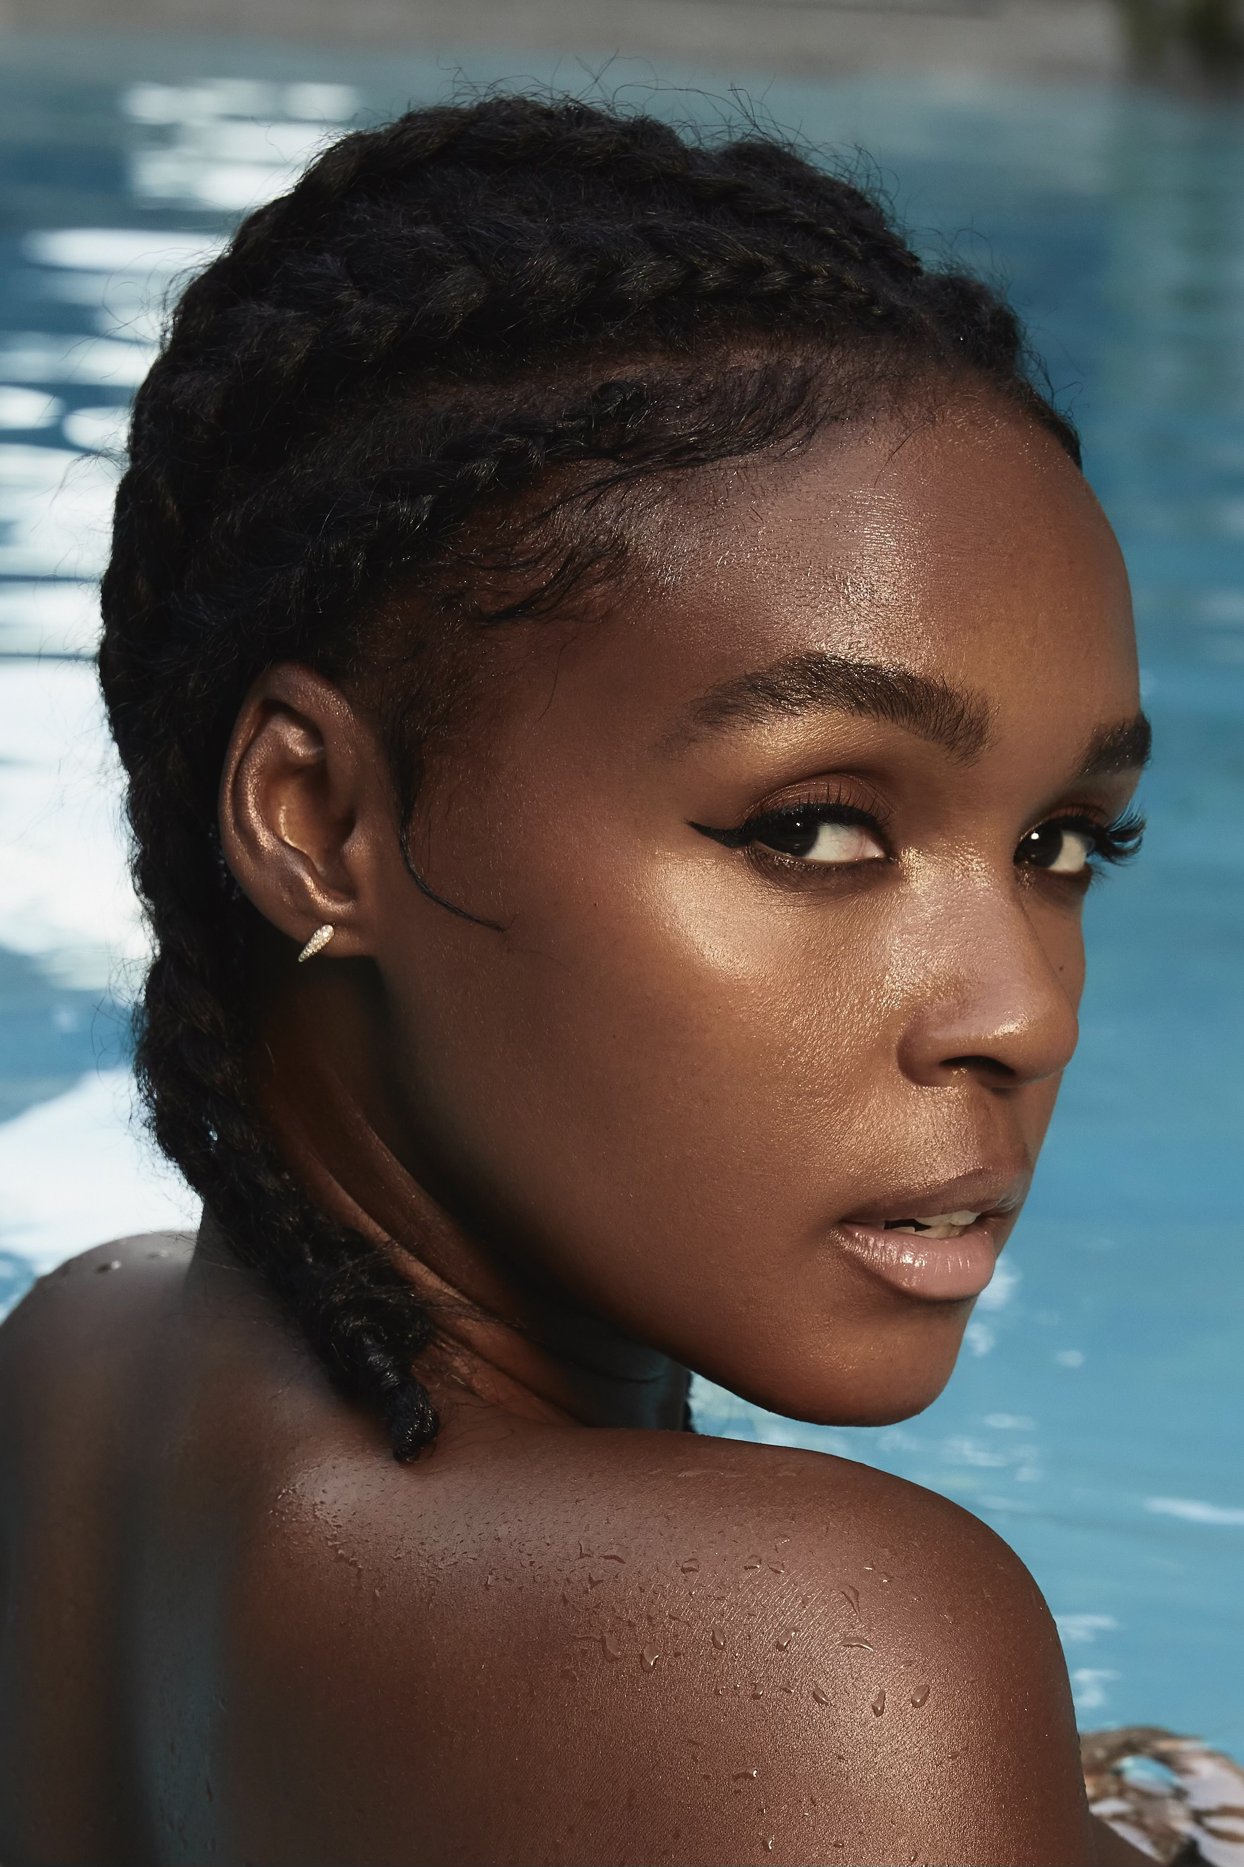
DOWNLOAD PRESS IMAGE
Photo Credit: Jheyda McGarrell

CONNECT WITH JANELLE MONÁE
OFFICIAL | FACEBOOK | INSTAGRAM | TWITTER | YOUTUBE

JANELLE MONÁE PR CONTACTS
Sheila Richman // Sheila.Richman@atlanticrecords.com
Fairley McCaskill // Fairley.McCaskill@atlanticrecords.com
Jessica Nall // Jessica.Nall@atlanticrecords.com
Kelly Bush Novak // kbushnovak@id-pr.com
Court Barrett // cbarrett@id-pr.com
Elif Mamak // emamak@id-pr.com

