MULTI-PLATINUM RAPPER LIL SKIES WANTS TO “MAKE A TOAST” TO THE HATERS

“MAKE A TOAST” ARRIVES WITH OFFICIAL MUSIC VIDEO
DIRECTED BY SAM MCGRATH

DOWNLOAD/STREAM “MAKE A TOAST” | WATCH OFFICIAL MUSIC VIDEO

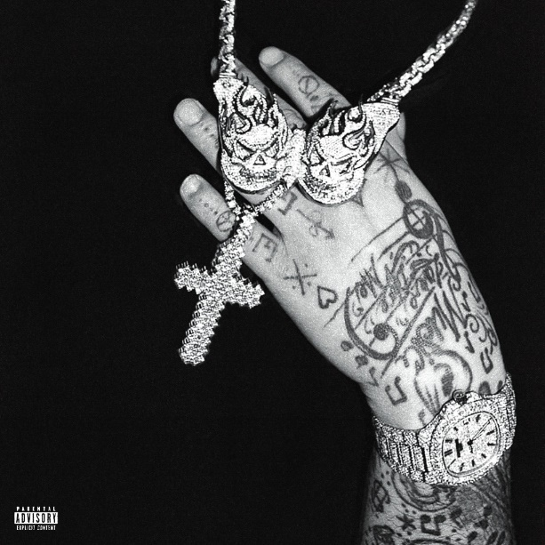
DOWNLOAD HI-RES COVER ART

(New York, NY – February 21, 2023) Multi-Platinum rapper and explosive performer Lil Skies returns with new single “Make A Toast.” Available everywhere now via Atlantic Records. “Make A Toast” arrives with an official video directed by Skies’ long-time creative collaborator, Sam McGrath – Watch HERE. With each periodic single release, Lil Skies’ fans remain patient and eager to hear what is coming next and line up to watch him light it up on the stage.

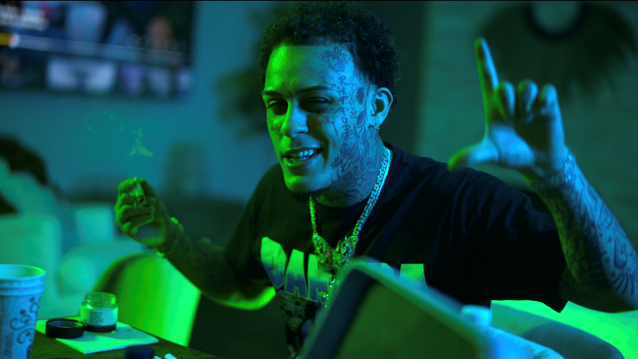

With over 7.4 billion streams to date, the multi-platinum rapper Lil Skies has been minted as a rising star. Skies always delivers heightened storytelling in addition to catchy and combustible bars underpinned by charisma and emotion including his 2019 chart-topping RIAA Certified-Gold debut album, Shelby and 2X RIAA Certified-Platinum singles “Red Roses,” featuring Landon Cube, “Lust,” and “Nowadays,” featuring Landon Cube.

Receiving praise from Rolling Stone, Billboard, Complex, Noisey, Hypebeast and many more as a milestone artist, Lil Skies is just as powerful on stage as he is in the studio. The past few years have seen him lighting it up on his own U.S. headline tour along with a support role on Wiz Khalifa and Rae Sremmurd's “Dazed & Blazed” amphitheater tour and festival appearances as Made In America, Rolling Loud, and more.

DOWNLOAD HI-RES PHOTOS HERE

CONNECT WITH LIL SKIES

LILSKIES.COM

SOUNDCLOUD | FACEBOOK | TWITTER |INSTAGRAM | PRESS SITE

Press contact: corey.brewer@atlanticrecords.com

