PARAMORE RELEASE NEW TRACK “C’EST COMME ÇA”

The third Track Taken From Their Highly Anticipated Sixth Studio Album THIS IS WHY
Out February 10th On Atlantic Records

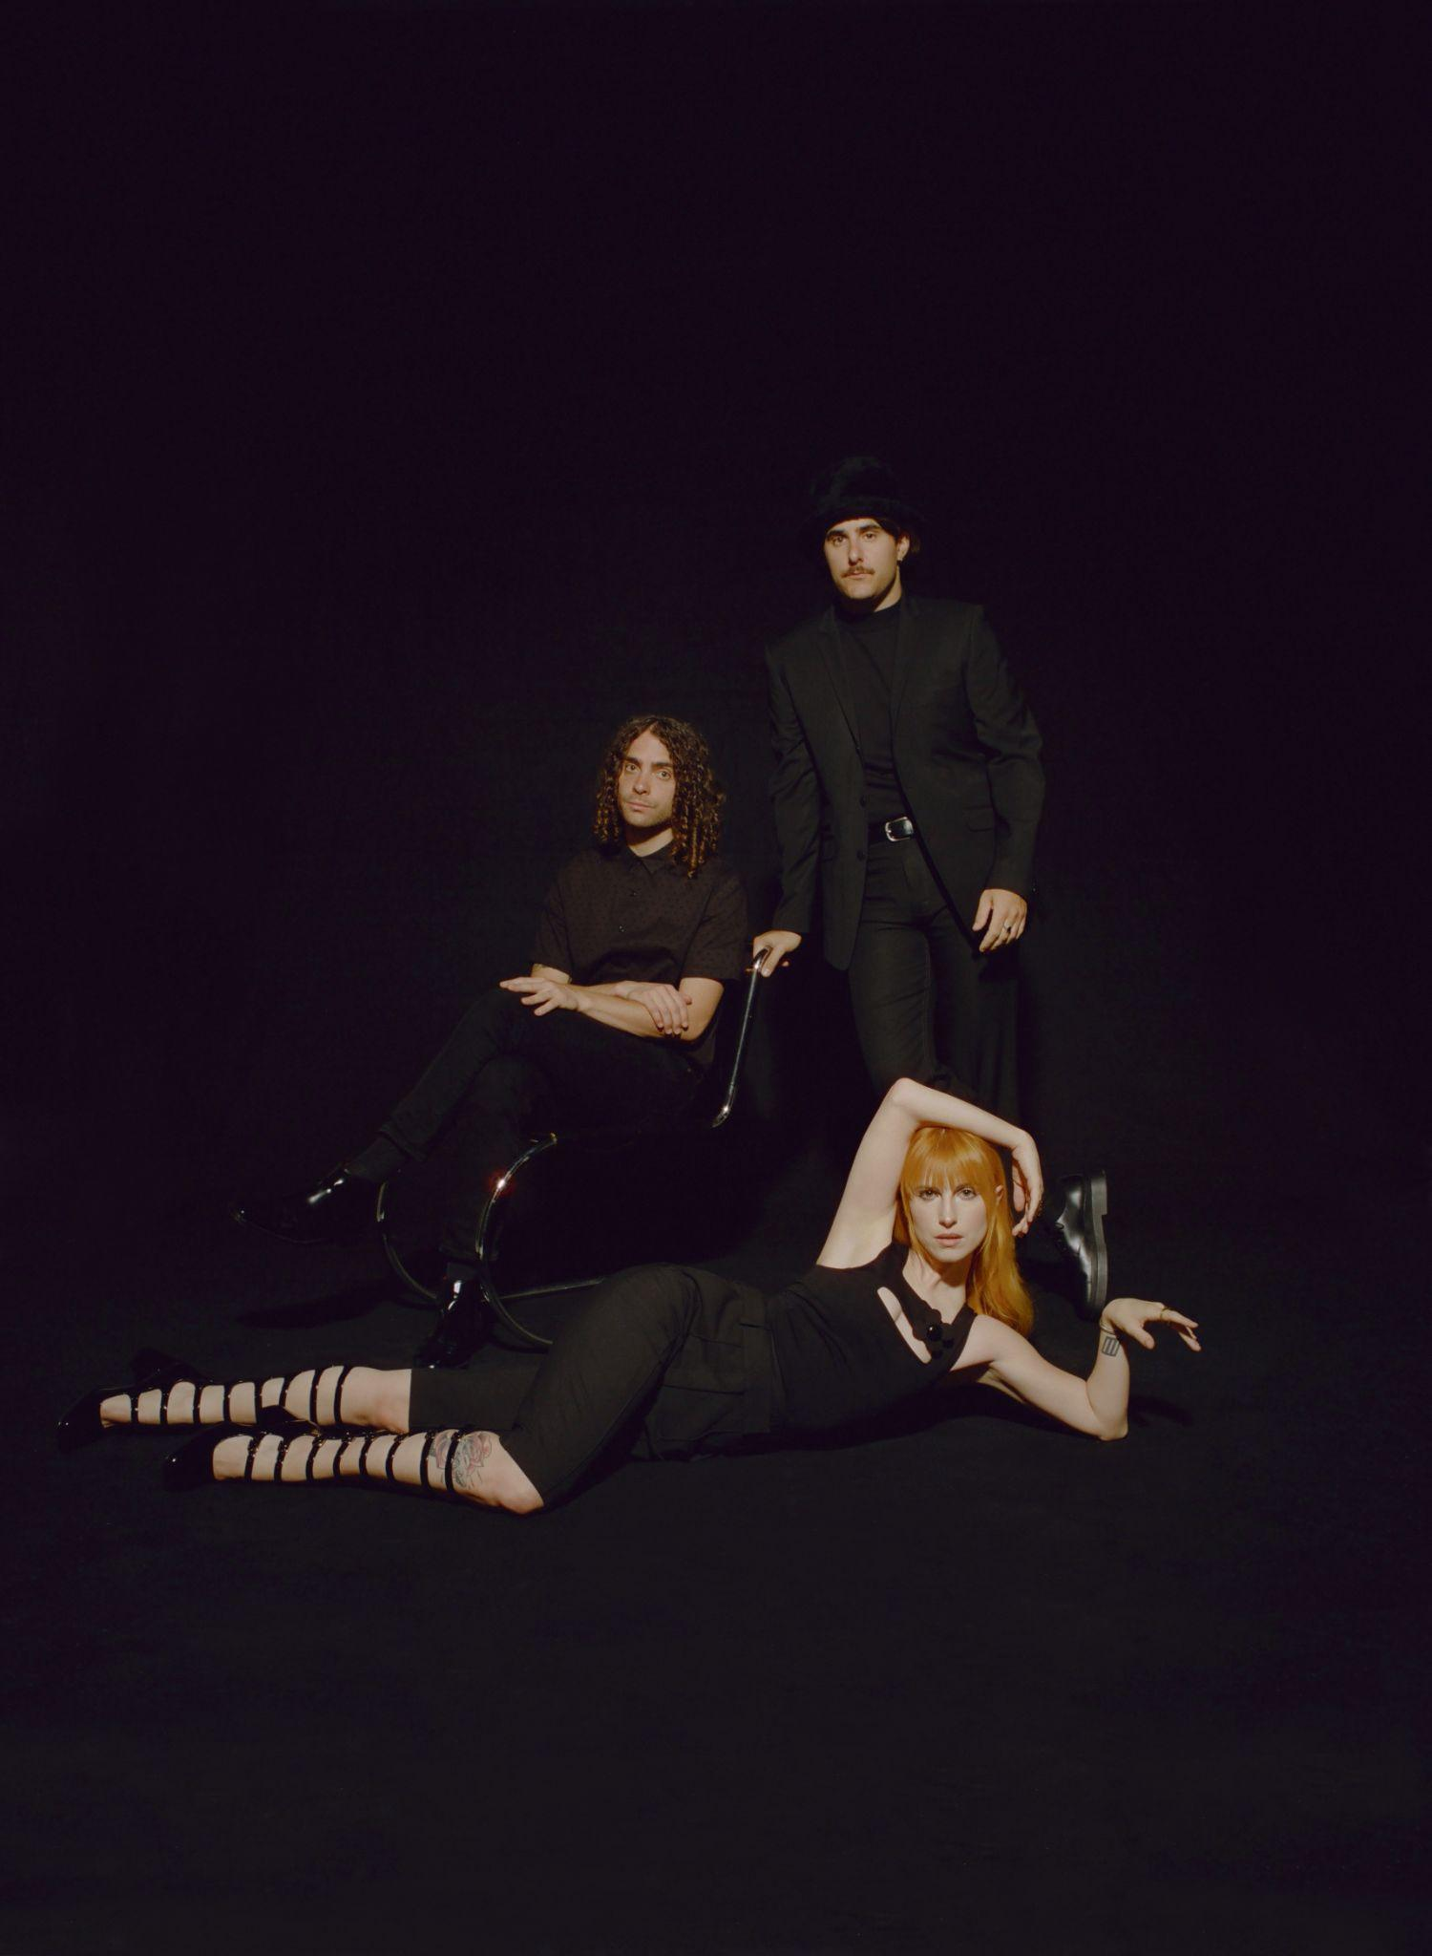
(L-R Taylor York, Zac Farro, Hayley Williams. Photo credit: Zachary Gray, download HERE)

I know that regression is rarely rewarded / I still need a certain degree of disorder/ I hate to admit getting better is boring/ But the high cost of chaos?/ Who can afford it?

Today, Paramore’s electrifying return continues with the release of new song “C’est Comme Ça.” This is the third track to be released from their eagerly anticipated new album This is Why - out February 10th via Atlantic Records.

Of the song - whose title translates literally from French as “it’s like that” but is more akin to the English-language expression “that’s just how it is” - singer Hayley Williams says, “I’m trying to get un-addicted to a survival narrative. The idea of imminent doom is less catastrophic to me than not knowing anything about the future or my part in it. The guys and I are all in much more stable places in our lives than ever before. And somehow that is harder for me to adjust to.”

STREAM “C’EST COMME ÇA” HERE
WATCH THE VIDEO FOR “C’EST COMME ÇA” HERE

The Grammy-winning trio revealed their new album plans in September with the release of the album’s title track. “This Is Why,” currently climbing streaming and alternative radio charts around the globe - now at #2 at Alternative Radio! - and saw the beloved band make their Tonight Show Starring Jimmy Fallon debut in between a run of intimate theater dates and festival headlines.

Excitement for Paramore’s live shows has never fiercer; they were recently announced to headline the kick-off of the Bud Light Super Bowl Music Fest in Glendale, AZ on Feb 9th and will join Taylor Swift on the opening nights of her Eras Tour there on March 17th and 18th. Prior to their tour kickoff, the band will be doing a special, intimate album release show for fans on February 6 at The Grand Ole Opry House in Nashville.

Spring 2023 sees Paramore embark on their own global tour in support of This is Why, kicking off in South America in March, followed by a UK run in April, and a North American run starting in May. Support comes from Bloc Party, Foals, The Linda Lindas and Genesis Owusu. For the band’s largest headline arena shows in more than a decade they’ll make stops at some of the most iconic venues including two nights at London’s O2 Arena, two nights at New York’s Madison Square Garden, Toronto’s Scotiabank Arena, Austin’s Moody Center, two nights at Los Angeles’ Kia Forum, Seattle’s Climate Pledge Arena and more before wrapping up in St. Paul, MN at Xcel Energy Center on August 2nd. The band are donating a portion of their ticket sales to organizations working in areas of essential community support, including Support & Feed and REVERB.

When Paramore revealed they were recording together in January 2022 the response from music fans around the world was immediate and celebratory. In the time since the Grammy-winning, RIAA-certified multi-Platinum band released their last album, After Laughter - and Hayley Williams unveiled two lauded solo albums - Paramore have become more popular than ever. Over the last few years Paramore’s influence and popularity has snowballed, as the age of streaming organically propelled them into a position as one of the world’s biggest, most culturally compelling rock bands. For the band, who formed as teenagers in Tennessee, their 20 year trajectory has seen them grow from youthful outsiders to bone-fide pop culture icons, permeating the musical landscape by inspiring a new generation of musical talent.

Watch the video for “This Is Why”
Watch the video “The News”

PRE-ORDER THIS IS WHY HERE

UPCOMING PARAMORE TOUR DATES:
Mon Feb 6 - Nashville, TN - Grand Ole Opry House
Thu Feb 9 - Phoenix, AZ - Bud Light Super Bowl Music Fest 2023+
Thu March 2 - Santiago De Surco, Peru - Arena Perú
Sun March 5 - Santiago, Chile - Movistar Arena
Tue March 7 - Comuna 14, Argentina - Argentinian Racetrack of Palermo
Thu March 9 - Rio De Janeiro, Brazil - Qualistage
Sat March 11 - São Paulo, Brazil - Centro Esportivo Tiete
Sun March 12 - São Paulo, Brazil - Centro Esportivo Tiete
Tue March 14 - Bogotá, Colombia - Movistar Arena
Fri March 17 - Glendale, AZ - State Farm Stadium=
Sat March 18 - Glendale, AZ - State Farm Stadium=
Thu April 13 - Dublin, Ireland - 3Arena
Sat April 15 - Cardiff, United Kingdom - International Arena
Mon April 17 - Glasgow, United Kingdom - OVO Hydro
Tue April 18 - Manchester, United Kingdom - AO Arena
Thu April 20 - London, United Kingdom - O2 Arena
Sat April 22 - Birmingham, United Kingdom - Utilita Arena
Sun April 23 - London, United Kingdom - O2 Arena
Tue May 23 – Charlotte, NC – Spectrum Center*~
Thu May 25 – Atlanta, GA – State Farm Arena*~
Sat May 27 – Atlantic City, NJ – Adjacent Festival+
Tue May 30 – New York, NY – Madison Square Garden*~
Wed May 31 – New York, NY – Madison Square Garden*~
Fri June 02 – Washington, DC – Capital One Arena*~
Sun Jun 04 – Cleveland, OH – Rocket Mortgage Fieldhouse*~
Mon Jun 05 – Indianapolis, IN – Gainbridge Fieldhouse*~
Wed Jun 07 – Detroit, MI – Little Caesars Arena*~
Thu Jun 08 – Toronto, ON – Scotiabank Arena*~
Sat Jun 10 – Columbus, OH – Schottenstein Center*~
Sun Jun 11 – Pittsburgh, PA – PPG Paint Arena*~
Tue Jun 13 – Orlando, FL – Amway Center*~
Wed Jun 14 – Hollywood, FL – Hard Rock Live*~
Thu Jul 06 – New Orleans, LA – Smoothie King Center^!
Sat Jul 08 – Fort Worth, TX – Dickies Arena^!
Sun Jul 09 – Austin, TX – Moody Center^!
Tue Jul 11 – Houston, TX – Toyota Center^!
Thu Jul 13 – Denver, CO – Ball Arena^!
Sun Jul 16 – San Diego, CA – Viejas Arena^
Wed Jul 19 – Los Angeles, CA – Kia Forum^
Wed Jul 20 – Los Angeles, CA – Kia Forum^
Sat Jul 22 – San Francisco, CA – Chase Center^
Mon Jul 24 – Seattle, WA – Climate Pledge Arena^!
Tue Jul 25 – Portland, OR – Veterans Memorial Coliseum^!
Thu Jul 27 – Salt Lake City, UT – Vivint Arena^!
Sat Jul 29 – Tulsa, OK – BOK Center^!
Sun Jul 30 – St Louis, MO – Enterprise Center^!
Wed Aug 02 – St. Paul, MN – Xcel Energy Center^!

*With Support Bloc Party
^With Support from Foals
!With Support from The Linda Lindas
~With Support from Genesis Owusu
+Festival Performance
=Supporting Taylor Swift

Tickets for Paramore

Praise for Paramore:

“One of the most influential bands of their generation” - The Guardian

“another bold yet sonically grounded triumph: while the production recalls the art-rock idiosyncrasies of After Laughter, Hayley Williams sneers, spins and strikes with the tenacity of her Riot! Work.” - Billboard

“Williams sings, with biting mock-sweetness, over a backbeat and a hopping bass line. Choppy, clenched guitar chords goad her as she sneers an irritated response to a sourly divided national mood” - New York Times

“...it's working as a power trio here: a singer, drummer and guitarist barreling ahead at the most thrilling heights of their musicianship” - NPR

“Fan interaction was an integral part of the concert, and perhaps what makes Paramore shows so special — besides Williams’ never-faltering powerhouse vocals and the band’s tight musicality.” - Variety

“With a packed setlist that spanned 20 years of hit-making, the band celebrated everything they've achieved - and proved that the best is yet to come." - Rolling Stone

“one of the most influential alternative rock bands of their generation” - The Face

KEEP UP WITH PARAMORE:
Web/ Instagram /TikTok/ Twitter /Facebook

For more information on Paramore:

Chloë Walsh @ The Oriel Co / Anna Ross @ The Oriel Co

chloe@theoriel.co
anna@theoriel.co

Tour requests:
Alex Courides @ The Oriel Co:
alex@theoriel.co

Atlantic Records contact:
Christina Kotsamanidis
Christina.Kotsamanidis@atlanticrecords.com

