FOR IMMEDIATE RELEASE
FEBRUARY 22, 2023

RELLYSKI IS READY TO “WORK IT OUT”

FLORIDA RAPPER MAKES MAJOR LABEL DEBUT
WITH SMOOTH NEW SINGLE

LISTEN TO “WORK IT OUT” HERE | WATCH OFFICIAL MUSIC VIDEO HERE

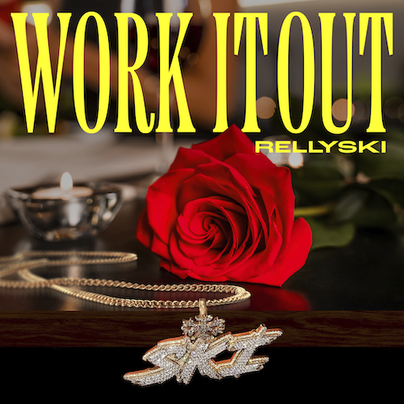
DOWNLOAD HI-RES IMAGE

Opa-locka, FL-based rapper Rellyski has shared his major label debut single, “Work It Out,” available now via Bad Habit/Atlantic Records. The smooth new track showcases Rellyski’s hypnotic flow over the dreamy production and throwback R&B beat. The new single arrives alongside a Chris Moreno directed video. Watch HERE.

ABOUT RELLYSKI:
Having already attracted acclaim from Lyrical Lemonade, Early Rising, and more, Rellyski draws a fine line between gritty hip-hop storytelling and soulful vocal delivery, coating raw reality in magnetic melodies to examine trials, tribulations, triumphs, and everything in between. Raised by a single mother, music surrounded the Opa-locka, FL-based artist from a young age, his voice honed thanks to Grandma by regular visits to church for choir rehearsals. Though he listened to everything from R&B to rap, Rellyski initially gravitated towards football, shining on the field as a receiver and free safety. Recruited by Ohio’s Heidelberg University in Ohio, he channeled his musical interests by recording demos at the school radio station. Unfortunately, financial stress forced Rellyski to return to Florida where he began focusing like a laser on making music. In 2020, he uploaded “FO’REAL” to SoundCloud, catching the attention of the innovative new label Bad Habit, home to such artists as genre-busting trio Fade ‘Em All and GRAMMY® Award-winning global superstar Burna Boy.

Named by Miami New Times as one of “10 Miami Rappers to Watch in 2022,” Rellyski picked up steam in 2021 with tracks like “Flowers” and “Spalding,” the latter of which generated over 500K worldwide streams and paved the way for last year’s SKI SZN mixtape. Now, with “Work It Out” and more new music to come, Rellyski is sharpening his scorching signature style and “Miami Bounce” sound, refining and defining his vision to create a one-of-a-kind “Hood Lullaby” in the process.

“Authenticity is the biggest thing for me,” Rellyski says. “I want people to see me for me. A lot of people put on a face. Things are either fabricated or exaggerated. I’m just pushing me. I’m not trying to do too much or too little—I’m trying to give you me. I’m just a kid from Opa-locka with a goal. I’m a star who’s just getting his chance to shine. Once you pull back the curtain, you’re going to get blinded.”

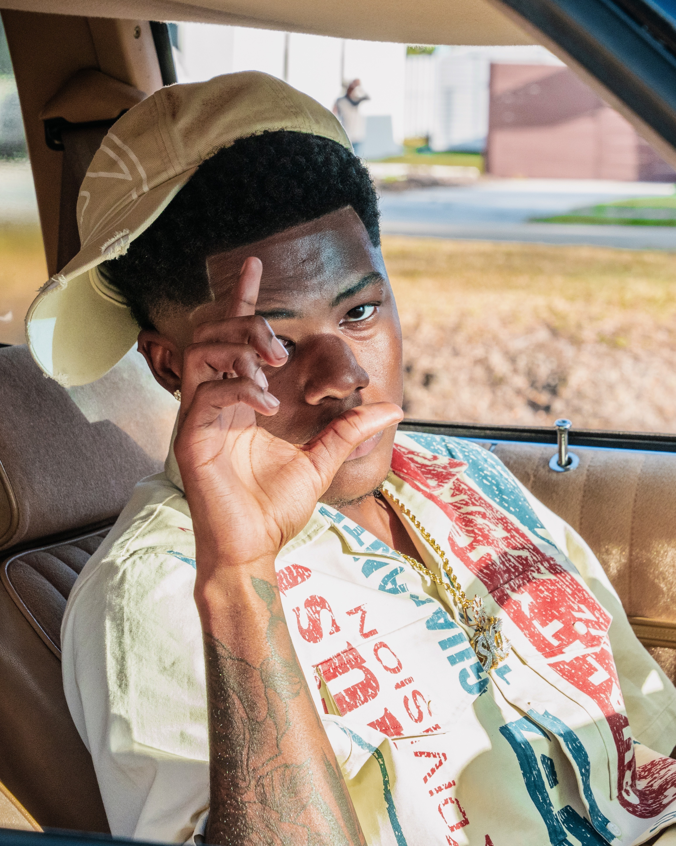
DOWNLOAD HIGH-RES PRESS PHOTO(S) HERE
# # #

CONNECT WITH RELLYSKI
INSTAGRAM | TWITTER | YOUTUBE

PRESS CONTACT
FAIRLEY MCCASKILL | FAIRLEY.MCCASKILL@ATLANTICRECORDS.COM

