FOR IMMEDIATE RELEASE
FEBRUARY 17, 2023

RITON RETURNS WITH NEW SINGLE
“SUGAR (FEAT. SOAKY SIREN)”

DANCEFLOOR-READY ANTHEM SAMPLES 50 CENT’S ICONIC SMASH “CANDY SHOP”

NEW SINGLE MARKS RITON’S FIRST RELEASE ON BIG BEAT RECORDS/ATLANTIC RECORDS

LISTEN TO “SUGAR (FEAT. SOAKY SIREN)” HERE

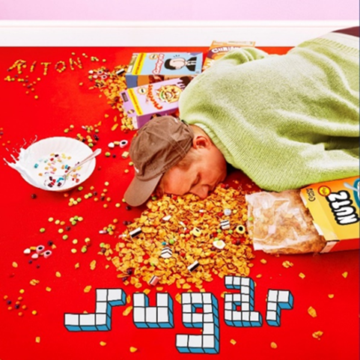
DOWNLOAD ARTWORK HERE

GRAMMY winning DJ/producer Riton returns with the release of his new single, ‘Sugar (feat. Soaky Siren)’ – available everywhere now via Atlantic Records / Big Beat Records HERE.

Ushering in a new era of music from one of UK dance music’s true trailblazers, ‘Sugar’ lands as the perfect introduction to Riton’s bright new technicolour world.

The pre-cursor to an incoming mixtape due later this year, ‘Sugar’ is an explosive, peak-time dance anthem, niftily flipping a cut-and-paste sample from 50 Cent’s 2005 classic, ‘Candy Shop.’ Bold, hyper-infectious and packing the sort of rowdy, carefree energy that feels woven into the fabric of all Riton’s forthcoming music, ‘Sugar’ marks an exciting jump off point.

‘Sugar’ also drops alongside a first-of-its-kind generative AI visualiser, developed by the WMG Global Data Science team – Watch HERE. Created using a model that generates images based off of text descriptions, (known as Stable Diffusion), which was further trained on Riton’s face and moodboards, the team were also able to make the visuals react to the audio using AI, isolating audio individual elements and feeding them back into the animation. “It was a really exciting collaboration between data science and Atlantic’s creative team as we refined the aesthetic together,” explains Philip Watson, who headed up the visualiser’s creation.

‘Sugar (feat. Soaky Siren)’ is out now on Atlantic Records: https://lnk.to/riton-sugar

About Riton
Riton has been at the vanguard of UK dance music for over 20 years. A legendary and vastly influential producer straddling both the underground (Ed Banger, Soul Wax, Ministry Of Sound) and the mainstream, he boasts collaborations with everyone from Fat Boy Slim, The Chemical Brothers and Diplo to Tame Impala and M.I.A., racking up over 2 billion global streams in the process. He also shared co-production on Silk City’s 2018 GRAMMY-winning smash ‘Electricity’ ft. Dua Lipa, as well as earning a 2017 GRAMMY nomination for ‘Rinse & Repeat’ ft. Kah-Lo and a BRIT nomination for 2021 UK #4 single ‘Friday’ ft. Mufasa and Hypeman – a record fast closing in on 1 billion streams of its own.

About Soaky Siren
Born and raised in the Bahamas, Soaky Siren has been tearing into the Los Angeles music scene with a fierce, kinetic sound and style that has established Soaky as a multi-platinum, Latin Grammy-nominated songwriter. Her first EP as an artist, “LUCAYA,” is influenced by her birthplace, a project that can be vividly described as “urban resort,” and which showcases Soaky’s multifaceted artistic range. As a rapper, singer and songwriter, Soaky is in the rare echelons of artists that can release everything from urban to dancehall to pop.

Connect With Riton:
Instagram | Twitter | Facebook | Tik Tok

Connect With Soaky Siren:
Instagram | Twitter | Facebook | Tik Tok

Contact:
Jessica Nall / Atlantic Records
Jessica.Nall@atlanticrecords.com

