RITON, MAJOR LEAGUE DJZ & KING PROMISE
TEAM UP ON NEW SINGLE

‘CHALÉ’ FT. CLEMENTINE DOUGLAS

LISTEN HERE

WATCH OFFICIAL VISUALISER HERE

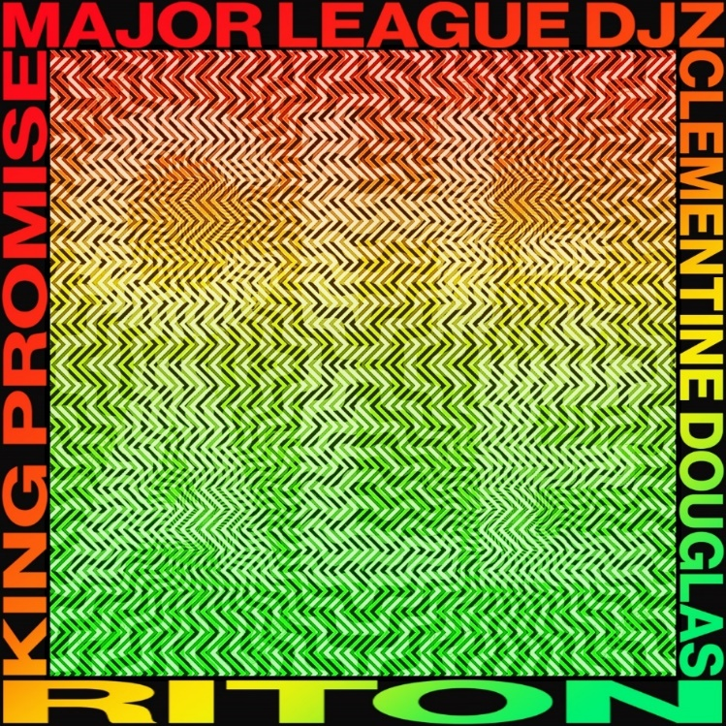

Riton, Major League Djz and King Promise have joined forces on new single, ‘Chalé’, featuring Clementine Douglas – listen HERE.

Out now on Atlantic Records, ‘Chalé’ sees Riton – seminal, GRAMMY-nominated UK dance music stalwart and producer behind 2021 international mega-hit ‘Friday’ ft. Mufasa & Hypeman – and much-revered South African Amapiano pioneers, Major League Djz, team up on a record bursting with energy and musicality.

Chalé – a phrase commonly used as both an icebreaker and term of endearment in Ghana and across West Africa that simply translates to mean ‘friend’ – also enlists Ghanaian star King Promise, who has already collaborated with the likes of Wiz Kid., WSTRN and Kojey Radical, and breakout vocalist, Clementine Douglas.

Featuring an infectious, pulsating beat and rhythmic patterns, the hook echoes a conversation between Promise and Douglas, both expressing their desire to live life freely and fully of enjoyment regardless of opinion – a fitting motif for a track that captures joy so viscerally.

Look out for the Major League Djz special Amapiano remix coming soon.

Riton x Major League Djz x King Promise – ‘Chalé’ ft. Clementine Douglas is out now: https://lnk.to/Chale

About Riton
Riton has been at the vanguard of UK dance music for over 20 years. A legendary and vastly influential producer straddling both the underground (Ed Banger, Soul Wax, Ministry Of Sound) and the mainstream, he boasts collaborations with everyone from Fat Boy Slim, The Chemical Brothers and Diplo to Tame Impala and M.I.A., racking up over 2 billion global streams in the process. He also shared co-production on Silk City’s 2018 GRAMMY-winning smash ‘Electricity’ ft. Dua Lipa, as well as a 2017 GRAMMY nomination for 2017’s ‘Rinse & Repeat’ ft. Kah-Lo and a BRIT nomination for 2021 UK #4 single ‘Friday’ ft. Mufasa and Hypeman – a record fast closing in on 1 billion streams of its own.

About Major League Djz
Major League Djz are twin brothers Bandile and Banele Mebere who recently inked a major deal with Atlantic UK and US earlier this year, which will see them conquer the global scene with their unique genre-mashing, diverse and distinctive DJ sets. Having entwined their sound within the UK and international scene, Major League Djz have worked with the likes of Headie One, Diplo and Major Lazer to name a few. The South African brothers’ mission to bring “Amapiano To The World” has led to Bandile and Banele being heralded as pioneers of the African sound and are on a quest to deliver South African house music to the globe. The duo recently wrapped a largely sold out North American tour and will also be performing Manchester’s Warehouse Project on November 25th- tickets are available to purchase HERE.

About King Promise
King Promise, the self-proclaimed ‘vibe supplier’, has amassed over 35 million streams to date and has already collaborated with the likes of Wiz Kid ,Mr Eazi, Omah Lay, Kojey Radical, and WSTRN to name a few. Heavily inspired by the Ghanaian sounds he grew up on, Promise been immersed in music for most of his life. Influenced by his musical father, his after-study secret singing sessions led him to lead his university choir, unleashing his passion for music. With dreams of catapulting his local sound into the global stratosphere, he quickly set his sights helping to build the bridge between Africa, the diaspora and the rest of world.

About Clementine Douglas
Breakout singer-songwriter Clementine Douglas, who lends her honeyed vocals to the ‘Chalé’ is an artist very much on-the-rise, and has already collaborated with the likes of TSHA, Chase & Status, Doma Holla, Hannah Wants and more.

Connect With Riton:
Instagram | Twitter | Facebook | Tik Tok

Connect With Major League Djz:
Instagram |Twitter | Facebook | Tik Tok | Website

Connect With King Promise:
Instagram |Twitter | Facebook | Tik Tok

Connect With Clementine Douglas:
Instagram |Twitter

