BURNA BOY EARNS FIRST EVER NUMBER #1 AT URBAN MAINSTREAM RADIO WITH GLOBAL SMASH “LAST, LAST”

NOMINATED FOR “FAVORITE AFROBEATS ARTIST” AT 2022 AMERICAN MUSIC AWARDS

FANS ARE ABLE TO VOTE FOR THE AMAS HERE

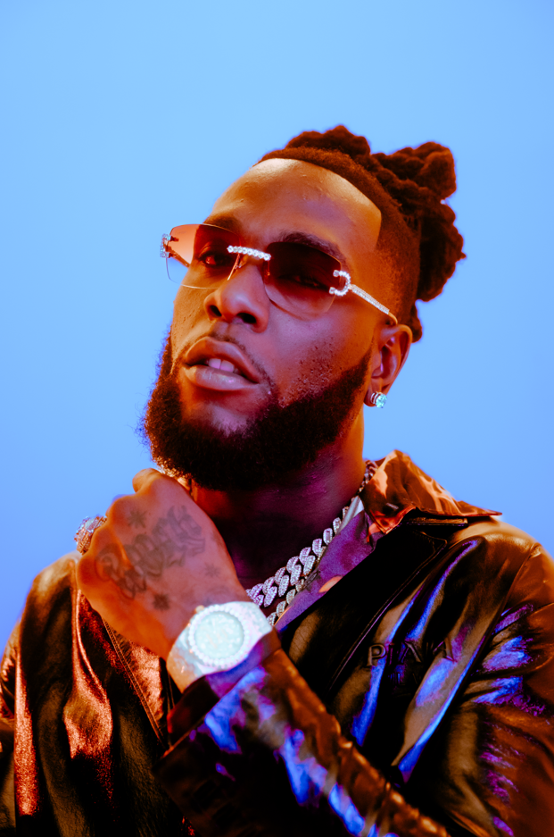
DOWNLOAD ASSETS HERE

GRAMMY Award-winning global superstar Burna Boy earns first ever #1 at Urban Radio with “Last, Last." Today, the African Giant received a 2022 American Music Awards nomination for “Favorite Afrobeats Artist.” The American Music Awards are LIVE Sunday, November 20 at 8/7c on ABC and taking place at the Microsoft Theater in Los Angeles. Fans are able to vote for the AMAs here.

WATCH BURNA BOY PERFORM “LAST, LAST” ON THE TONIGHT SHOW STARRING JIMMY FALLON
WATCH BURNA BOY PERFORM “LAST, LAST” AT THE 2022 BILLBOARD MUSIC AWARDS
WATCH BURNA BOY TEACH JIMMY THE AFRO MOONWALK DANCE MOVE

Burna Boy continues to reach new heights with his sixth studio album “LOVE, DAMINI,” marking his highest U.S. debut to date on the Billboard Top 200, topping the Billboard U.S Afrobeats Songs chart for 8 weeks and continuing to climb at Rhythm Radio. The album also continues to grow internationally as it finished at #2 in the UK and Netherlands, becoming his highest charting album in those territories, and the #1 album on Apple Music in 47 countries. LOVE, DAMINI was selected as a The New York Times’ Critics Pick with additional praise from Rolling Stone, Billboard, Vulture, Variety and many more. Burna Boy recently announced an extension of his stadium tour, find new upcoming dates here. Catch the latest official music video for “It’s Plenty” from LOVE, DAMINI.
CONNECT WITH BURNA BOY
TWITTER | FACEBOOK | INSTAGRAM | YOUTUBE
PRESS CONTACTS
Corey Brewer | Corey.Brewer@atlanticrecords.com
Selam Belay | Selam.Belay@atlanticrecords.com

