FOR IMMEDIATE RELEASE
MARCH 3, 2023

BANKROL HAYDEN IS BACK WITH “BOP SLIDE
(FEAT. OHGEESY, BLUEFACE & MAXO KREAM)”

STAR-STUDDED SINGLE HERALDS EAGERLY AWAITED NEW MIXTAPE, 29,
DUE MARCH 10

FIRST-EVER NORTH AMERICAN HEADLINE TOUR
KICKS OFF APRIL 15 IN SAN DIEGO, CA

LISTEN HERE

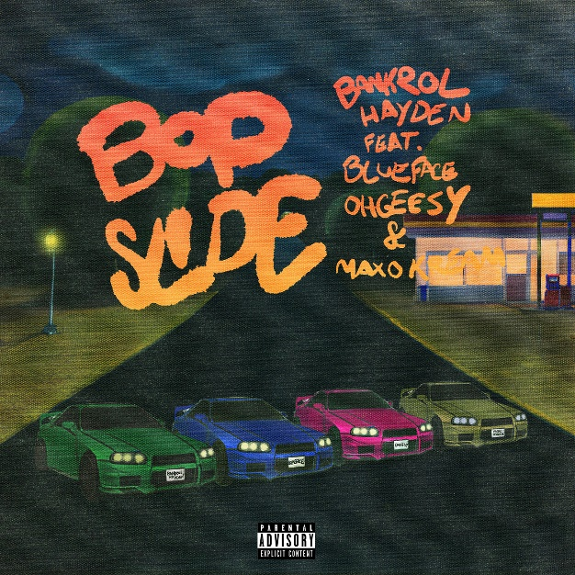

DOWNLOAD HI-RES ARTWORK

“Bankrol Hayden has continuously released memorable music since debuting in 2018. His quick, melodic flow is unique, and his hooks stay with you.” – POPDUST

Rising hip-hop star Bankrol Hayden unveils his star-studded single, “Bop Slide (Feat. OhGeesy, Blueface & Maxo Kream),” out now. Produced by Alex Goldblatt (Roddy Ricch), Tom Levesque (Roddy Ricch, YG, Ty Dolla $ign), Callan Wong (Lil Mosey, Lil Tecca) and Diego Ave (Megan Thee Stallion, Wiz Khalifa, Kali, Doechii); the triumphant horns andmbass-boosted groove, sees Hayden dropping an undeniable chant as a trifecta of true rap heavyweights, turn up with equally quotable and engaging bars.

“All of these guys fucked with the record, hopped on it, and showed love,” Bankrol Hayden says. “What’s dope is Maxo represents Texas, so it’s not just in the West Coast box. It’s different.”

“Bop Slide (Feat. OhGeesy, Blueface & Maxo Kream)” is the latest track to herald Bankrol Hayden’s much-anticipated new mixtape, 29, set to arrive March 10th. The project was unveiled earlier this year with the melodic “Can’t Change For You (Feat. charlieonnafriday & Arden Jones),” joined by an official music video directed by JakeTheShooter. Watch HERE.

Bankrol Hayden wrapped up 2022 with Christmas basketball anthem, “Courtside.” Produced by longtime collaborator Einer Bankz (Travis Scott, 21 Savage), the bespoke track was created specifically for EPSN and ABC’s “NBA on Christmas Day” campaign and was featured extensively over the holiday season throughout all NBA on ESPN coverage, spanning promos, in-game placement, social media, and more. Named as the featured artist for all “NBA on Christmas Day” coverage, Bankrol Hayden – accompanied by producer Einer Bankz – celebrated the premiere of “Courtside” with a special appearance and live performance on ESPN’s NBA Today. Watch HERE.

Bankrol Hayden will celebrate his recent successes and much more with a long-awaited North American tour – his first headline run to date. “The 29 Tour” begins April 15 at San Diego, CA’s Voodoo Room and then continues through a May 18 finale at Los Angeles, CA’s The Echo. For more information and ticket availability, please visit www.bankrol.co.

BANKROL HAYDEN
THE 29 TOUR

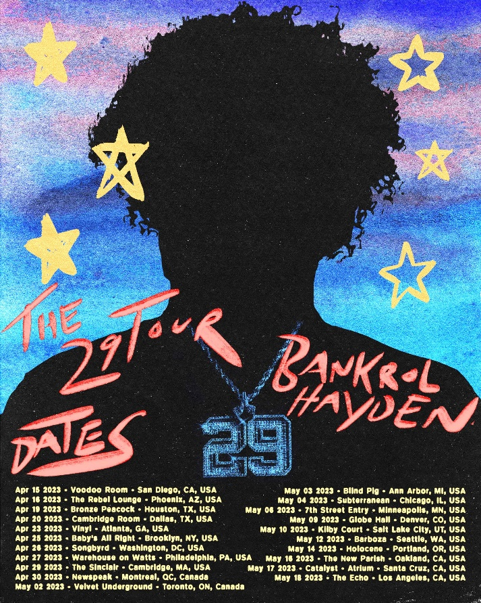

APRIL
15 – San Diego, CA – Voodoo Room
16 – Phoenix, AZ – The Rebel Lounge
19 – Houston, TX – Bronze Peacock
20 – Dallas, TX – Cambridge Room
23 – Atlanta, GA – Vinyl
25 – Brooklyn, NY – Baby’s All Right
26 – Washington, DC – Songbyrd
27 – Philadelphia, PA – Warehouse on Watts
29 – Cambridge, MA – The Sinclair
30 – Montreal, QC – Newspeak

MAY
2 – Toronto, ON – Velvet Underground
3 – Ann Arbor, MI – Blind Pig
4 – Chicago, IL – Subterranean
6 – Minneapolis, MN – 7th Street Entry
9 – Denver, CO – Globe Hall
10 – Salt Lake City, UT – Kilby Court
12 – Seattle, WA – Barboza
14 – Portland, OR – Holocene
16 – Oakland, CA – The New Parish
17 – Santa Cruz, CA – Catalyst (Atrium)
18 – Los Angeles, CA – The Echo

# # #

ABOUT BANKROL HAYDEN:
With over 1B streams to date to date, Bankrol Hayden is a true phenomenon, continuously earning fans around the globe with his positive brand of soulful, pop-forward hip-hop. The talented young artist first broke out in 2017 with a series of popular YouTube videos and SoundCloud favorites. Viral smashes as “B.A.N.K.R.O.L.,” “29,” and the RIAA gold certified “Brothers (Feat. Luh Kel)“ followed, the latter of which scored 30M Spotify streams and 6.5M YouTube plays in under six months. Bankrol Hayden made his Atlantic Records debut in 2020 with the hugely popular “Costa Rica,” quickly earning RIAA gold certification before following up with his powerful debut mixtape, Pain Is Temporary, highlighted by such emotionally charged tracks as “Whatchu On Today (Ft. Polo G),” “Drop A Tear (Ft. Lil Baby),” and “Rich Bitch,” all joined by official music videos streaming now at YouTube.

“Can’t Change For You” continues a run of radiant new music from Bankrol Hayden, including “Deep End (Feat. Lil Skies),” “Van Hayden,” “F*ck Love” the RIAA gold-certified “Costa Rica,” “Cabo,” “No Drama,” and 2021’s smash hit, “Come Through (Ft. Lil Tecca),” the latter of which boasted over 100M worldwide streams after making top playlists such as Spotify’s “Rap Caviar” and “Most Necessary,” Apple Music’s “#OnRepeat” and “The Plug,” Amazon’s “Fresh Hip-Hop,” and more.

Featured among YouTube’s “Artist on the Rise: Trending” series, Bankrol Hayden has also proven to be an electrifying live performer. Recent highlights include Chicago’s Juice WRLD Day Festival and a series of summer festival sets.

CONNECT WITH BANKROL HAYDEN
OFFICIAL | FACEBOOK | INSTAGRAM | TIKTOK | TWITTER | YOUTUBE

PRESS CONTACT
FAIRLEY MCCASKILL | FAIRLEY.MCCASKILL@ATLANTICRECORDS.COM

# # #

