FOR IMMEDIATE RELEASE
MARCH 24, 2023

CATIE TURNER LIFTS THE CURTAIN ON COMEDY & TRAGEDY

AMBITIOUS MULTIPLATFORM PROJECT BEGINS WITH NEW SINGLE “HYPERFIXATIONS”

COMEDY & TRAGEDY: THE HEADLINE TOUR GETS UNDERWAY JUNE 3 IN DALLAS, TX

LISTEN TO “HYPERFIXATIONS” | WATCH OFFICIAL MUSIC VIDEO

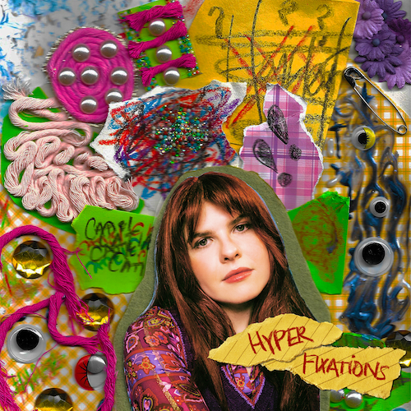
DOWNLOAD HI-RES ARTWORK

“There is a universal message that resonates well into adulthood in Catie Turner's aching, existential honesty…The intimate directness of her voice, over a supple acoustic melody, suggests wisdom beyond her years.” – TIME

Acclaimed singer-songwriter Catie Turner has shared her latest deeply introspective, upbeat pop record, “Hyperfixations,” releasing alongside an official music video – Watch HERE.

“‘Hyperfixations,’ for me, is a normal therapy session,” says Catie. “Semi-concerning lyrics, but with a beat that says, ‘Hey, she’s kind of doing something!’ It’s about living inside my head to the point it affects my ability to love and to perceive love; it affects my ability to perceive life. I really hope you enjoy it, whether as a down-to-enjoy-some-chaos type of person or a fellow neurodivergent over-thinker.”

“Hyperfixations” marks the first chapter of Catie’s ambitious new project, Comedy & Tragedy, a two-part collection of songs and visuals to be released throughout 2023. Comedy & Tragedy: Act 1 and Comedy & Tragedy: Act 2 will showcase Turner’s gift for intensely personal songcraft while simultaneously flexing her sonic versatility with a newfound creative edge. At the heart of the project is Catie’s belief in the dichotomy of drama – that truth cannot exist without both comedy and tragedy. Along with “Hyperfixations,” this week saw Turner lifting the curtain on Comedy & Tragedy: The Musical: The Series, with the release of the first two episodes - Watch HERE.

Catie will celebrate her new music and more with her biggest US live run thus far. Comedy & Tragedy: The Headline Tour gets underway June 3 at Dallas, TX’s Deep Ellum Art Company with stops at New York’s Mercury Lounge and Los Angeles’ Troubadour. Tickets for all announced dates are on sale now; additional dates will be announced soon. For updates and ticket information, please visit www.catieturner.com.

CATIE TURNER
COMEDY & TRAGEDY: THE HEADLINE TOUR

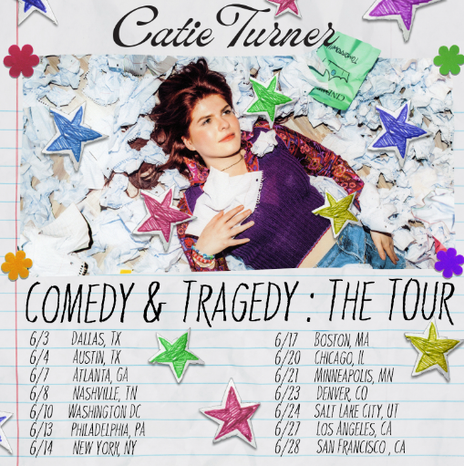

JUNE
3 – Dallas, TX - Deep Ellum Art Company
4 – Austin, TX - The Ballroom
7 – Atlanta, GA - Vinyl
8 – Nashville, TN - The Basement East
10 – Washington, DC - Union Stage
13 – Philadelphia, PA - World Café Live
14 – New York, NY - Mercury Lounge
17 – Boston, MA - Brighton Music Hall
20 – Chicago, IL - Lincoln Hall
21 – Minneapolis, MN - 7th Street Entry
23 – Denver, CO - Globe Hall
24 – Salt Lake City, UT - Kilby Court
27 – Los Angeles, CA - Troubadour
28 – San Francisco, CA - Brick & Mortar Music Hall

# # #

A self-proclaimed “overthinking, overwhelmed musician with a talent in overcomplicating situations,” Catie Turner’s heart-wrenching breakthrough hit single, “God Must Hate Me,” proved a viral phenomenon upon its November 2021 release. Applauded by American Songwriter as “a platform for all sorts of reflections and interpretations…one of (Turner’s) most successful songs to date,” the track earned more than 1.2M streams in its first week, landing Catie on the cover Spotify’s influential “Next Gen Singer Songwriters” playlist. Now with almost 70M global streams, “God Must Hate Me” is joined by a powerful live performance video, filmed live at the historic St. Ann’s Church in Brooklyn, NY – Watch HERE.

Named by PEOPLE as one of “25 Emerging Musical Artists You Should Add to Your Playlist,” Turner spent much of last year on the road, including a major US run supporting Canadian pop band Valley and a well-received series of dates as special guest on Léon’s Fade Into A Dream: The North American Tour.

# # #

DOWNLOAD HI-RES IMAGE // PHOTO CREDIT: LISSYELLE

# # #

CONNECT WITH CATIE TURNER
OFFICIAL | FACEBOOK | INSTAGRAM |TIK TOK | TWITTER | YOUTUBE

For press inquiries, please contact:
Kelly McWilliam, Kelly.McWilliam@atlanticrecords.com
Paige Rosoff, Paige.Rosoff@atlanticrecords.com

