FOR IMMEDIATE RELEASE
MARCH 31, 2023

CHARLOTTE LAWRENCE REVEALS “BODYBAG”

ACCLAIMED SINGER-SONGWRITER RETURNS WITH POWERHOUSE NEW SINGLE

LISTEN TO “BODYBAG” | WATCH VISUALIZER

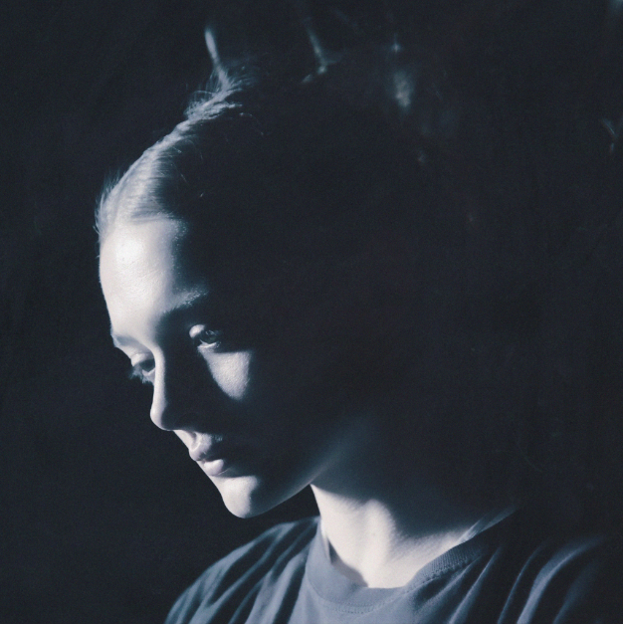
DOWNLOAD HI-RES ARTWORK

Los Angeles-based singer-songwriter Charlotte Lawrence has shared her powerhouse new single, “Bodybag.” Recently featured on Apple TV’s new hit series Shrinking (starring Jason Segal and Harrison Ford), the track is joined by a visualizer – Watch HERE.

“Bodybag” follows last year’s hauntingly beautiful “Morning.” Produced by Ben Gibbard (Death Cab for Cutie, The Postal Service) and Andy Park (Phoebe Bridgers, Mac Miller) and co-written by Lawrence, Gibbard and Park, the track arrived alongside a stunning music video – Watch HERE. “Morning” was met by critical acclaim from high profile media outlets worldwide, including Wonderland which wrote, “With a cinematic music video masterfully capturing the melancholic themes that lace the new track, one that boasts ripples of an acoustic guitar and the angelic vocals catapulting the rising talent towards industry domination, it is one sure to pierce the soul and ignite some serious sad girl feels.”

Hailed by Billboard for her “haunting take on pop rock,” Charlotte Lawrence has quickly proven a landmark milestone artist, fusing deeply personal lyrics with larger-than-life melodies and epic choruses to create a remarkable, multi-faceted musical vision all her own. The Los Angeles-based singer-songwriter has earned critical acclaim – and millions of worldwide streams – for breakthrough hits such as “Just The Same,” “Sleep Talking,” “Why Do You Love Me,” “Navy Blue,” and “Joke’s On You,” the latter of which was featured on Atlantic Records’ hit 2020 soundtrack, BIRDS OF PREY: THE ALBUM.

2021 saw the arrival of Charlotte, an intimate collection of songs detailing Lawrence’s struggles with anxiety, addiction, and dependence on such standout tracks as “Talk You Down,” “You,” and more. The EP “displays a young artist working with full confidence in her abilities,” wrote CLASH, while Atwood Magazine simply raved, “A stunningly evocative and visceral 22-minute affair, Charlotte showcases the expansive breadth and intimate depth of Charlotte Lawrence’s seemingly limitless artistry – finding her dwelling in the caverns of the self and rising to breathtaking heights as she bares her soul for all to see, hear, and feel.”

Lawrence – who followed Charlotte with the stripped-down companion volume, Charlotte (Acoustic) – celebrated the EP with her late night TV debut, performing “Talk You Down,” on ABC’s Jimmy Kimmel Live! and swiftly followed by a stellar rendition of “You” on CBS’s The Late Show With Stephen Colbert. Having firmly established herself as a major new pop force, Lawrence has received critical applause from an array of publications, including Vanity Fair, Cosmopolitan, Harper’s Bazaar, W, i-D, V Magazine, Hypebae, Ones To Watch, and many more. Now, with “Bodybag” and more new music to come, Charlotte Lawrence continues to push her innovative blend of dark pop aesthetics with alternative rock energy even further into the extraordinary unknown.

“I want to share pain and heartbreak and sex and all the emotions everybody feels,” says Charlotte Lawrence, “and hopefully people can connect to that and relate. I always thought that I shouldn't be vocal about what I wanted to do. I was shy and scared. Finally I've grown enough as a person that I feel confident to say I want to perform in arenas and share my music with as many people as I can. I wanna do everything.”

# # #
DOWNLOAD PRESS PHOTO // CREDIT: SHERRIE GARCIA

CONNECT WITH CHARLOTTE LAWRENCE
OFFICIAL | FACEBOOK | INSTAGRAM | TWITTER | YOUTUBE

FOR PRESS INQUIRIES, PLEASE CONTACT:
Kelly McWilliam / Kelly.McWilliam@atlanticrecords.com

