MARCUS MUMFORD & MAREN MORRIS RELEASE NEW REIMAGINED VERSION OF “LOOK AT US NOW (HONEYCOMB)” EXCLUSIVELY ON AMAZON MUSIC – LISTEN HERE

AMAZON ORIGINAL VERSION OF DAISY JONES & THE SIX SINGLE OUT NOW

WATCH A “BEHIND THE SCENES” VIDEO OF THE RECORDING PROCESS HERE

CO-WRITTEN BY GRAMMY® AWARD WINNERS MUMFORD & BLAKE MILLS, WITH PRODUCTION FROM MILLS

DAISY JONES & THE SIX DEBUT AT #1 ON BILLBOARD EMERGING ARTISTS CHART

AURORA DEBUTS AT #1 ON BILLBOARD SOUNDTRACKS CHART; #4 VINYL ALBUMS & AMERICANA/FOLK ALBUMS; #9 CURRENT ALBUM SALES; #10 TOP ALBUM SALES

BUY/STREAM AURORA HERE | PURCHASE ON VINYL HERE

LIMITED SERIES ADAPTATION OF NEW YORK TIMES BESTSELLING LITERARY PHENOMENON OUT NOW ON PRIME VIDEO – PRODUCED BY AMAZON STUDIOS AND HELLO SUNSHINE

“Stillwater walked so Daisy Jones & The Six could stage-dive… the harmonies on ‘Look At Us Now (Honeycomb)’ are infectious… you can imagine that The Six really were the biggest band in the world for a minute.” – ROLLING STONE

“Aurora is an unprecedented project for a book-to-screen adaptation and musical storytelling on television” – ENTERTAINMENT WEEKLY

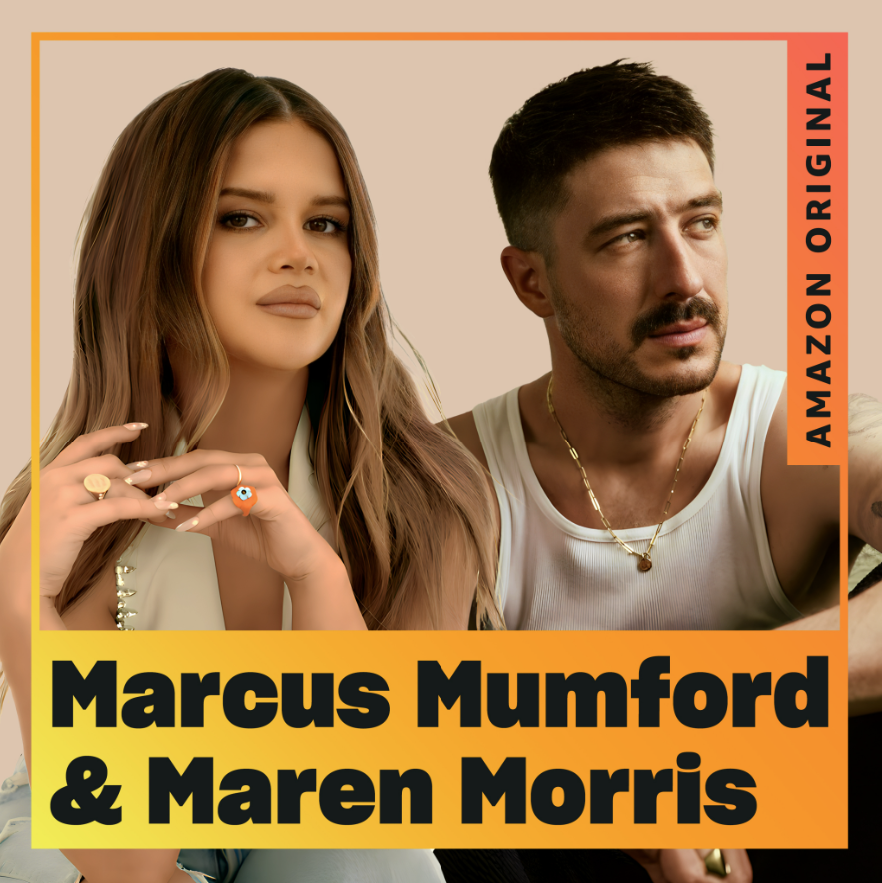
download hi-res artwork here

Atlantic Records is proud to share the stunning new Amazon Original version of “Look At Us Now (Honeycomb),” performed by Marcus Mumford & Maren Morris – out today exclusively via Amazon Music (buy/listen here).

The track marks a reimagined version of the single which first appeared on Aurora, the debut album from Daisy Jones & The Six – subjects of the eponymous limited series which debuted on March 3 on Prime Video.

Mumford co-wrote the original version of the track, alongside GRAMMY®-winning songwriter, producer, and multi-instrumentalist Blake Mills (Bob Dylan, Fiona Apple, Alabama Shakes, John Legend, Perfume Genius). Mills served as producer for the original track, as well as today’s reimagined version.

Today’s release arrives accompanied by a “behind the scenes” mini-doc showcasing Mumford, Morris, and Mills recording the rework, alongside footage of the cast of Daisy Jones & The Six captured during production of the series – watch HERE.

Speaking on today’s release and the music of the limited series, Morris shares: “Shows depicting the reality of what it takes to become a band or what it’s really like touring can so often get it wrong. One of the components of 'Daisy Jones' is that they chose to ground this fictional universe with real songwriting. The music in the show that Blake Mills created and the incredible performances by the actors gives this world a heartbreaking authenticity. I’m so honored to have gotten to sing on 'Look At Us Now' with Marcus.”

Mumford explains the recording of the reimagined version: “Blake and I wrote ‘Look At Us Now (Honeycomb) together - with a bit of help - about a year and a half ago for Daisy Jones & The Six. This time around, we stripped the song right back down to acoustic guitar and a vocal – which is how it was written – and then kind of built it back up from there until we landed on an arrangement that we liked. I’ve been a fan of Maren for a long time – both her solo music and her work with The Highwomen – and this duet needed a voice like hers. We’re just honestly so thankful she agreed to do it.”

Fans can hear Marcus Mumford and Maren Morris’ reimagined version of “Look At Us Now (Honeycomb)” on the TWYG playlist on Amazon Music.

The original duet – featuring lead vocals from the limited series co-stars Riley Keough and Sam Claflin – currently sits at the top of viral charts around the globe.

The full-length album Aurora has also been met with tremendous acclaim, with Daisy Jones & The Six debuting at #1 on Billboard’s Emerging Artists chart – becoming the first act from a scripted series or film to do so. (They also became the first such act to hit #1 on the iTunes Top Albums chart).

The album itself debuted at #1 on Billboard’s Soundtracks chart, #4 on the Billboard Vinyl Albums & Americana/Folk Albums charts, #9 on Top Current Albums, #10 on Top Albums, and more.

Aurora was produced in its entirety by Mills, with additional production from renowned producer Tony Berg (Phoebe Bridgers, Andrew Bird). Taken from page to screen to recording studio, it marks the storied debut album from the titular band of Taylor Jenkins Reid’s beloved, New York Times bestselling novel Daisy Jones & The Six.

Today’s single is timed with the release of the penultimate set of episodes of the groundbreaking limited series adaption ‘Daisy Jones & The Six,’ streaming now on Prime Video (watch here). Starring Riley Keough, Sam Claflin, Suki Waterhouse, and more, it currently ranks as the #1 Prime Video series and boasted a massive 1.5 billion social impressions within the first 3 days of the show’s rollout earlier this month. The final two episodes will arrive next Friday, March 24th.

The highly-anticipated series arrived via Amazon Studios and Reese Witherspoon’s media company Hello Sunshine, who optioned Reid’s work in 2018 – before Daisy Jones & The Six ever even hit bookshelves. Upon the novel’s release in early 2019, it received coveted recognition as a ‘Reese’s Book Club Pick.’

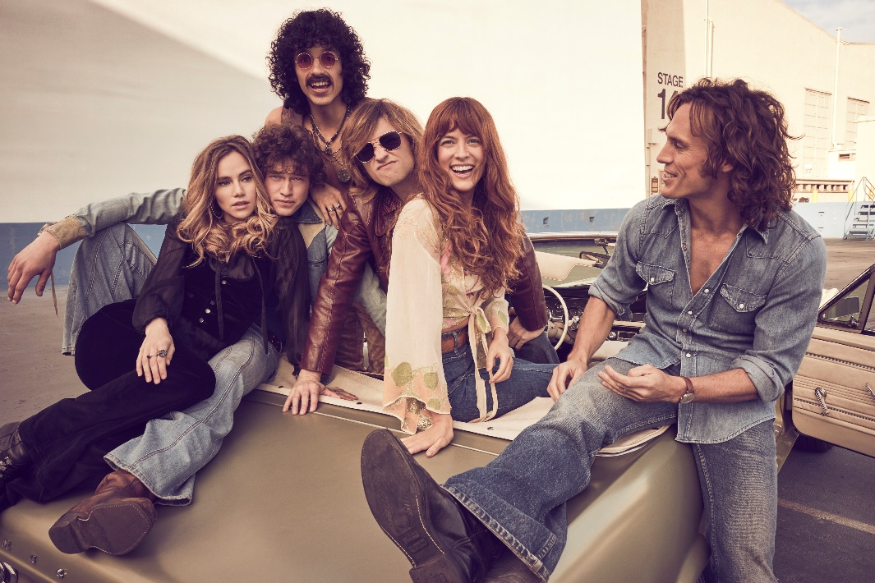
download hi-res photo here

With over 25 original songs, co-written by GRAMMY®-winning songwriter, producer, and multi-instrumentalist Blake Mills, Aurora and other music from throughout Daisy Jones & The Six boasts co-writing credits from several of the biggest names in music, including Marcus Mumford and Jackson Browne, with additional production from renowned record producer Tony Berg, and alongside instrumentalists from The Who, Nine Inch Nails, Pearl Jam, David Bowie, Elton John, Jeff Beck, The Wallflowers, and more. Other co-writers on Aurora include Chris Weisman, Ethan Gruska, and Z Berg, among others.

Mills – who also executive produced the music from the series – recorded the entirety of Aurora with Keough and Claflin at Sound City Studios. The iconic Van Nuys, CA space – now jointly run by Mills and Berg – also serves as the backdrop in both the book and limited series for the creation of the album.

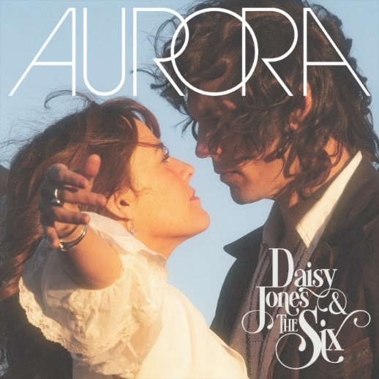
download hi-res album artwork here

***

DAISY JONES & THE SIX – AURORA TRACKLIST:
- Aurora
- Let Me Down Easy
- Kill You To Try
- Two Against Three
- Look At Us Now (Honeycomb)
- Regret Me
- You Were Gone
- More Fun To Miss
- Please
- The River
- No Words

ABOUT DAISY JONES & THE SIX – THE LIMITED SERIES:
Based on the best-selling novel by Taylor Jenkins Reid, Daisy Jones & The Six is a limited musical-drama series detailing the rise and precipitous fall of a renowned rock band. In 1977, Daisy Jones & The Six were on top of the world. Fronted by two charismatic lead singers—Daisy Jones (Riley Keough) and Billy Dunne (Sam Claflin)—the band had risen from obscurity to fame. And then, after a sold-out show at Chicago's Soldier Field, they called it quits. Now, decades later, the band members finally agree to reveal the truth. This is the story of how an iconic band imploded at the height of its powers.

The series stars Riley Keough as Daisy Jones, Sam Claflin as Billy Dunne, Camila Morrone as Camila Dunne, Will Harrison as Graham Dunne, Suki Waterhouse as Karen Sirko, Josh Whitehouse as Eddie Roundtree, Sebastian Chacon as Warren Rhodes, Nabiyah Be as Simone Jackson, and Tom Wright as Teddy Price, with a special guest appearance by Timothy Olyphant as Rod Reyes.

From Amazon Studios and Hello Sunshine, Daisy Jones & The Six is executive produced by Reese Witherspoon and Lauren Neustadter for Hello Sunshine and Brad Mendelsohn for Circle of Confusion. Scott Neustadter and Michael H. Weber created the series based on the novel by Taylor Jenkins Reid, who also produces. Scott Neustadter is executive producing and co-showrunning with Will Graham, who also serves as an executive producer. James Ponsoldt directed the first five episodes and serves as an executive producer, Nzingha Stewart directed four of the remaining episodes, and Graham directed one.

Daisy Jones & The Six premieres March 3, with new episodes released every Friday through March 24, exclusively on Prime Video in more than 240 countries and territories worldwide. For more information, visit the Amazon Studios Press Site.

***

CONNECT WITH DAISY JONES & THE SIX
WEBSITE | FACEBOOK | TWITTER | INSTAGRAM | YOUTUBE | TIKTOK

***

Atlantic Records Press Contact:
Libby Kober | Libby.Kober@atlanticrecords.com

Marcus Mumford + Maren Morris Press Contact:
Carla Sacks | carla@sacksco.com

Amazon Music Press Contact:
David Marek | davmarek@amazon.com

Prime Video Press Contacts:
Melissa Armstrong | Melissa.Armstrong@amazonstudios.com
Kevin McAlpine | Kevin.McAlpine@amazonstudios.com
Reegan Smyth | Reegan.Smyth@amazonstudios.com

