FOR IMMEDIATE RELEASE
MARCH 14, 2023

DON TOLIVER CELEBRATES ACCLAIMED NEW ALBUM
WITH LOVE SICK RADIO

COMPLETE VIDEO OF SPECIAL EVENT PREMIERES TODAY AT YOUTUBE
FOLLOWING INITIAL BROADCAST
ON AMP, THE LIVE RADIO APP FROM AMAZON

LOVE SICK INCLUDES THE RECENT SINGLES
“LEAVE THE CLUB (FEAT. LIL DURK & GLORILLA),”
“4 ME (FEAT. KALI UCHIS),”
AND “SLOW MOTION (FEAT. WIZKID)”

LOVE SICK SHORT FILM, PRESENTED BY ROTATION,
STREAMING NOW EXCLUSIVELY ON PRIME VIDEO
WATCH HERE

US ARENA DATES ALONGSIDE FUTURE’S “ONE BIG PARTY TOUR”
CURRENTLY UNDERWAY

LOVE SICK (DELUXE) AVAILABLE NOW VIA CACTUS JACK/ATLANTIC RECORDS HERE

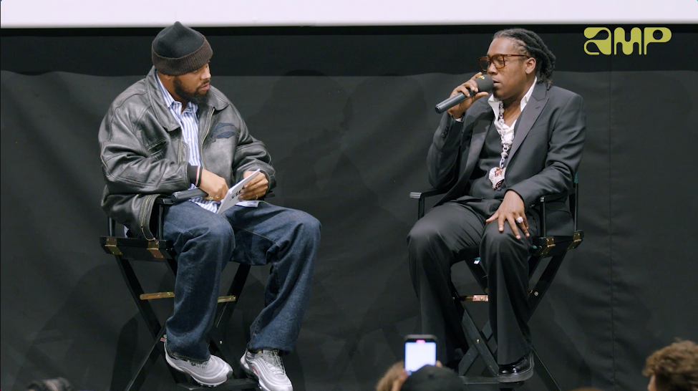
DOWNLOAD ALBUM ARTWORK

Hip-hop soul artist Don Toliver has shared the complete video of Love Sick Radio, an exclusive conversation moderated by Don’s longtime manager and A&R, Sickamore, that first premiered last month on Amp, the live radio app from Amazon, to celebrate the release of his third studio album, Love Sick, and accompanying self-written short film presented by Rotation—the hip-hop and R&B brand from Amazon Music—available exclusively on Prime Video. The Los Angeles-based broadcast sees Don discussing his new album and film while taking questions from fans in the live audience as well those listening and commenting live on the Amp app. The complete Love Sick Radio event is streaming now at the official Don Toliver YouTube channel HERE.

Love Sick is available now via Cactus Jack/Atlantic Records and includes such scintillating singles as “Slow Motion (Feat. Wizkid),” “Leave The Club (Feat. Lil Durk & GloRilla),” and “4 Me (Feat. Kali Uchis).” As noted, the album is joined by a self-written short film, Love Sick, presented by Rotation – the hip-hop and R&B brand from Amazon Music – streaming now exclusively on Prime Video HERE. Love Sick was quickly upgraded into an expanded deluxe edition featuring four additional tracks, including the brand new bangers as “Embarrassed (Feat. Travis Scott),” “Luckily I’m Having (Feat. Teezo Touchdown),” “No Pole,” and “Geronimo,” available HERE.

Don Toliver will celebrate Love Sick with a wide-ranging US tour schedule, including direct support on Future’s star-studded “One Big Party Tour,” traveling now through early April. Purchase tickets HERE.

Toliver received RIAA platinum certifications for his debut album, Heaven or Hell, and its monumental singles, the 3x Platinum “No Idea,” the 3x Platinum “After Party,” and the Platinum “Cardigan” in addition to “Euphoria (Feat. Kaash Paige & Travis Scott)” and “Had Enough (Feat. Quavo & Offset), both of which were recently certified Gold by the RIAA. Last year saw Don Toliver earn international applause with “Do It Right.” Hailed by CLASH as “a ready-made anthem, it’s bouncy funk fueled by a sample of the S.O.S Band’s classic ‘Take Your Time (Do It Right),’” the track is joined by glitterball-powered official visual, presented by Cactus Jack and Rotation, directed by award-winning French filmmaker Alexandre Moors (Kendrick Lamar, Juice WRLD, Miley Cyrus) and now boasting close to 9M views at YouTube HERE.

In addition, Don Toliver was featured in Rihanna’s Savage X Fenty Show Vol. 4, performing a scintillating medley of “Do It Right” and “Way Bigger,” the latter of which originally appears on his critically acclaimed sophomore album, 2021’s Life of a DON. The star-studded annual fashion experience can be viewed exclusively on Prime Video HERE.

Indeed, 2022 marked a landmark year for Don Toliver, with high profile features including SZA’s “Used,” Justin Bieber’s “Honest,” Kid Cudi’s “Somewhere To Fly” and “Burrow,” Baby Keem’s “Killstreaks,” Trippie Redd’s “Ain’t Safe,” and Wizkid’s “Special,” to name just a few. Released October 2021, Life of a DON made a spectacular chart debut upon its arrival, landing at #2 on Billboard’s “Top R&B/Hip-Hop Albums” and the Billboard 200 – Toliver's second US top 10 debut on the overall chart and highest charting album to date. Life of a DON includes such hit singles as “Drugs N Hella Melodies (Feat. Kali Uchis),” “Way Bigger,” “Flocky Flocky (Feat. Travis Scott),” and the RIAA gold certified “What You Need,” all of which are joined by dramatic visuals that have earned a combined 60M+ views via the official Don Toliver YouTube channel HERE.

ABOUT DON TOLIVER:
Soul singer, songwriter, and artist Don Toliver has earned worldwide attention for a unique sound that calls out his myriad musical influences of hip-hop, smoked-out R&B, ambitious pop, and even a bit of rock ‘n’ roll, creating a genre-bending lane of his own. After the 2018 mixtape Donny Womack, the Houston, TX native assembled his full-length debut, Heaven Or Hell, which claimed spots on mid-year and year-end lists by Complex and XXL, while Rolling Stone championed him among the “10 Biggest Breakthrough Artists of 2020.” Don then joined forces with Internet Money, NAV, and Gunna for the 4x platinum banger “Lemonade,” which they also performed on NBC’s The Tonight Show Starring Jimmy Fallon. 2021 saw Don team with Lil Durk and Latto for “Fast Lane,” the lead track on Atlantic Records’ F9: The Fast Saga (Original Motion Picture Soundtrack), followed by the blockbuster release of Life of a DON, once again showcasing his fluid ability to exist in multiple soundscapes and featuring production by Mike Dean, Hit-Boy, Mustard, and more. Through it all, he has gathered billions of streams, scored platinum plaques, and received praise courtesy of everybody from such media outlets as V MAN, W Magazine, Interview, and more. 2023 now marks a spectacular new era for Don and his fans around the world as he embarks on his most exciting musical journey thus far. Stay tuned…

DON TOLIVER
ON TOUR 2023

† w/ Future “One Big Party Tour”

MARCH
17 – Fort Lauderdale, FL – FLA Live Arena †
19 – Jacksonville, FL – Vystar Arena †
24 – Philadelphia, PA – Wells Fargo Arena †
25 – Columbus, OH – Nationwide Arena †
26 – Milwaukee, WI – Fiserv Forum †

APRIL
1 – Oakland, CA – Oakland Arena †
6 – Indianapolis, IN – Gainbridge Fieldhouse †
7 – Kansas City, MO – T–Mobile Center †
8 – Minneapolis, MN – Target Center †

# # #

CONNECT WITH DON TOLIVER
OFFICIAL I INSTAGRAM| TWITTER |FACEBOOK |YOUTUBE

PRESS CONTACT:
Brittany Bell, Brittany.Bell@atlanticrecords.com

