FOR IMMEDIATE RELEASE
MARCH 17, 2023

FRED AGAIN.. x SKRILLEX x FOUR TET
RELEASE NEW SINGLE ‘BABY AGAIN..’

LISTEN HERE

SOLD OUT MADISON SQUARE GARDEN LAST MONTH

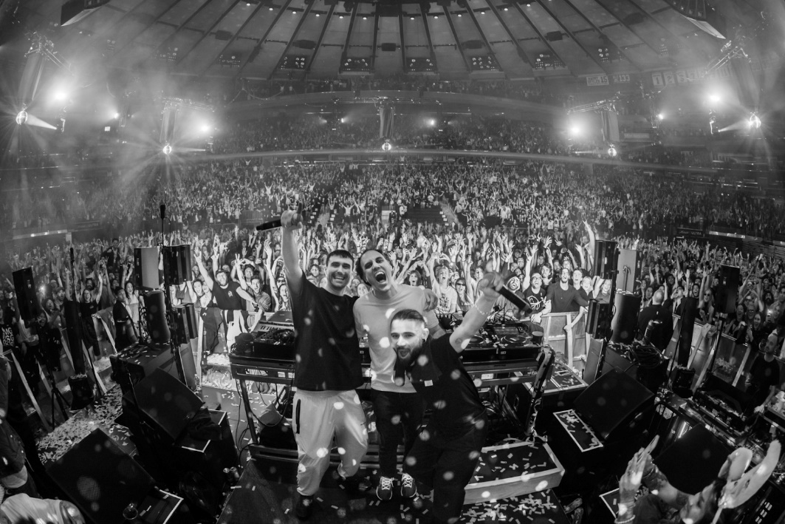
DOWNLOAD PRESS PHOTO HERE // CREDIT: CHRIS LAVADO

Following their record breaking sold out performance at Madison Square Garden last month, Fred again.., Skrillex and Four Tet today release their long-awaited collaboration ‘Baby again..’. First heard during Fred’s viral Boiler Room set last summer and played by all three artists as highlight moments in their sets ever since, ‘Baby again..’ was born out of an impromptu studio session in Pangbourne where Fred, Sonny and Kieran came together in the remote countryside location, sparking the ‘Pangbourne House Mafia’ name being coined by fans. Alongside the single, the supergroup will be releasing an hour-long looped version of ‘Baby again..’ at 8 AM PT / 11 AM ET using footage from their Madison Square Garden set. It will be available to watch here: https://fredagain.lnk.to/baby-again-video

Last month, Fred again.., Skrillex and Four Tet did a series of pop-up events across New York culminating in a 5-hour b2b set at Madison Square Garden (20,000 cap) that was announced only three days ahead of the show and sold out immediately. Fred dropped ‘Baby again..’ two hours into the set, creating an iconic moment when the full house lights turned off for the first time. The fanfare that followed Fred’s announcement of the New York run was unprecedented - kicking off with a rave at Good Room on Valentines Day, the trio also performed at Le Poisson Rouge and on a school bus for The Lot Radio, completely shutting down Times Square. New York was utterly transfixed by the trio for an entire week and it uniquely unified the city’s dance community in a way that has never been seen before.

So far in his short career, the prolific London artist has released three acclaimed, deeply personal albums from his Actual Life series which were beloved by fans and critics alike. Last year also saw Fred again.. become one of the year's most talked about live acts as he transformed his Actual Life records into an immersive, communal real-life experience for the first time. With shows selling out across the UK and USA (including three consecutive sold-out nights at London’s Brixton Academy in December), he was named one of Mixmag's "Top 10 Live Acts Of 2022" for the second consecutive year. Fred continued his upwards trajectory with the viral success release of his Boiler Room, which has to date surpassed over 15 million streams, overtaking the numbers seen by artists such as Disclosure, Richie Hawtin, Skream & Fatboy Slim in only 4 weeks.

Fred again.. Tour Dates
Saturday March 18, Lollapalooza , Buenos Aires, Argentina / Tickets
Sunday March 19, Lollapalooza , Santiago, Chile / Tickets
Friday March 24, Estereo Picnic, Bogota , Colombia / Tickets
Saturday March 26, Lollapalooza , Sao Paolo, Brazil / Tickets
Friday 31 March, Tecate Pal Norte, Monterrey, Mexico / Tickets
Saturday 1 April, Ceremonia, Mexico City, Mexico / Tickets
Friday, 2 June Primavera Sound, Barcelona, Spain / Tickets
Thursday 8 June, Primavera Sound Madrid, Madrid, Spain / Tickets
Friday 9 June, Primavera Porto, Portugal / Tickets
Saturday 10 June, Parklife Festival, Manchester, United Kingdom / Tickets
Friday 23 June - Glastonbury Festival, UK / Website
Friday 30 June, Down the Rabbit Hole Festival, Beuningen, Netherlands / Tickets
Saturday 1 July, Rock Werchter, Werchter, Belgium / Tickets
Sunday 2 July, Garorock, Marmande, France / Tickets
Sunday August 6 2023, Osheaga Festival, Montreal / Tickets
26th August - Connect Festival, Scotland, UK / Tickets
2nd September - Electric Picnic, Ireland / Tickets

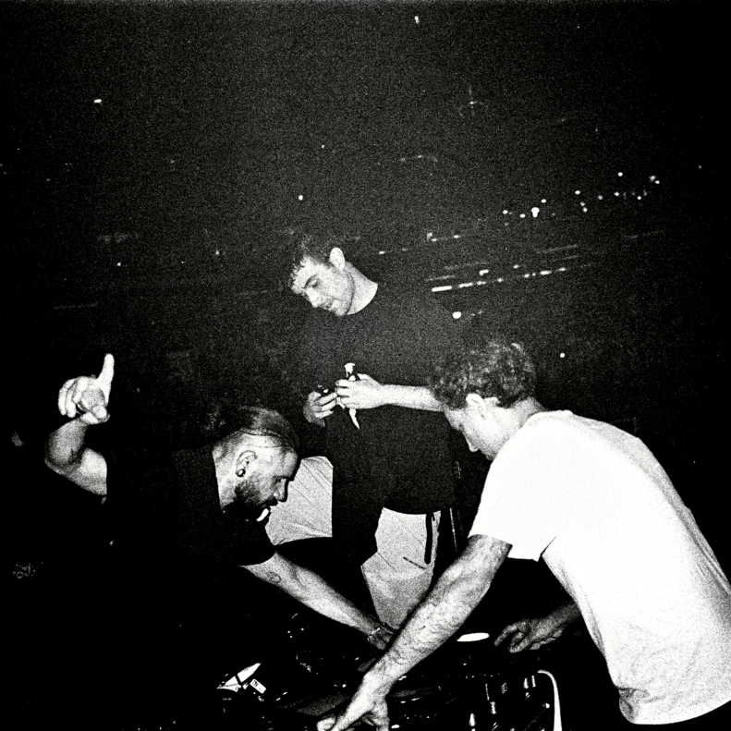
DOWNLOAD ARTWORK HERE

Follow Fred again..
OFFICIAL SITE / INSTAGRAM / TIKTOK

For more information on Fred again.., please contact:
Kelly McWilliam / Kelly.McWilliam@atlanticrecords.com

